A Boy Bishopping Medieval Christmas!
Teacher Notes

Overview
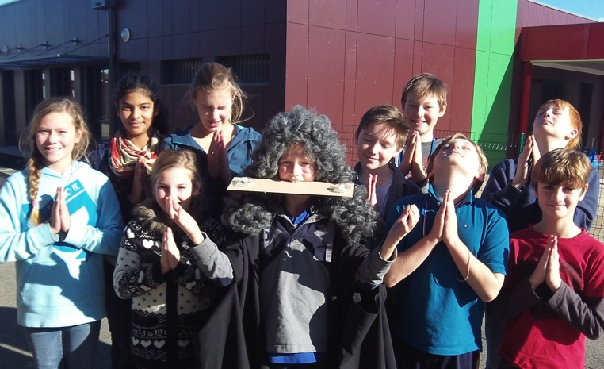
• In this activity students will learn how people celebrated Christmas in the Middle Ages. In particular, the class will re-enact the ceremony of the “Boy Bishop”. This ceremony will provide one student with special religious powers for 24 hours. In particular, that student will have the power to marry pairs of people in the class (although in church law these marriages will only be valid for 24 hours)!

Pre-Class Preparation
• You will need a piece of wood, two candles, a pillow, and ideally a priest’s costume.
• You can also prepare a pile of slips with the names of each boy in the class, and a second pile of slips with the name of each girl in the class.

Task 1: Reading, Factual Test, and selection of the Boy Bishop
• As a class, read through the ‘essential information’ handout.
• Afterwards, a factual test will follow.
• The five best scoring students will have the opportunity to explain what their Christmas sermon would be about if they are elected as ‘Boy Bishop’. To be historically accurate they should do this whilst “making strange faces and speaking in a feigned voice” (see below).
• The class will then vote on who should become the ‘Boy Bishop’ after hearing from all three candidates.

Task 2: Consecrating the Bishop
• The winning candidate should be seated in a chair wearing a gown, and take a piece of wood in his mouth with two candles burning at either end. The class then has to march around him three times chanting “We consecrate a Christmas Bishop pro nobis”.
NOTE: Stress that in the Middle Ages this was considered to have genuine legal force!

Task 3: Here comes the bride!
The teacher should read this source to the class as an introduction to what functions the Boy Bishop will perform:
“He marries as many couples from the guild as he wants while making strange faces and speaking in a feigned voice, and then the married couples must offer something. Those offering something which is not good enough are hit by a bag filled with ashes that the Bishop has kept under his cape.”

• At this point, give each member of the class a few minutes to come up with an idea for a suitable medieval gift that they will provide to the bishop.
• After students have thought about their present, the Bishop will select one boy and one girld at random couples (best of all, have a pile of slips with the girls’ names, and a second pile with the boys’ names, prepared in advance).
• The couple has to hold hands and the boy bishop will declare ‘I now pronounce you man and wife’. The rest of the audience should applaud.
• Then, either the husband or the wife (the teacher can choose) then tells the bishop what present they plan to offer to him. He either blesses them if he regards this as fair, or hits them with the ‘bag of ashes’ (a feather pillow or similar) if he doesn’t.
• The teacher will take a photograph of each of the happy couple with their guests (the classmates). Expect plenty of noise and hilarity at this stage…!

• To round off the exercise, students could be asked to write an answer to the question:
a. If you were placed in charge of Christmas, what things would you change and why?
b. If you were given charge of this school, what things would you change and why?

A Medieval Christmas – Essential Information for Students - Factual Test to Follow
• Christmas was important for Medieval people. The word 'Christes Maesse' first appears in a Saxon book in 1038 and the Christmas ‘Carol’ involved singing and dancing (the word derives from the French "carole" or the Latin "carula" meaning a circular dance).
• William the Conqueror, to underline the support he’d had from the Pope, had his coronation on Christmas day at Westminster Abbey. This was such a big occasion that the cheering inside the Abbey made the guards outside think the king was being attacked. They ran to his assistance and the coronation ended in a riot, with people killed and houses burned!

ChilderMass
• December 28th is "Holy Innocents Day" or "Childermass Day".
• This is the day when King Herod ordered that all children under two years of age should be killed. In this way he hoped to kill the infant Jesus.
• December 28th was seen by many then as a day of bad luck. No-one would get married on that day; no-one would start a building on that day and Edward IV refused to be crowned on that day.
• In Medieval England, children were reminded of Herod’s cruelty by being beaten!

[video clip here from Horrible Histories - http://goo.gl/bNKdqI]

The Boy Bishop
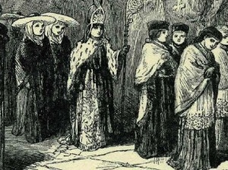
• The ceremony of the Boy bishop formed part of the pranks which turned the world upside down to combat the dreariness of midwinter.
• The ‘boy bishop’ was elected by the choirboys of each diocese on the Feast of St. Nicholas, December 6 (Saint Nicholas is known to us as Santa Claus).
• The boy bishop and his chosen assistants took control of various duties within the church, for 24 hours, beginning with Vespers (the evening prayer service) on the night of December 27.

a. In Britain
• The boy would be dressed up in vestments and he was seated in the bishop's throne. He had the authority to bless the people, and was required to preach at least one sermon on a subject of his choice.
• Afterwards he would go out in a procession, where he would receive gifts of money and food.
• Even the English kings would participate in the fun – Edward I had one boy bishop give a sermon before him in 1299 and his son Edward II awarded another boy bishop ten shillings in 1316.

b. In Europe
• In mainland Europe the practice was a little different. One account from Denmark describes how someone became the bishop:
“Christmas Bishop is the name of a young man who is consecrated bishop in a Christmas game which goes as follows: they place one from their own guild, that is to say the guild of unmarried people, on a chair, blacken his face and put a stick in his mouth with a piece of candle on either end. Then the young men and women run around him in a circle and sign: ‘We consecrate a Christmas Bishop pro nobis”, and when this had been done three times he had been consecrated Christmas Bishop”.

These marriages are actually valid for 24 hours according to Church law!

Factual Test for students

In which year do we find the first reference to “Christes Masse” in an English book?
Which King of England had his coronation on Christmas Day, 1066?
In which city did this coronation take place?
What name is ‘Holy Innocents’ Day’ otherwise known as?
On what day does this take place?
Which Biblical King ordered the murder of all children aged less than 2 years?
Which King of England refused to be crowned on that day in case it brought him bad luck?
The ‘Boy Bishop’ was elected on 6th December, which is the feast of which patron saint of children?
What name do we give to the evening prayer service where the Boy Bishop began his 24-hour reign over the church?
To consecrate a boy bishop, the local choir has to march around him three times chanting “We consecrate a bishop….”?

If you are in the top 5 scoring students, you will have the chance to become the “Boy Bishop” and will have to explain to the class what your Christmas sermon would be about. Write your thoughts about what this sermon could be about here:

If you are married by the Boy Bishop, you will be expected to tell him what gift you will give him at a later date. Write your idea for a present here. Note: this needs to be something that would have been available to ordinary people in the Middle Ages. But if he doesn’t like it, he’ll whack you on the head with a sack of ashes.

Teacher answer sheet
In which year do we find the first reference to “Christes Masse” in an English book? | 1038
Which King of England had his coronation on Christmas Day, 1066? | William the Conqueror
In which city did this coronation take place? | London
What name is ‘Holy Innocents’ Day’ otherwise known as? | Childermass
On what day does this take place? | December 28th
Which Biblical King ordered the murder of all children aged less than 2 years? | Herod
Which King of England refused to be crowned on that day in case it brought him bad luck? | Edward IV
The ‘Boy Bishop’ was elected on 6th December, which is the feast of which patron saint of children? | St. Nicholas (Santa Claus)
What name do we give to the evening prayer service where the Boy Bishop began his 24-hour reign over the church? | Vespers
To consecrate a boy bishop, the local choir has to march around him three times chanting “We consecrate a bishop….”? | Pro Nobis

This lesson forms part of a whole series of Christmas-themed lessons for different year groups that can be found at www.activehistory.co.uk.

