Have Yourself a Very Nazi Christmas!
A Case Study in Third Reich Propaganda

Introduction
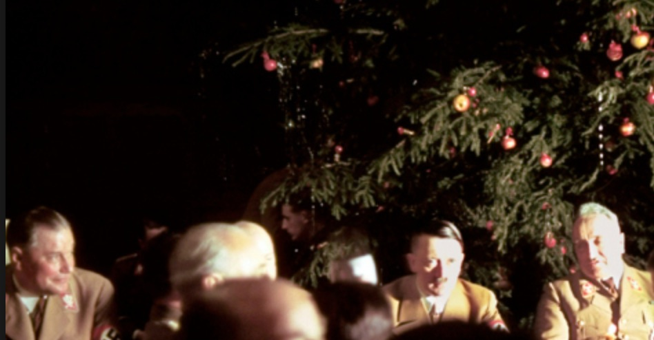
• In this activity you will consider how effectively the Nazis used propaganda to manipulate the message of Christmas so that it promoted Nazi ideology.
• You will consider which aspects of Christmas traditions that Hitler would particularly dislike (and so remove) and which aspects he could use for Nazi propaganda (and so keep).
Hitler at a 1941 Christmas Party
• You will then formulate your own ‘rebranding’ campaign for a “Nazi Christmas”, present it to the class, then compare it to what Hitler actually did to form your judgement about the effectiveness of Nazi propaganda.
• There will be three teams for the task. Your job is to persuade your teacher that your plan is the most effective, and be prepared to challenge the ideas proposed by the other team. It’s a case of ‘Survival of the Fittest’!

Task 1: Classroom discussion
• Your teacher will divide the board into two columns titled “Features of Nazism” and “Features of Christmas”.
• Contribute ideas to build up the two columns.
• Then discuss as a class any initial thoughts you have about which features of Christmas are particularly compatible and incompatible with Nazi ideology.

Task 2: Individual Work
a. Comprehension
• Your teacher will give each student in the class a sheet of information about a specific feature of Christmas (there are three different sheets).
• For the sheet that you are given, underline or highlight in one colour all the details which the Nazis would find useful for propaganda purposes, and in another colour all those details which they would be keen to censor.
• Make notes in the margin to help you explain your choices.

b. Formulating a plan
• When you have finished, turn the sheet over and try to come up with some ideas about how you are going to ‘rebrand’ this aspect of Christmas to promote as many Nazi ideals as possible.

Task 3: Group Work
a. Feedback
• The class will now be arranged into three groups consisting of people who have been working on the same worksheet.
• The members of the group should exchange their ideas, first by discussing the things which they think the Nazis would find useful, and then those things which they think they would be keen to reject.

b. Formulating a plan
You should now discuss the plans you came up with for ‘rebranding’ this aspect of Christmas. One person should take charge of being the ‘team leader’ at this point and deciding upon the best overall ideas ready to present to the class in the next stage of the task.

Task 3: Whole-class discussion
• The “Santa Claus” team should present its plan to the class first of all. The rest of the class should be prepared to question, challenge and criticise aspects of the plan.
• Your teacher will then provide you with details about what the Nazis actually did with relation to this issue and the whole class should take notes. This teacher presenation can be found at ActiveHistory at http://goo.gl/dzA2dH.
• “Team Santa” should also offer their opinions about whether they consider these ideas to be good or bad, and explain why. They will also be given a question from the teacher presentation at http://goo.gl/dzA2dH.
• The process will then be repeated for the other teams, and the teacher will declare an overall winner at the end.
• As a homework exercise, you may be required to write an answer to the question “How effectively did the Nazis use propaganda to manipulate the message of Christmas to promote Nazi ideology?”

Team 1: Santa Claus
Santa Claus can trace his oldest origins to Odin, one of the major gods in Germanic mythology who was depicted as a white-bearded man with magical powers. During the winter solstice, also known as Yule, Odin led a hunting party in the sky with an eight-legged horse named Sleipnir. Children would leave their boots by the chimney filled with carrots and hay to feed Sleipnir. Christianity adopted this figure and renamed him Santa Claus in honour of St. Nicholas, the Christian bishop of Myra, a Roman town in Turkey. St. Nicholas was Greek and lived during the third and fourth centuries. His kindness to children is well recorded. On one occasion, He gave three bags of gold to a father to save his daughters from prostitution. On another occasion, he resurrected three boys who had been murdered, dismembered and pickled by an innkeeper. Because of these stories, gift-giving celebrations still take place on St. Nicholas Day, December 6th, in many countries. The Protestant Reformation saw the popularity of Catholic saints decline, and in Germany Santa Claus became partnered with a character who focused more on punishing and even kidnapping bad children than rewarding good ones: this rather fearful figure is known as Krampus or Ruklaus (Rough Nicholas). He is hairy, usually brown or black, and has the horns of a goat and a long, pointed tongue.

Team 2: Jesus Christ
Jesus was a Jew who came from Nazareth, a town in modern-day Israel. He promoted a religion based on forgiveness (“Love your enemies and pray for those who persecute you”), nonviolence (“all who draw the sword will die by the sword”) and brotherhood (“Do to others whatever you would like them to do to you”). The only occasion where he used physical force was when he expelled greedy money changers (bankers) out of the Jerusalem temple where they had set up business. He criticised the Jewish rabbis for not showing sufficient respect for God. This, along with his claim to be “King of the Jews” and the long-awaited “Messiah” (son of God) led to his arrest and crucifixion by the Jewish authorities on charges of blasphemy. In the 19th century, racial theorists were troubled by the idea that Jesus was Jewish, and they developed a theory that, as an Aramaic-speaking Galilean, he was probably racially descended from the ‘Aryan’ Assyrians who populated Galilee in the 8th century BC. It is now established that Jesus was not born in the Winter (shepherds do not ‘watch their flocks by night’ at this time of the year). Rather, he was born at Easter time, but the Christians cleverly hijacked the ancient winter solstice festival and made it their own.

Team 3: The Christmas Tree
The evergreen fir tree has traditionally been used to celebrate winter festivals (pagan and Christian) for thousands of years. Pagans used branches of it to decorate their homes during the winter solstice, as it made them think of the spring to come. In many countries it was believed that evergreens would keep away witches, ghosts, evil spirits, and illness. The Romans used Fir Trees to decorate their temples at the festival of Saturnalia. Christians use it as a sign of everlasting life with God. The first documented use of a tree at Christmas and New Year celebrations is in town square of Riga, the capital of Latvia, in the year 1510. The first first person to bring a Christmas Tree into a house, in the way we know it today, may have been the 16th century German preacher Martin Luther. In Germany, the first Christmas Trees were decorated with edible things, such as gingerbread and gold covered apples. Later came the tradition of adding ornaments with religious connections – the star of Bethlehem on the top of the tree, for example. The tradition spread to England after Prince Albert (Queen Victoria's German husband) had a Christmas Tree set up in Windsor Castle in 1848.

