Have a Very Cromwellian Christmas!
Teacher Notes

Overview
• This lesson covers how and why the Protestant Reformation led to the emergence of a ‘Puritan’ movement which banned Christmas altogether.
• Students will research how various Christmas traditions that we take for granted actually have very little basis in the Bible.
• They will research these traditions for themselves, turn them into quiz questions.

Pre-Class Preparation
• Have one of Martin Luther’s hymns playing as students enter for some atmosphere:
https://www.youtube.com/watch?v=O6k8DFb8fWs

Teacher Notes

Roleplay Task
As charmingly as possible, introduces yourself as a 'Ghost of Christmas Past': a loyal follower of Martin Luther who has taken power in England after overthrowing a King suspected of being a Catholic.
Say to the class "As you might know, Luther's guiding principle was that a 'pure' church should not respect anything that isn’t in the Bible. So we call ourselves 'Puritans'. Today, we’re going to design an ideal Christmas stripped away of all stupid Catholic and Pagan superstitions!”

Maintaining a positive tone, you should then divide the board into two columns:

Head up the first column as “Luther’s Great Ideas!”. Start students off by writing “No respect for anything not in the Bible”. Then ask them to provide some of Luther’s key ideas formulated around this 'Bible-Based' (evangelical) religion (e.g. no popes, no purgatory, no powerful priests, no worship of saints). Stress, after each example that is provided, why these are such 'good' ideas to whip up some enthusiasm for this 'cool' rebel.
Head up the second column as “How we celebrate Christmas!”. Then ask the students "So, who's looking forward to celebrating Christmas this year? How will you be celebrating?". Respond to each suggestion with an increasingly stony face as you write up their ideas (e.g. exchanging presents; decorating a tree; having a big meal and a party).

At this point, your mood should turn nasty. In full fire-and-brimstone mode, remind them that according to Luther’s central principle, if these things are not stated in the Bible, then they are a downright distraction at best, ungodly at worst! As sober Christians, we should not celebrate, but commemorate, Xmas!

Now go through each idea in the second column asking whether it has any basis in the Bible. Cross out angrily all those that clearly don’t fit the bill!

When this process is finished, and basically everything has been removed from the second column, announce that you have made the following law about Christmas:
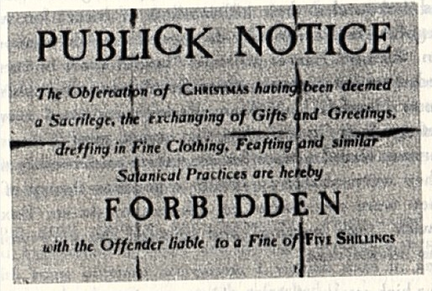
(full screen version available here - http://goo.gl/LNL1wi).

Wait patiently for the applause (which is unlikely to be forthcoming), and then storm (briefly) out of the classroom to give you the opportunity to come out of role.

Return to the classroom and ask the students if they know who the character was. Tell them it was Oliver Cromwell, “Lord Protector” of England between 1649-1660 after the execution of King Charles I.

Task 1: Individual Research
Provide students with a double-sided copy of the student worksheet (here - http://goo.gl/tNqLst). This provides them with a range of research questions based around some of the key ‘myths’ of Christmas and gives them a template in which to record their answers.

Task 2: Classroom Quiz
• Take in the quiz question templates from the students, and hand each student a scrap of paper to record their answers.
• Shuffle up the questions and then read the first question out, along with the four answers in random order as “a, b, c, d” (be sure to make a note of the correct answer/corresponding letter!). For added interest, you can name which student wrote the question before reading it out. Their challenge is to look suitably ‘poker-faced’ when the four possible answers are read out!
• Each student writes down what they think is the correct answer (a, b, c or d).
• Repeat for the other questions.
• Finally, go back thorugh each question and ask the author to tell the class the correct answer. How many people did they fool into choosing a wrong answer? (make a note and give them extra points as appropriate!)

Teacher notes for some of the key questions can be found here - http://goo.gl/KCT074.

Task 3: The Winners
• There should be two winners announced:
a) The student who was able to trick the most people into failing to choose the correct answer for the question they researched;
b) The student who answered the most questions correctly.

Variations
• For added interest, get students to divide 100 points between each of the four possible answers (a, b, c, d) to reflect their confidence in the right answer, in this sort of format:
 | a | b | c | D
Q1 | 50 | 50 | 0 | 0
Q2 | 100 | 0 | 0 | 0
Q3 | 0 | 20 | 40 | 20

• Students circle off the number for each correct answer based on the teacher feedback. They then add up their overall score and the teacher determines the winner in this way.

Comments? Suggestions?
Contact me via www.activehistory.co.uk

