A Very Victorian Christmas!

Introduction: The Decline of Christmas
• The Victorian period created our modern version of Christmas.
• In earlier times, Christmas, the Twelve Days of Christmas was an extended holiday, leisurely enjoyed during the long, cold winter when farming was quiet.
• However, the Industrial Revolution meant that there were more people, moving between more places, and working in factories that could stay open all year round.
• Robert Southey said in 1807 that "In large towns the population is continually shifting; a new settler neither continues the customs of his own province in a place where they would be strange, nor adopts those which he finds, because they are strange to him, and thus all local differences are wearing out”.
• The cholera epidemics of the 1830s, and poor harvests in the next decade (the “Hungry Forties”) took place against a background of class struggle, social fracture and violent political unrest. Britain was in desperate need of cheering up!

The reinvention of Christmas
• The 1840s saw three key traditions of our modern Christmas emerge.
• Can you identify each one from this brief description? Your teacher will provide you with the answer afterwards along with an image (available at ActiveHistory here - http://goo.gl/tA5aQm) from which you can take notes.

Answer
What am I?
In its simple form it is a small cardboard tube covered in a brightly coloured twist of paper. When it is 'pulled' by two people, each holding one end of the twisted paper, the friction creates a small explosive 'pop' produced by a narrow strip of chemically impregnated paper. The cardboard tube tumbles a bright paper hat, a small gift, a balloon and a motto or joke.
What am I?
It provides a way of remembering yourself to family and friends over the Christmas period. The first Victorian examples were by John Horsley. The featured Christmas scenes, including Father Christmas, robins, evergreens and snow scenes. The standardisation and lowering of postage rates in 1840, which made letters easier and cheaper to send, contributed to the rapid spread of this new custom.
What am I?
The custom of having this object in the house over the Christmas period first originated in Germany. According to legend, Martin Luther started the tradition. The English started placing these things in their house during the Georgian period but the practice only became widespread in the 1840s when Queen Victoria made it fashionable when she was shown alongside hers, 'hung with lights and sugar ornaments'. Charles Dickens referred to it as that 'new German toy'.

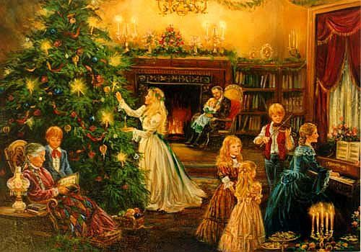

Main Task
• Circle the correct answer for each statement. If your teacher wishes to make this more interesting, you may be asked to divide 100 points between the two options to reflect how confident you are that you know the correct answer.
• Your teacher will tell you the correct answers afterwards. If you divided 100 points between the answers, award yourself the points allocated to the answers that you guessed correctly and add up your totals at the end.
• Top scorers will be awarded sweets or paired up to pull Christmas crackers!

Christmas Crackers! | A | B
The Christmas Cracker was invented by | Sam Jones | Tom Smith
It was first put on sale in the year | 1845 | 1847
By trade, he was a | Confectioner | Gunmaker
He came from | Birmingham | London
He got the idea for the ‘cracking’ noise from a | Log fire | Nutcracker
Christmas Cards!
The Christmas card was invented to replace handwritten greeting letters by | Henry Cole | George Logg
He invented it because his family, friends and colleagues numbered | 100 | 1000
It was first put on sale in | 1840 | 1843
The original design showed a family | Eating dinner | Opening presents
The custom spread rapidly due to the invention of the | Penny Post | Envelope
Christmas Trees!
The Christmas Tree was made popular in England by | Prince Albert | Isambard Brunel
He brought the custom across from his homeland of | Germany | Norway
The Royal family were shown with a Christmas tree in | 1848 | 1842
This image appeared in the | Punch Magazine | Illustrated London News
Most trees are Norwegian Spruce, but Victorians used the more expensive… | Schadenfreude | Springelbaum

Main Task
Using the correct answers to the questions, copy the completed sentences into this table:
Christmas Crackers | Christmas Cards | Christmas Trees
You will then take a vote to decide which of these three developments was the most important and which of the three men deserve to be regarded as a real-life “Father Christmas”!

