Ebeneezer Scrooge: Villain or Hero?
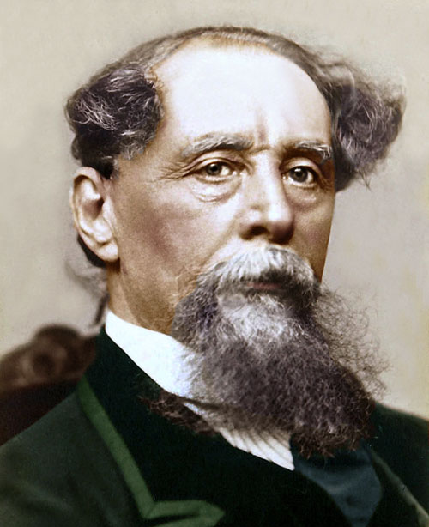
• The most important single figure in the Victorian recreation of Christmas was Charles Dickens, a Londoner who had grown up in poverty himself.
• Dickens gave his readers a clear vision of what Christmas could and should be.
▪ He did this through his short story, A Christmas Carol (1843), which tells the story of Ebeneezer Scrooge, the mean old employer of poor Bob Cratchit.
• Scrooge is persuaded by the ghosts of Christmas past, present and future to change his ways. By the end of the story, Scrooge has decided to treat his workers with more respect, to give generously to charity, and to enjoy the warmth of a family celebration by joining the Cratchit family for a Christmas feast.

Task 1: The traditional story
• Watch the video summary of the story of “A Christmas Carol”, which can be found here (alternatively, your teacher may simply talk you through the story).
• Use this to provide captions for each of the original illustrations from the story (overleaf).

Continuum Graph
Your teacher may also draw a line across the board labelled “Good guy” at one end and “Bad guy” at the other. All students should write their names along the line where they think Scrooge belongs.

Task 2: An alternative reading
• Arguably, the message of A Christmas Carol is completely twisted – Scrooge should be seen as a hero, not a villain!

Source: Is Scrooge really the hero of the story?
Scrooge gives Cratchit the day off for Christmas – he just complains about having to do so.
Scrooge allows people to not pay their debts to him at Christmas when they say they don’t have the money – but he points out that Christmas is not an emergency, and they are being dishonest by borrowing money from him knowing they can’t pay it back in time.
Scrooge represents ‘responsible lending’. Banks only function if they can loan money out and get it back with interest. If they fail to collect on their loans by lendning money to people who cannot afford to pay, the whole system collapses and everyone suffers.

For these reasons only, Scrooge is then unfairly terrorised by three ghosts and forced to change his ways. Isn’t this rather unfair on Scrooge? Is Dickens irresponsibly arguing that “Christmas is a time when you should spend what you don’t have and get into debt, and when you should expect people richer than you to give you lots of free stuff”? Why does the story make Scrooge the villain when the worst thing he does is work hard, play by the rules, and criticise people who act selfishly?

Now repeat the caption-creating exercise, but this time in a way designed to make Scrooge the hero rather than the villain!

Continuum Graph
If your teacher drew the continuum graph on the board, write your name a second time. Join the two instances of your name together to explain why (and if) your opinion has changed.
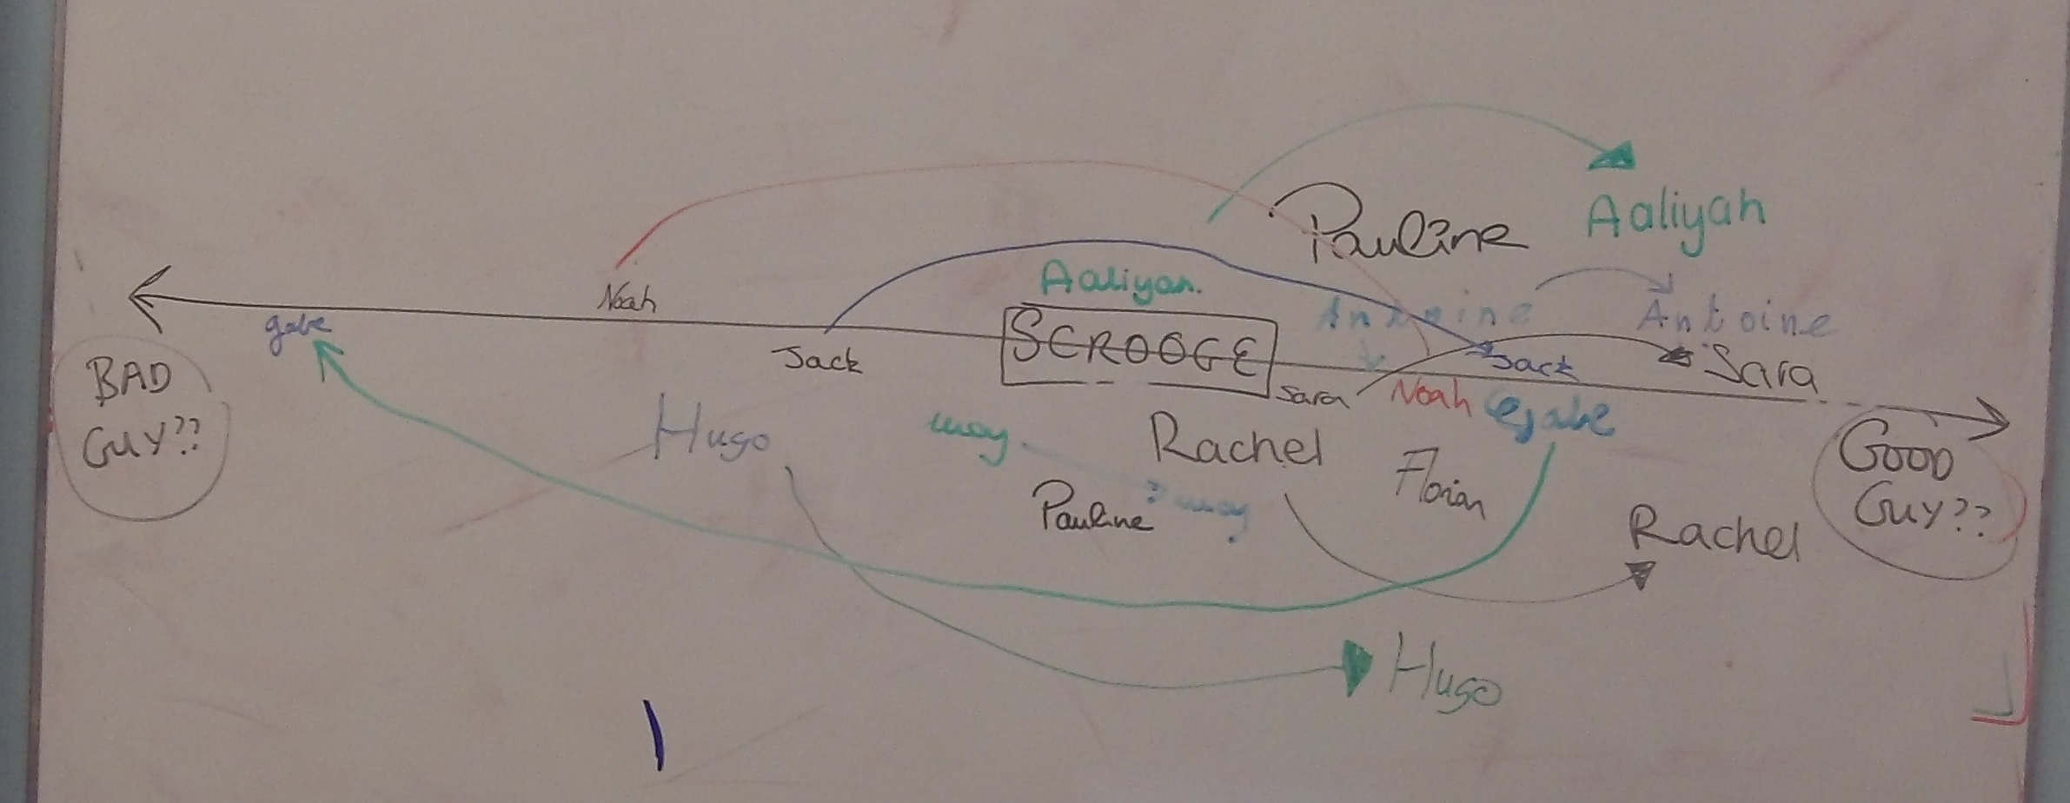

A Christmas Carol: The Original Story: Summarise what is happening in the story

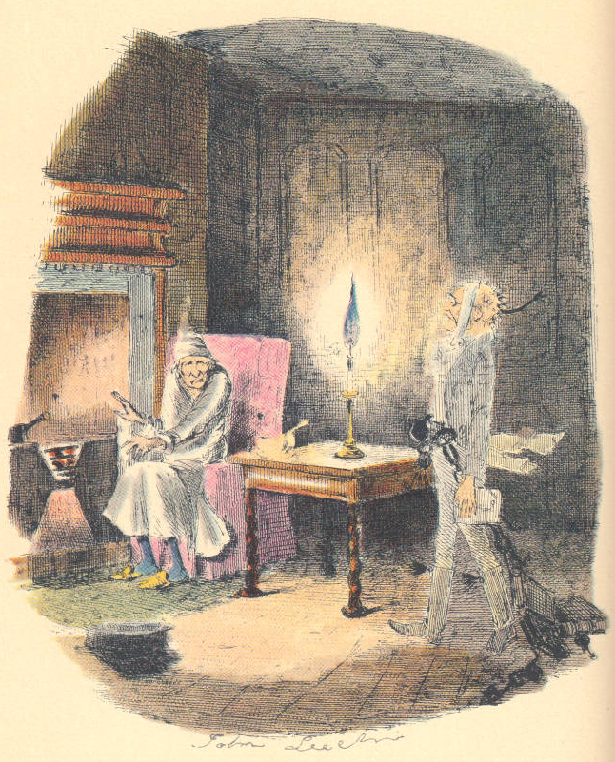 | 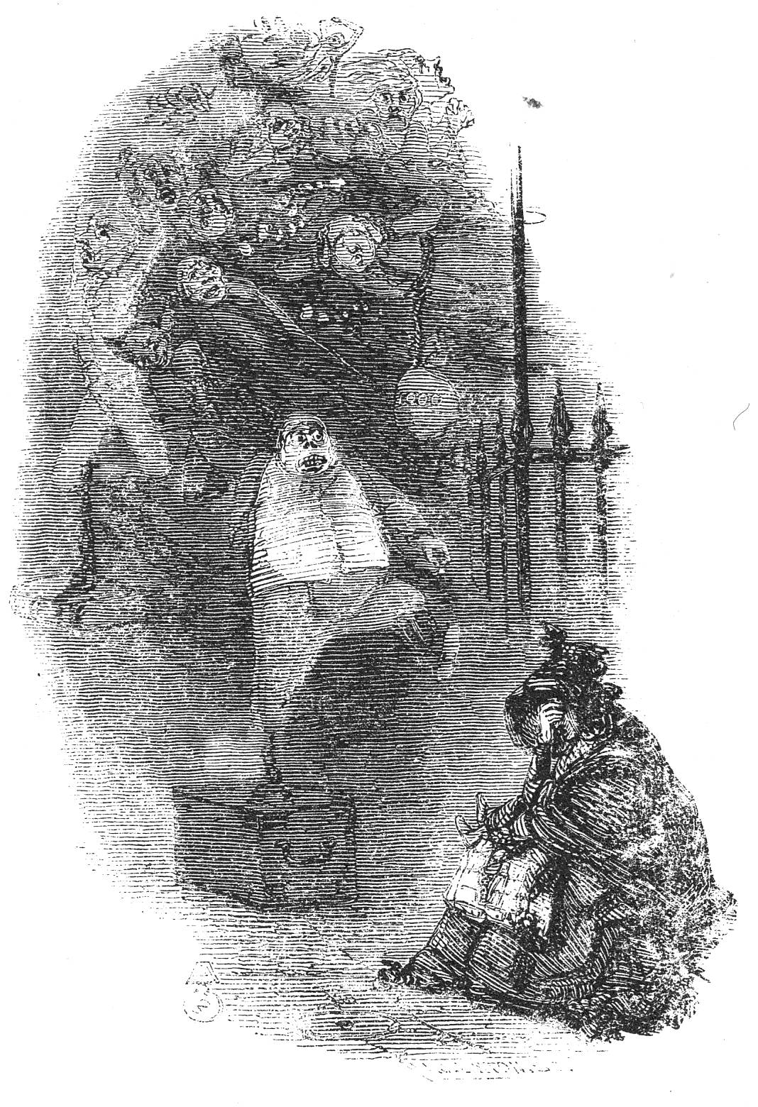
Marley's Ghost  Click here to enter text. | The Ghosts of Departed Usurers, or, The Phantoms  Click here to enter text.
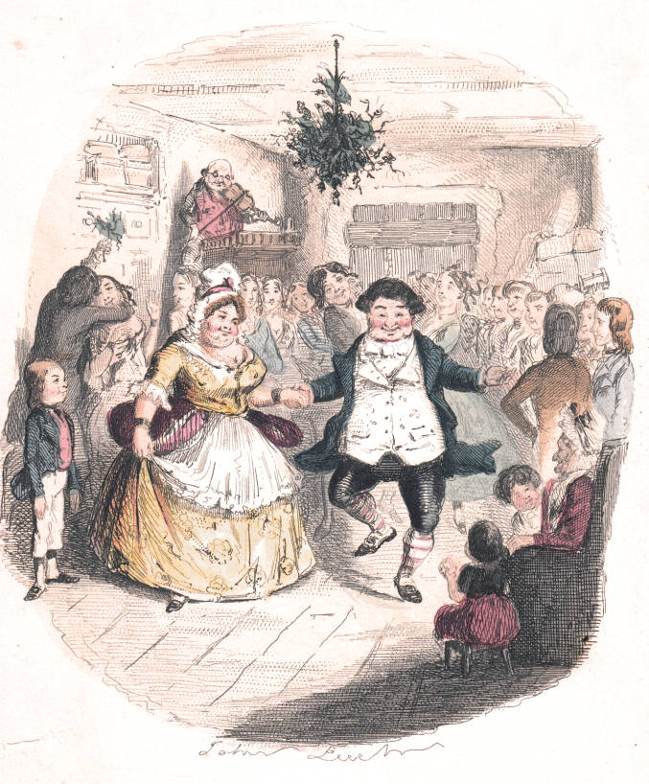 | 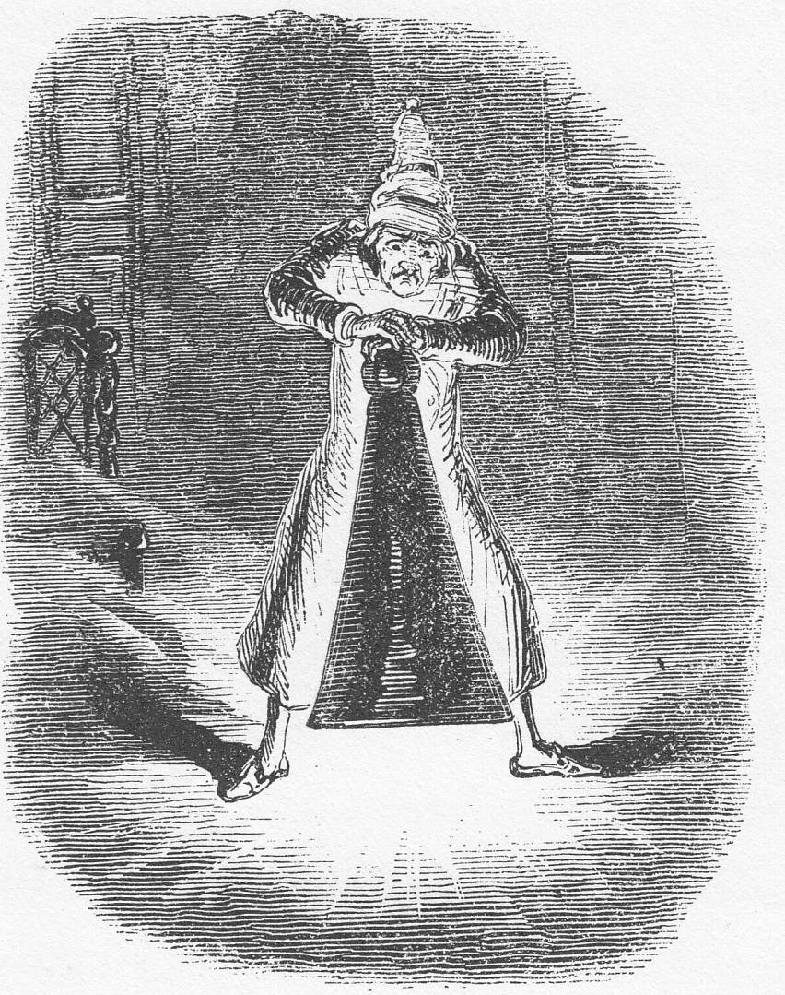
Mr. Fezziwig's Ball  Click here to enter text. | Scrooge Extinguishes the First  of the Three Spirits  Click here to enter text.
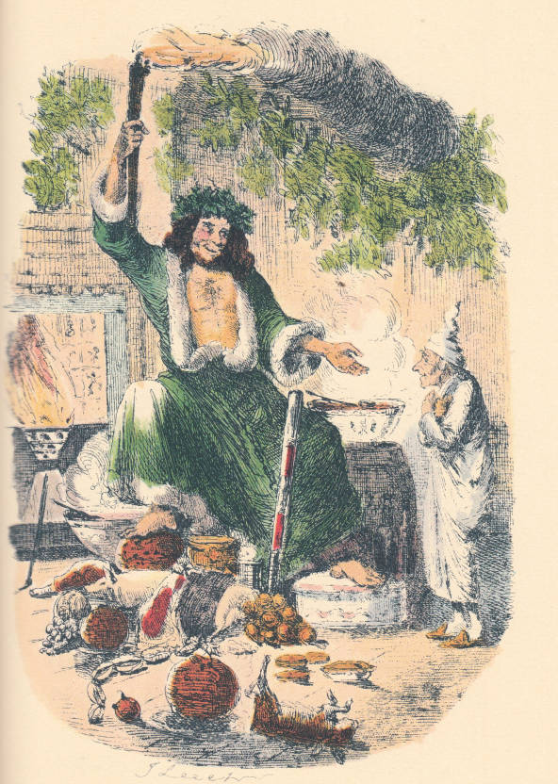 | 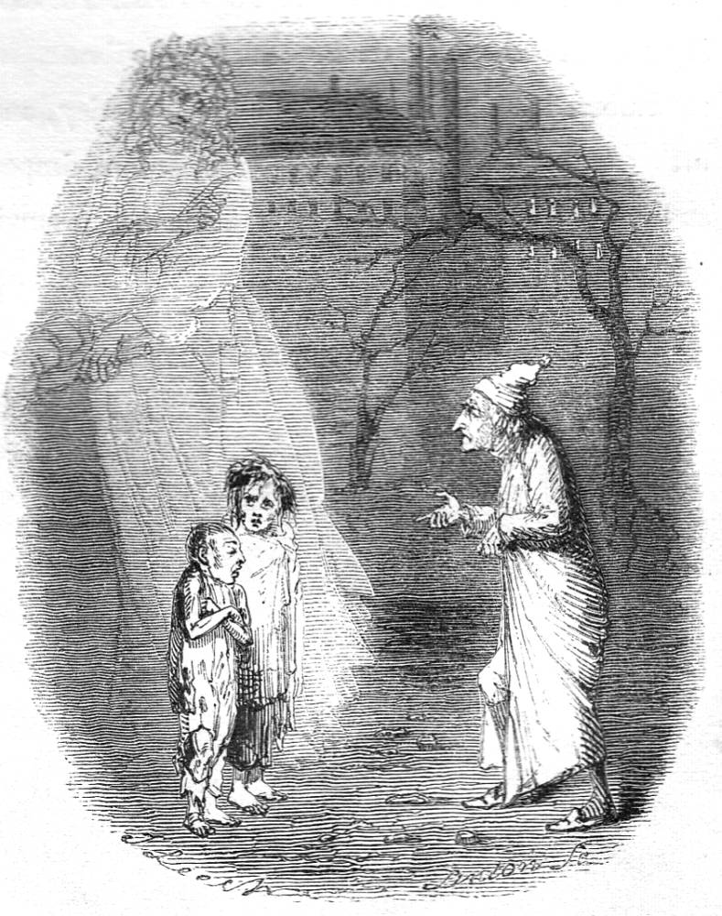
The Second of The Three Spirits  Click here to enter text. | Ignorance and Want  Click here to enter text.
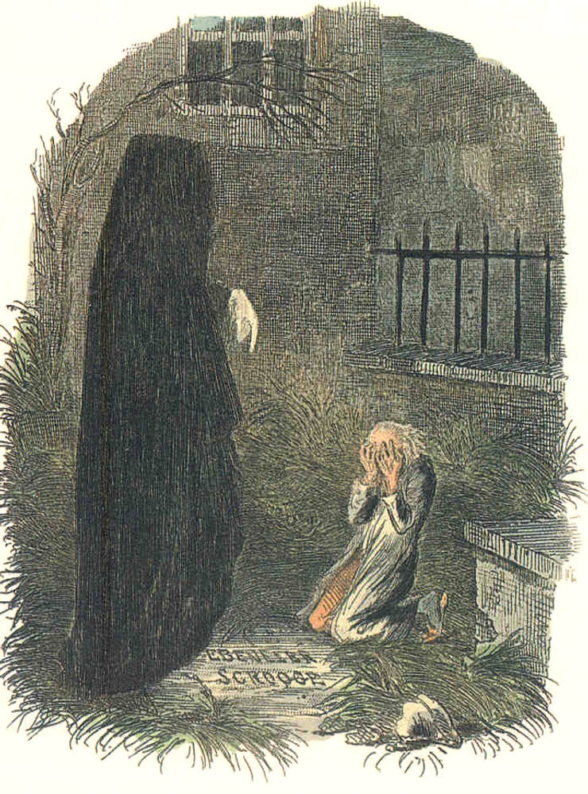 | 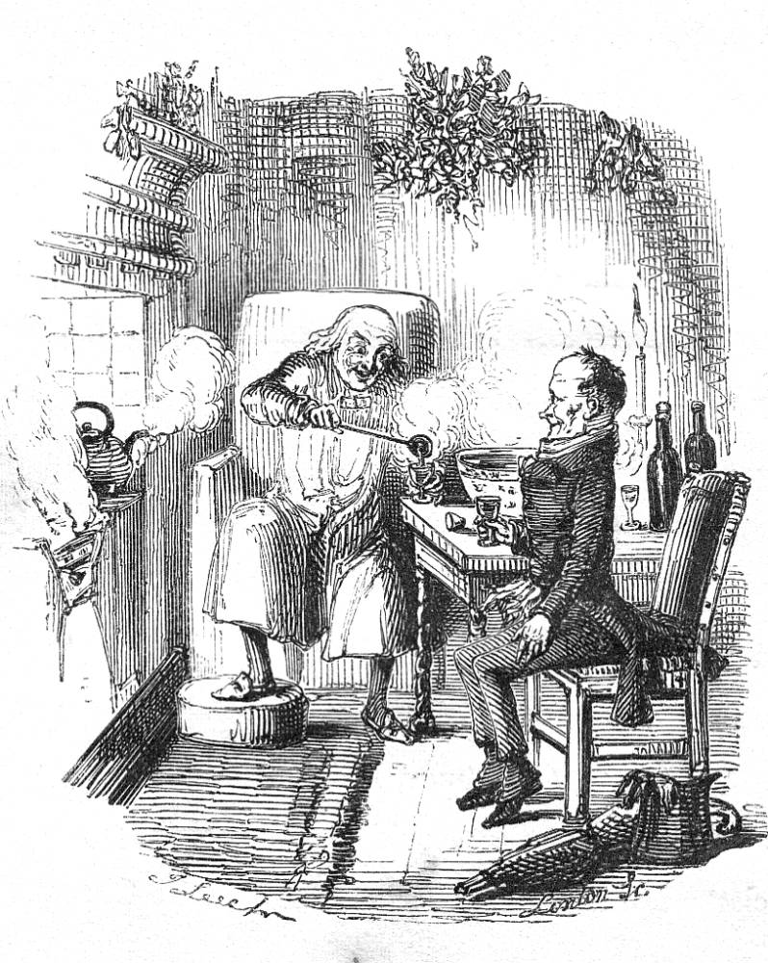
"The Last of the Spirits" — The Pointing Finger  Click here to enter text. | "Scrooge and Bob Cratchit"  Click here to enter text.

A Christmas Carol: The Original Story: Summarise what is happening in the story

Click here to enter text. | Click here to enter text.
Click here to enter text. | Click here to enter text.
Click here to enter text. | Click here to enter text.
Click here to enter text. | Click here to enter text.

