Statues and History

Key Question: Should monuments of controversial historical figures be removed, or does this make us victims of history rather than subjects who can understand and engage with it?

• In June 2020, in one of many “Black Lives Matter” (BLM) demonstrations which took place after the murder of George Floyd in the USA, a statue of the slave trader Edward Colston was torn down by an angry crowd of demonstrators in Bristol, UK. It was then vandalised, dragged to the local harbour, and then dumped into the sea as the crowd cheered:

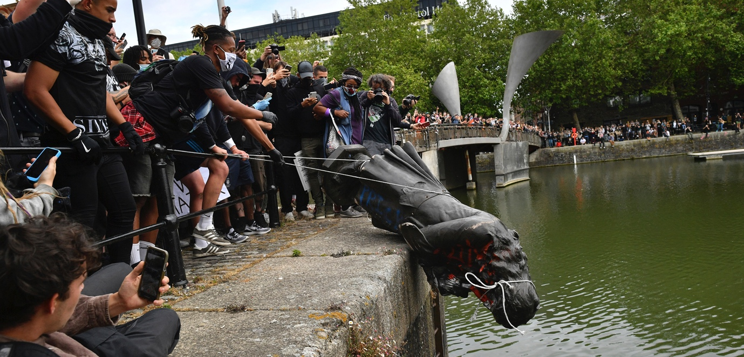

This dramatic event re-ignited a debate about the future of hundreds of statues of historical figures which fill our public spaces in the UK, the US and elsewhere.
- On one side of the argument are those who argue that tearing down statues of controversial figures demonstrates a healthy willingness to challenge outdated attitudes and to reassess our relationship with our historical past.
- On the other side of the case are people who contend the opposite: the destruction of such statues reflects a cowardly unwillingness to acknowledge and come to terms with the fact that our society is built on a racist, sexist, uncomfortable past.

Whatever the case, the argument is a heated one. So, it is important to have a rational, meaningful debate so that the future of such statues is settled maturely: not in a way which makes people feel that breaking the law is needed before their voices will be heard.

Question 1: How do we decide which individuals are so controversial that the future of their statue should be reconsidered?
• In the wake of the events in Bristol, the status of many other statues around the UK came under the spotlight. There were calls for statues of Queen Victoria, Winston Churchill and even Mahatma Gandhi to be removed on the basis of beliefs they held and things they did which today many people would regard as being deeply offensive.
• The fact that someone like Gandhi – the father of Indian independence and widely regarded as a champion of nonviolence and peaceful, positive change – was being labelled a ‘villain’ rather than a ‘hero’ helps make the point that nobody is perfect and that everyone has flaws.
• Therefore, on this basis the important question is not whether the people commemorated by statues had flaws (everyone does) but rather how serious those flaws were and the degree to which they outweighed their merits.

Task: Which is the most controversial statue?
• Here is a range of statues which have been pinpointed on an interactive map by the online campaign “Topple the Racists” (https://www.toppletheracists.org).
• Divide the following figures between the class. Research your allocated figure to identity:
(a) How they can be regarded as heroes worthy of commemoration and
(b) Why some people argue they are villains whose statues should be removed.
• Share your findings and take a vote at the end about which one of these characters most deserves to have his statue reconsidered, and which one most deserves to remain in place.

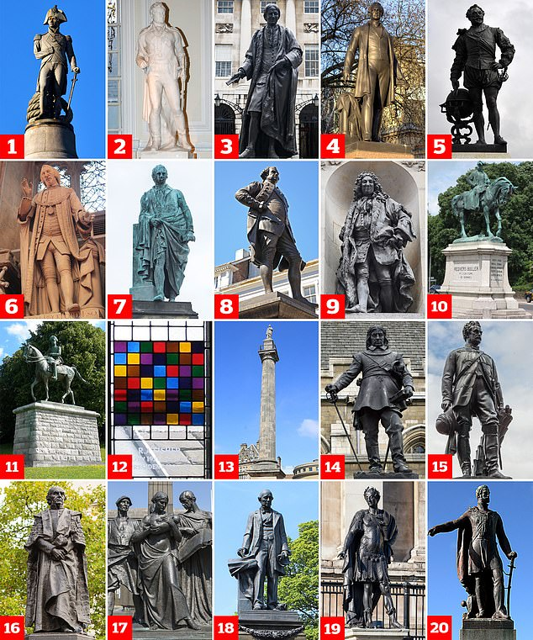

(1) Lord Nelson; (2) Sir Thomas Picton; (3) Thomas Guy; (4) Sir Robert Peel; (5) Sir Francis Drake; (6) William Beckford; (7) Henry Dundas; (8) Clive of India; (9) John Cass; (10) General Sir Redvers Buller; (11) Lord Kitchener; (12) Ronald Fisher; (13) Lord Grey; (14) Oliver Cromwell; (15) Colin Campbell, Lord Clyde; (16) William Ewart Gladstone; (17) William Leverhulme; (18) William Armstrong; (19) King James II; (20) General James George Smith Neill

Question 2: In the case of individuals that are now felt to be controversial, what should we do about their statues?
Broadly speaking, there are two main ideas about what should happen to statues of figures which are agreed to be controversial.
1. Remove them from public spaces and relocate them in a museum as part of an appropriate exhibition (about the slave trade or the British Empire, for example).
2. Leave them where they are but provide a more detailed, balanced account about the person commemorated by the statue rather than simply the positives.

Task: “Should I stay or should I go?” – source work
Use the following sources to complete this table with appropriate quotes.
Note: some sources might cover more than one of these three positions.
Compare your findings as a class and vote on your own favoured position at the end.

 | The protestors are wrong.  Controversial statues should stay in place. | The protestors have a point.  Controversial statues should be given more context. | The protestors are right.  Controversial statues should be removed.
A
B
C
D
E
F
G
H
I

Source A
Every time a statue comes down, we learn a little more. As a nation, we excuse the actions of people in the past by claiming that it was simply a different time, with different values, forgetting that many brave people at the time protested against these atrocities…As our ideas about the world change, so too does our attitude to the heroes and victories that our ancestors chose to commemorate. When those heroes were anything but heroic, leaving their statues standing is an insult to the modern values we claim to hold. This isn’t a sinister erasure of history: this is re-evaluating our history based on new evidence and ideas.
Dr. Charlotte Riley, University of Southampton

Source B
The damage done to 21st-century Britain by collective public denial about empire goes far beyond statues. We have too many statues in Britain [but] rather than purging them...it would make more sense to surround some of the more controversial ones with information that encourages people to think about why they were put there.
Martin Kettle, journalist for The Guardian

Source C
These campaigners’ worthy aim is to make modern Britain learn the lessons of its racist and colonial past, and yet they reckon that will be better achieved by removing evidence of that past. Do they really believe that they are simply correct about everything now – that, after millions of years, humanity has cracked it, that the truth about how to be has been discovered and must be propagated and enforced? History warns us that terrible things are done by people who think like that.
David Mitchell, writer and comedian

Source D
The British, every bit as much as the Germans, helped develop a system of scientific racism...Yet while the Germans have faced up to the darkest periods of their past, we have not even made a start to this process. Our vast ignorance of everything that is most uncomfortable about our imperial past is damaging, every day, our relations with the rest of the world. In particular our misplaced nostalgia for our imperial past is encouraging us to overplay our Brexit hand. Contrary to fantasies of Brexiters, our former colonies are not about to warmly embrace us...Indians, in particular, have bitter memories of British rule. In their eyes we came as looters and subjected them to centuries of humiliation...In 1947, at the end of the Raj, Indians removed all their imperial statues to suburban parks where explanatory texts gave them proper historical context. We could do the same.
William Dalrymple, historian
Source E
Campaigners are not arguing for right over wrong, neither are they contesting the past in order to change the world. Instead, they are insisting that they shouldn’t have to feel bad.
They argue that they are traumatised at the sight of a statue or a flag. These students are not fearless crusaders for justice, they are fragile victims demanding protection from words and images. They are not making history but eroding it.
In fact, trying to shield minorities from the sight of past racists or from the full story of Britain’s imperial heritage suggests that campaigners think they are not capable of coping with, let alone making, history. This in itself is a form of elitist racism. And it is not true.
Professor Cheryl Hudson, University of Liverpool

Source F
History should never be forgotten because it's only from a study of the past that one can make sense of the present and prepare for the future. Pulling down statues is nothing new, however, nor is the changing of street names and even those of cities and countries.
It has happened time and again through history. Most of us in the West cheered when the swastikas were blown up in 1945...Slave traders were most certainly tyrannical and oppressive, and the evils of slavery were appreciated long before Edward Colston's statue was raised in Bristol.
That such statues still stand is quite clearly an offence to many and especially to those whose family origins can be found in that appalling trade. Removing such edifices from public places is not airbrushing history.
James Holland, writer and historian

Source G
The attempt to airbrush historical stuff from the present is the height of authoritarianism. It's an attempt not merely to control what people can think and say today, but to project contemporary conformism back in time. Yet being surrounded by statues of flawed historical figures and dead eccentric writers is part of living in a complex, colourful society. They're reminders of history's ups and downs, and its changes.
"He who controls the past controls the future," said Orwell. Yes, that's it. The intolerant students and others seeking to smash past images and ideas really have their eye on establishing their future authority to determine what all of us may think and say.
This depiction of history as a wounding thing speaks to today’s cult of self-victimisation, the deep 21st-century urge to define oneself as a victim of circumstance rather than a shaper of destiny.
Brendan O'Neill, editor of Spiked magazine

Source H
Statues are not history; rather, its opposite. History is argument; statues brook none. The whole honour of history lies in its contrarian irrepressibility; its brief to puncture the pieties of power, should they belie the truth. It’s often only when statues are threatened that they are noticed. Let [the statues] disappear, then, but not into canals, ponds or rubbish dumps, since arbitrary acts of destruction shut down debate quite as much as uncritical reverence. Better, surely, to relocate them to museums where, properly curated, they can trigger genuine debate and historical education. One thing that the pandemic has wrought is a confrontation with big historical matters: who are we as a nation, what we have been, and where we are going? If the Men in Stone (and they are overwhelmingly men) can deepen that understanding they will have served their purpose better than ever they did up on their pigeon-stained plinths.
Sir Simon Schama, Historian

Source I
Allowing the statues issue to get in the way of the anti-racism debate would be a mistake, and would empower objects that we mostly ignore. At the heart of London is the perfect arena that shows how inert and invisible statues are most of the time. There are seven statues within Trafalgar Square. One of them – obviously – is Lord Nelson, 170 feet up on his column. But who else is standing there? How many of the people who argue that the removal of any statue, anywhere, at any time represents an “erasure of history” have used the statues at the very centre of our capital city to learn some of that history?
We do need to rethink who is memorialised in our public spaces. Bristol is a better city without Edward Colston. But statues are a symptom of the problem, not the problem itself. The real conversation has to be about racism and how we confront it.
David Olusoga, historian and broadcaster

