Afghanistan
The 20-Year War

• Afghanistan, and its capital city Kabul, have been strategically important throughout history. Lying midway along the famous "Silk Road", Afghanistan also serves as a gateway to India. Sitting on trade and migration routes including the oil-rich Persian Gulf, Afghanistan has been called the "Central Asian roundabout":

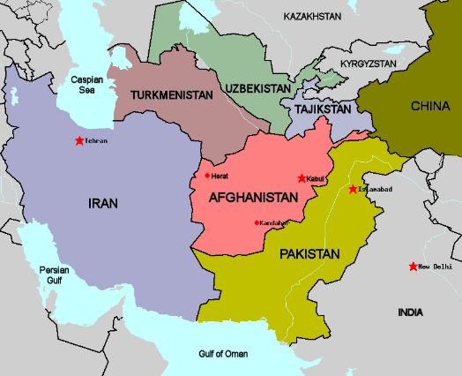

• The decision of the USA to withdraw from Afghanistan this year has been every bit as controversial as its decision to invade in the first place more than 20 years ago.
• In this unit of study we will learn about the background to this 20-year war, and use our knowledge to debate such issues as:
• Was the US right to invade Afghanistan in 2001?
• Was the US right to withdraw from Afghanistan in 2021?

Task 1: Essential overview
• Read carefully through the following timeline as a class, making sure you are clear on all the key terms.
• Working individually, add an appropriate image in the right-hand column of each row using a Google search.
• Extension Task: reduce the text in this timeline down to a maximum of 500 words by removing the parts of the story which you think are least important.

 |  | Relevant Image
c. 1870-1970 | • In the 19th Century, Britain and the USSR struggled (and ultimately failed) to establish control of Afghanistan. The country declared its independence in 1919, and ten years later, in 1929, Afghanistan's became a monarchy. | ???
1945 | • At the end of World War Two, two rival superpowers emerged: the capitalist USA in the West, and the communist USSR in the East. The frosty relations between these superpowers, both of whom were soon armed with a battery of nuclear weapons, became known as the Cold War. | ???
1978 | • To the alarm of the USA, the Afghan communist party (PDPA) launched a revolution in 1978.  • The PDPA replaced religious laws with communist ones. Men had to cut their beards, mosques were closed, women were given the right to vote and forced marriages were banned.  • The USSR provided economic and military support to the new communist government, return for the right to mine minerals and natural gas. | ???
1979 | • Communism was not popular with the Afghan people, and the government became unstable: the President was overthrown and executed by his own Prime Minister, who in turn was assassinated within months.  • Against this background of growing chaos, the USSR invaded Afghanistan in December 1979 with over 100,000 troops. | ???
1980s | • The USA channelled $40 million of military aid to the Afghan “Mujahideen” rebels (watch the film "Charlie Wilson's War"). As part of the Mujahideen  effort, Osama bin Laden created Al Qaeda in Afghanistan in 1988.  • Using the Islamic faith as their unifying force, the rebels wore down the USSR, who withdrew in 1989. | ???
1990s | • With the USSR defeated, the Afghan rebel factions started fighting each other for power, and Afghanistan descended into civil war.  • The two most extreme Islamic groups which emerged in Afghanistan were Al Qaeda and the Taliban.  • In 1996 the Taliban seized control of Kabul. They imposed edicts forbidding women from attending school or leaving their face uncovered. If women broke certain rules, they were publicly whipped or executed. | ???
2001 | • The USA, alarmed at these developments, channelled aid to Ahmad Shah Massoud, who led the Afghan faction opposed to the Taliban and Al Qaeda.  • He was assassinated by the Taliban on September 9th 2001. Two days later, on September 11th, Al Qaeda orchestrated the suicide-bomber attacks on the World Trade Centre in New York.  • When the Taliban refused to hand over Osama bin Laden, US-led forces bombed Taliban and al-Qaeda targets everywhere inside Afghanistan.  • In December 2001, the Taliban was toppled and a new Afghan government was formed with US support. | ???
2000s-2010s | • Over the next 20 years, the US and its allies invested in Afghanistan to help establish democracy.  • The Taliban, which relocated to hideouts in Pakistan, refused to compromise enter meaningful negotiations.  • As the US got bogged down in another war in Iraq, the Taliban were able to start creeping back into Afghanistan. | ???
2020 | • In February 2020, with no end in sight to the US military occupation, President Donald Trump agreed to withdraw all troops by May 1, 2021, in return for a Taliban promise not to attack them on the way out.  • From that point US troops began to return home in large numbers and Afghan resistance to the Taliban began to crumble. | ???
2021 | • When President Biden took office in January 2021, he took the decision to continue the withdrawal, although he extended the deadline to August 31st.  • On 15 August 2021, the Taliban entered Kabul. The 20-year war cost $2 trillion and claimed the lives of more than 3,500 US coalition troops and more than 100,000 Afghans.  • Although the Taliban claim they will respect basic human rights, there are genuine fears that they will massacre political and religious opponents and trample of human rights, especially those relating to women. | ???

Task: Factual Understanding
1. Why did the 1978 communist revolution in Afghanistan prove to be unpopular?
???

2. When and why did the US first get involved in Afghanistan?
???

3. Why did the Taliban and Al Qaeda decide to attack the USA on September 11th 2001?
???

4. How did the US respond in the years that followed?
???

5. What were the overall results of the US decision to withdraw from Afghanistan?
???

