What do protest songs tell us about the nature of opposition to the Vietnam War?

Role of Musicians
▪ The Vietnam War was the first major war in which popular musicians used their lyrics to protest against the war. Listen to at least several of the following songs to help you develop this table with some detail (TIP: work down the list). All of them are easily available on YouTube, and you can also access them through the ActiveHistory Spotify Jukebox: (http://www.activehistory.co.uk/spotify.htm).

 | Central criticism | Key lyric to illustrate point
Barry McGuire, “Eve of Destruction”
Country Joe & the Fish, “Feel Like I’m Fixin’ to Die Rag”
Neil Young, “Ohio”
John Fogerty (CCR), “Fortunate Son”
Buffy St. Marie, “Universal Soldier”
John Lennon, “Gimme Some Truth”
Tom Paxton, “Lyndon Johnson told the Nation”
Phil Ochs, “Draft Dodger Rag”
Jacqueline Sharp, “Honor our Commitment”
Jimmy Cliff, “Vietnam”
Joan Baez, “Siagon Bride”
Paul Simon, “7 O’Clock News”

Suggested approach – Silent Discussion
▪ Your teacher may wish to start this exercise by getting you to engage in a ‘silent discussion’ looking at the lyrics of a range of different songs, then asking you to choose three each that you wish to listen to.
▪ Discuss your choices: why did you pick them? What style of music do you anticipate will accompany the lyrics of each song?
▪ Proceed to find a recording of the songs using Spotify, YouTube or similar. Select your favourite to share with the class. The teacher will add up the votes and play the top five to the class.
▪ Finally, use your findings to complete the table above.

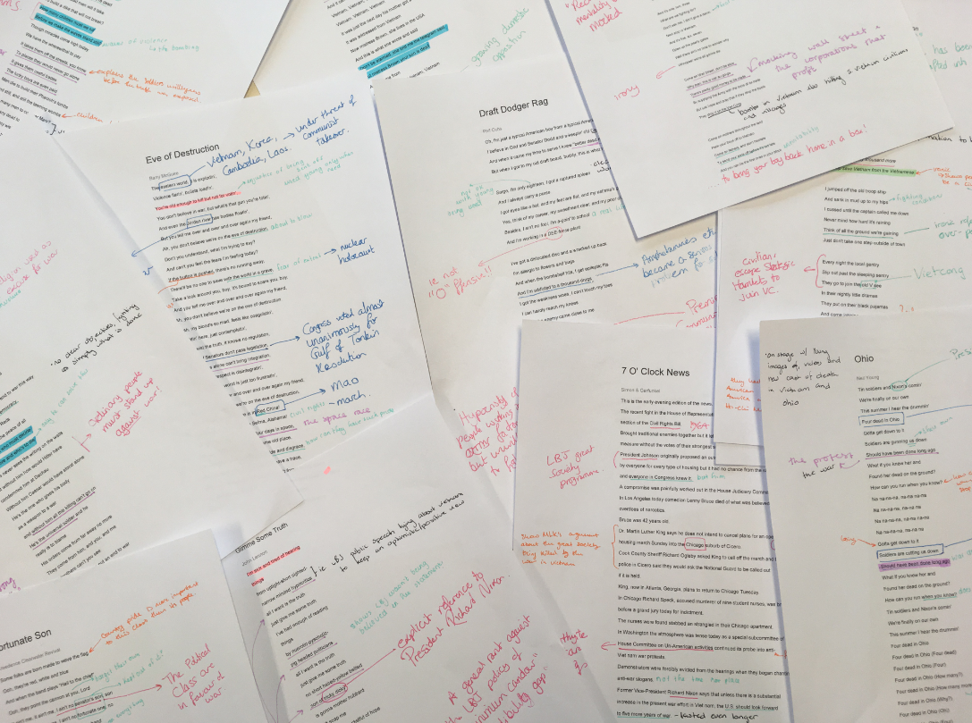

Eve of Destruction
Barry McGuire
The eastern world, it is explodin',
Violence flarin', bullets loadin',
You're old enough to kill but not for votin',
You don't believe in war, but what's that gun you're totin',
And even the Jordan river has bodies floatin',
But you tell me over and over and over again my friend,
Ah, you don't believe we're on the eve of destruction.
Don't you understand, what I’m trying to say?
And can't you feel the fears I’m feeling today?
If the button is pushed, there's no running away,
There'll be no one to save with the world in a grave,
Take a look around you, boy, it's bound to scare you, boy,
And you tell me over and over and over again my friend,
Ah, you don't believe we're on the eve of destruction.
Yeah, my blood's so mad, feels like coagulatin',
I’m sittin' here, just contemplatin',
I can't twist the truth, it knows no regulation,
Handful of Senators don't pass legislation,
And marches alone can't bring integration,
When human respect is disintegratin',
This whole crazy world is just too frustratin',
And you tell me over and over and over again my friend,
Ah, you don't believe we're on the eve of destruction.
Think of all the hate there is in Red China!
Then take a look around to Selma, Alabama!
Ah, you may leave here, for four days in space,
But when your return, it's the same old place,
The poundin' of the drums, the pride and disgrace,
You can bury your dead, but don't leave a trace,
Hate your next door neighbor, but don't forget to say grace,
And you tell me over and over and over and over again my friend,
You don't believe we're on the eve of destruction.
No, no, you don't believe we're on the eve of destruction.

Fixin’ to die rag
Country Joe McDonald
Well, come on all of you, big strong men
Uncle Sam needs your help again
He's got himself in a terrible jam
Way down yonder in Vietnam
So put down your books and pick up a gun
We're gonna have a whole lotta fun

And it's one, two, three
What are we fighting for?
Don't ask me, I don't give a damn
Next stop is Vietnam;
And it's five, six, seven
Open up the pearly gates
Well there ain't no time to wonder why
Whoopee! we're all gonna die

Well, come on generals, let's move fast;
Your big chance has come at last
Now you can go out and get those reds
'Cause the only good commie is the one that's dead
And you know that peace can only be won
When we've blown 'em all to kingdom come

And it's one, two, three
What are we fighting for?
Don't ask me, I don't give a damn
Next stop is Vietnam;
And it's five, six, seven
Open up the pearly gates
Well there ain't no time to wonder why
Whoopee! we're all gonna die

Come on Wall Street, don't be slow
Why man, this is war au-go-go
There's plenty good money to be made
By supplying the Army with the tools of its trade
But just hope and pray that if they drop the bomb
They drop it on the Viet Cong

Come on mothers throughout the land
Pack your boys off to Vietnam
Come on fathers, and don't hesitate
To send your sons off before it's too late
And you can be the first ones in your block
To have your boy come home in a box!

Ohio
Neil Young
Tin soldiers and Nixon's comin'
We're finally on our own
This summer I hear the drummin'
Four dead in Ohio
Gotta get down to it
Soldiers are gunning us down
Should have been done long ago
What if you knew her and
Found her dead on the ground?
How can you run when you know?
Na na-na-na, na-na na-na
Na na-na-na, na-na na
Na na-na-na, na-na na-na
Na na-na-na, na-na na
Gotta get down to it
Soldiers are cutting us down
Should have been done long ago
What if you knew her and
Found her dead on the ground?
How can you run when you know?
Tin soldiers and Nixon's comin'
We're finally on our own
This summer I hear the drummin'
Four dead in Ohio
Four dead in Ohio (Four dead)
Four dead in Ohio (Four)
Four dead in Ohio (How many?)
Four dead in Ohio (How many more?)
Four dead in Ohio (Why?)
Four dead in Ohio (Oh!)
Four dead in Ohio (Four)
Four dead in Ohio (Why?)
Four dead in Ohio (Why?)

Fortunate Son
Creedence Clearwater Revival
Some folks are born made to wave the flag
Ooh, they're red, white and blue
And when the band plays "Hail to the chief"
Ooh, they point the cannon at you, Lord
It ain't me, it ain't me, I ain't no senator's son, son
It ain't me, it ain't me, I ain't no fortunate one, no
Some folks are born silver spoon in hand
Lord, don't they help themselves, oh
But when the taxman comes to the door
Lord, the house looks like a rummage sale, yes
It ain't me, it ain't me, I ain't no millionaire's son, no
It ain't me, it ain't me, I ain't no fortunate one, no
Some folks inherit star spangled eyes
Ooh, they send you down to war, Lord
And when you ask them, "How much should we give?"
Ooh, they only answer "More! More! More!" yoh
It ain't me, it ain't me, I ain't no military son, son
It ain't me, it ain't me, I ain't no fortunate one, one
It ain't me, it ain't me, I ain't no fortunate one, no no no
It ain't me, it ain't me, I ain't no fortunate son, no no no

The Universal Soldier
Buffy Sainte-Marie
He's five feet two and he's six feet four
He fights with missiles and with spears
He's all of 31 and he's only 17
He's been a soldier for a thousand years
He's a Catholic, a Hindu, an athiest, a Jain,
a Buddhist and a Baptist and a Jew
and he knows he shouldn't kill
and he knows he always will
kill you for me my friend and me for you
And he's fighting for Canada,
he's fighting for France,
he's fighting for the USA,
and he's fighting for the Russians
and he's fighting for Japan,
and he thinks we'll put an end to war this way
And he's fighting for Democracy
and fighting for the Reds
He says it's for the peace of all
He's the one who must decide
who's to live and who's to die
and he never sees the writing on the walls
But without him how would Hitler have
condemned him at Dachau
Without him Caesar would have stood alone
He's the one who gives his body
as a weapon to a war
and without him all this killing can't go on
He's the universal soldier and he
really is to blame
His orders come from far away no more
They come from him, and you, and me
and brothers can't you see
this is not the way we put an end to war

Gimme Some Truth
John Lennon
I’m sick and tired of hearing
things
from uptight-short sighted-
narrow minded hypocritics
all I want is the truth
just give me some truth
I’ve had enough of reading
things
by nuerotic-pyschotic-
pig headed politicians
all I want is the truth
just give me some truth
no short haired-yellow bellied
son of tricky dicky
is gonna mother hubbard
soft soap me
with just a pocketful of hope
money for dope
money for rope
I’m sick to death of seeing
things
from tight lipped-
condescending -mommies little
chauvinists
all I want is the truth
just give me some truth
I’ve had enough of watching
scenes
of schizophrenic - ego - centric
- paranoic - prima - donnas
all I want is the truth
just give me some truth

Lyndon Johnson Told the Nation
Tom Paxton
I got a letter from L.B.J
It said, "This is your lucky day"
It's time to put your khaki trousers on
Though it may seem very queer
We've got no jobs to give you here
So we are sending you to Vietnam

Lyndon Johnson told the nation
Have no fear of escalation
I am trying everyone to please
Though it isn't really war
We're sending fifty thousand more
To help save Vietnam from the Vietnamese

I jumped off the old troop ship
And sank in mud up to my hips
I cussed until the captain called me down
Never mind how hard it's raining
Think of all the ground we're gaining
Just don't take one step outside of town

Every night the local gentry
Slip out past the sleeping sentry
They go to join the old V see
In their nightly little dramas
They put on their black pajamas
And come lobbing mortar shells at me

We go round in helicopters
Like a bunch of big grasshoppers
Searching for the Viet Cong in vain
They left a note that they had gone
They had to get down to Saigon
Their government positions to maintain

Draft Dodger Rag
Phil Ochs
Oh, I'm just a typical American boy from a typical American town
I believe in God and Senator Dodd and a-keepin' old Castro down
And when it came my time to serve I knew "better dead than red"
But when I got to my old draft board, buddy, this is what I said:

Sarge, I'm only eighteen, I got a ruptured spleen
And I always carry a purse
I got eyes like a bat, and my feet are flat, and my asthma's getting worse
Yes, think of my career, my sweetheart dear, and my poor old invalid aunt
Besides, I ain't no fool, I'm a-goin' to school
And I'm working in a DEE-fense plant

I've got a dislocated disc and a wracked up back
I'm allergic to flowers and bugs
And when the bombshell hits, I get epileptic fits
And I'm addicted to a thousand drugs
I got the weakness woes, I can't touch my toes
I can hardly reach my knees
And if the enemy came close to me
I'd probably start to sneeze

Ooh, I hate Zhou Enlai, and I hope he dies,
Onething you gotta see
That someone's gotta go over there
And that someone isn't me
So I wish you well, Sarge, give 'em Hell!
Kill me a thousand or so
And if you ever get a war without blood and gore
I'll be the first to go

Honor Our Commitment
By Jacqueline Sharpe (1966, folk)
O, gather round you bully boys and hear just what I say.
We’ve got a Great Society in the good old U. S. A.
So listen, nations of the earth, we give our promise true:
If you don’t obey your Uncle Sam, his troops will visit you.

And we’ll honor our commitment, honor our commitment,
Even if the world goes up in the smoke of a mushroom cloud.
Honor our commitment, honor our commitment.
Get buried with our brothers in one great communal shroud.

Now, widows all like candy canes, and orphans all like jam,
And Band-aids come in handy for the wounded in Vietnam.
So send your package out today to the homeless kids and wives,
We’re sure the ones we haven’t killed will love us all their lives.
We dream of peace ‘most every night, we talk of peace each day,
And we have learned a little game we’ll teach you how to play.

Now, which hand holds the olive branch and which hand holds the bomb?
You guessed it—this one offers peace, and that one drops napalm.
You marching intellectuals, you poets and you priests,
You mothers with your babes in arms, you longhaired, bearded beasts.
It’s all right when you talk of beauty, love and all that pap,
But when it comes to life and death, you’d better shut your trap.

Vietnam
Jimmy Cliff
Hey, Vietnam, Vietnam, Vietnam, Vietnam
Vietnam, Vietnam, Vietnam
Yesterday I got a letter from my friend
Fighting in Vietnam
And this is what he had to say
'Tell all my friends that I'll be coming home soon
My time it'll be up some time in June
Don't forget, he said to tell my sweet Mary
Her golden lips as sweet as cherries
And it came from
Vietnam, Vietnam, Vietnam, Vietnam
Vietnam, Vietnam, Vietnam
It was just the next day his mother got a telegram
It was addressed from Vietnam
Now mistress Brown, she lives in the USA
And this is what she wrote and said
Don't be alarmed, she told me the telegram said
But mistress Brown your son is dead
And it came from
Vietnam, Vietnam, Vietnam, Vietnam
Vietnam, Vietnam, Vietnam
Somebody please stop that war now
It was just the next day his mother got a telegram
It was addressed from Vietnam
Now mistress Brown, she lives in the USA
And this is what she wrote and said
Don't be alarmed, she told me the telegram said
Oh, but mistress Brown your son is dead
And it came from
Vietnam, Vietnam, Vietnam, Vietnam
Vietnam, Vietnam, Vietnam
Somebody please stop it
Vietnam, Vietnam, Vietnam, Vietnam
Vietnam, Vietnam, Vietnam
What I'm saying now somebody stop that war

Saigon Bride
Joan Baez
Farewell, my wistful Saigon bride
I'm going out to stem the tide
A tide that never saw the seas
It flows through jungles, 'round the trees
Some say it's yellow, some say red
It will not matter when we're dead
How many dead men will it take
To build a dike that will not break?
How many children must we kill
Before we make the waves stand still?
Though miracles come high today
We have the wherewithal to pay
It takes them off the streets, you know
To places they would never go alone
It gives them useful trades
The lucky boys are even paid
Men die to build their Pharaoh's tombs
And still, and still the teeming wombs
How many men to conquer Mars?
How many dead to reach the stars?
Farewell, my wistful Saigon bride
I'm going out to stem the tide
A tide that never saw the seas
It flows through jungles, 'round the trees
Some say it's yellow, some say red
It will not matter when we're dead

7 O' Clock News
Simon & Garfunkel
This is the early evening edition of the news.
The recent fight in the House of Representatives was over the open housing
section of the Civil Rights Bill.
Brought traditional enemies together but it left the defenders of the
measure without the votes of their strongest supporters.
President Johnson originally proposed an outright ban covering discrimination
by everyone for every type of housing but it had no chance from the start
and everyone in Congress knew it.
A compromise was painfully worked out in the House Judiciary Committee.
In Los Angeles today comedian Lenny Bruce died of what was believed to be an
overdoes of narcotics.
Bruce was 42 years old.
Dr. Martin Luther King says he does not intend to cancel plans for an open
housing march Sunday into the Chicago suburb of Cicero.
Cook County Sheriff Richard Ogleby asked King to call off the march and the
police in Cicero said they would ask the National Guard to be called out
if it is held.
King, now in Atlanta, Georgia, plans to return to Chicago Tuesday.
In Chicago Richard Speck, accused murderer of nine student nurses, was brought
before a grand jury today for indictment.
The nurses were found stabbed an strangled in their Chicago apartment.
In Washington the atmosphere was tense today as a special subcommittee of the
House Committee on Un-American activities continued its probe into anti-
Viet nam war protests.
Demonstrators were forcibly evicted from the hearings when they began chanting anti-war slogans.
Former Vice-President Richard Nixon says that unless there is a substantial
increase in the present war effort in Viet nam, the U.S. should look forward to five more years of war.
In a speech before the Convention of the Veterans of Foreign Wars in New York,
Nixon also said opposition to the war in this country is the greatest single
weapon working against the U.S.
That's the 7 o'clock edition of the news, Goodnight.
Silent night Holy night
All is calm All is bright
Round yon virgin mother and child
Holy infant so tender and mild

