Has the Poppy Appeal got out of Control?

• In November each year, the British Legion conducts a charity fundraising campaign, the icon of which is the Red Poppy.

• In the media, at work and on the streets you will find millions of people wearing the poppy as a visible symbol of their support for the cause.

Task 1: Whole-class discussion

a. What does the British Legion actually stand for?

b. What does it do with the money it raises?

c. Why do you think some people might object to the “Poppy Appeal”?

Task 2: Individual research

Spend some time researching the answers to the same three questions using the internet. At the end of this phase, the teacher will go back through each of the three questions and discuss them again to see what fresh information has been found.

Task 3

• Read the article “Standing up against the poppy and the perversion of sport”. Underline any parts of the article that help to explain why this particular footballer is refusing to wear a poppy.

• List the ideas on the board. Which do you find the most / least persuasive reasons?

Task 4

• Your teacher will provide you with a cartoon produced directly after the article was published. Read through it together.

Next, your teacher will provide you with a blanked out version of the same cartoon.

• Your task is to re-write your own version of the cartoon but from the perspective of somebody who SUPPORTS the poppy appeal and DISAGREES with the arguments put forward in the original cartoon. Compare your stories as a class and place on display some of the very best ones.

Extension Task

Search YouTube for the “Sainsbury’s World War One advert” and watch it. What are the arguments for and against big businesses like this producing adverts which support the poppy appeal?

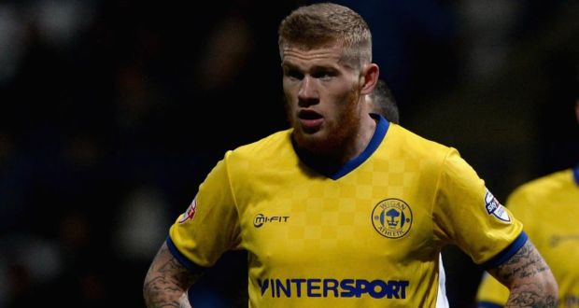
Standing up against the poppy and the perversion of sport

Opinion: ‘The underlying purpose of Remembrance is to soften the memory of futile slaughter the better to make the next generation ready to do its share of dying in wars caused by greed and imperial rivalries’

‘There are scores of other players who might resent their jerseys being used to promote British patriotism and sentimentalise war. But only James McClean (above) from Creggan Heights stood up and said so, explaining his refusal to wear a poppy playing for Wigan against Bolton on Friday night.

First published:Thu, Nov 13, 2014, 12:01
It’s possible Mesut Özil was not devastated at having to miss last Sunday’s Premier League match at Swansea. Out injured, the Arsenal midfielder didn’t have to decide whether to wear a poppy. Maybe he wouldn’t have minded. He is Turkish by background and German by birth, and might have felt awkward with an emblem on his chest commemorating the defeat of Germany and destruction of the Ottoman empire.
Sergio Agüero seemed unconcerned about wearing a British Legion badge as he put in a two-goal shift for Manchester City on Saturday. But it must have occurred to him to wonder about reaction back home in Argentina. There are scores of other players who might resent their jerseys being used to promote British patriotism and sentimentalise war. But only James McClean from Creggan Heights in Derry stood up and said so, explaining his refusal to wear a poppy playing for Wigan against Bolton on Friday night.
“For me to wear a poppy would be as much a gesture of disrespect for the innocent people who lost their lives in the Troubles – and Bloody Sunday especially. . . It would be seen as an act of disrespect to my people.”
The fashion for poppies on football shirts is new. The idea appears first to have been mooted about five years ago. Why? What new factor had come into play? What debate was there among fans, players, the Football Association?
Why is it that the real and relevant connection between football and the first World War goes entirely unmentioned even as the game is systematically misused in an effort to make war seem as natural an expression of identity as shouting for your team on Saturday afternoon?

Britain’s wars
Salespeople for the poppy suggest that support for Britain’s wars has nothing to do with it, that the red splodge they want to see on every lapel signifies only dignified remembrance of the war dead. Were there a syllable of truth in this we would hear a range of emotions and thoughts on the meaning of the war expressed at every poppy-strewn remembrance. But we do not.
Raise a shout of anger at so many lives lost or hoist a banner declaring “Never Again!” and you are liable to be arrested for – this has happened – breach of the peace.
The Royal British Legion puts it plainly that poppies are “worn to commemorate the sacrifices of our armed forces and to show support to those still serving today”.
Wearing the poppy is clearly not incompatible with organising a rerun of the slaughter.
Among the sights to be seen last weekend was Tony Blair – the man who told the lies that lured the British people into backing a war that left more dead than had fallen at the Battle of Mons – wearing a poppy of such size that, laid flat, would have provided landing space for a helicopter.

Endured horrors
If the first World War is to be remembered at football matches in November, why not actor Maxine Peake in the centre circle reading the words of a man who had endured the horrors before falling himself in the last days of the conflict.
“If you could hear, at every jolt, the blood/Come gargling from the froth-corrupted lungs/Obscene as cancer, bitter as the cud/Of vile, incurable sores on innocent tongues/My friend, you would not tell with such high zest/To children ardent for some desperate glory/The old Lie: Dulce et decorum est/Pro partia mori.”
You wouldn’t have to call for a minute’s silence. A hush would descend naturally.
Or mark the moment at Christmas 1914 when thousands of German and British-and-Irish soldiers on the western front stepped, timidly, tentatively at first, then teeming with joy, out from their trenches into no-man’s land to laugh, hug, clap one another on the back, share cigarettes. Of course, one side couldn’t speak the other’s language. But they found a common language in which they could celebrate their common humanity and played a game of football.
Was this not football’s finest hour? Was it not the moment in football’s history most relevant to remembrance of war, and specifically of the first World War?
Would a parade in the English and German football strips of the period not touch more hearts and make more moral sense than detachments of soldiers in full military dress leading poppy-festooned players onto the pitch?
Nothing of the sort will happen, of course. The underlying purpose of Remembrance is to soften the memory of futile slaughter the better to make the next generation ready to do its share of dying in wars caused by greed and imperial rivalries.
McClean was speaking up not just for himself and the right to choose whether to wear a poppy, but against the perversion of sport and for the integrity of football.

