Remembrance Day

• 11th November is Remembrance Day. At the Cenotaph memorial in London, and countless other sites around the world, the following extract from the poem “For the Fallen” will be read out:

“They shall grow not old, as we that are left grow old:
Age shall not weary them, nor the years condemn.
At the going down of the sun and in the morning
We will remember them.”

• However, it is very important to consider what “remembrance” should actually involve - otherwise it is merely an empty gesture.

Activity 1: WHY are we trying to remember?
• The British commemoration service is based around the Poppy Appeal: wearing a paper poppy on Remembrance Day. Poppies were the first flowers to grow in the battlefields of France after the fighting had finished – a symbol of spilt blood, but new hope.

• However, there is some debate about what message the poppy gives:
[a]. EITHER “These men died fighting for a noble cause. We should be prepared to do the same”
[b]. OR “These men died in a senseless conflict. We should ensure it never happens again”

Classroom Task: Each student in the class should raise their hand to show whether their view of Remembrance Day most closely matches interpretation [a] or [b] above.

The confusion about the exact purpose of remembrance is reflected by the poem “In Flanders Fields”, written during the war itself by John McCrae, a Canadian physician who died at the front in 1918:

In Flanders fields the poppies blow  Between the crosses, row on row  That mark our place; and in the sky  The larks, still bravely singing, fly  Scarce heard amid the guns below. | We are the Dead. Short days ago  We lived, felt dawn, saw sunset glow,  Loved and were loved, and now we lie  In Flanders fields. | Take up our quarrel with the foe:  To you from failing hands we throw  The torch; be yours to hold it high.  If ye break faith with us who die  We shall not sleep, though poppies grow / In Flanders fields.

Discussion Point:
Does this poem suggest that the war was a “noble cause” or a “senseless conflict”? Be prepared to explain your choice.

Activity 2: The Poppy Appeal
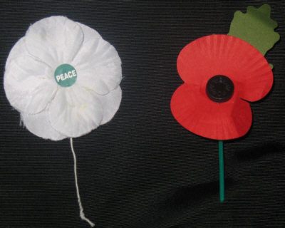
There are two types of poppy that you could choose to wear on Remembrance Day: Red or White.
Each has a different message. Have a look at the websites for each charity to complete this table. You may also watch http://www.youtube.com/watch?v=p_W5M48qmTM, a Sky News item on this very subject (an offline version has also been provided to your teacher)

 | Red Poppy Appeal | White Poppy Appeal
Website | www.poppy.org.uk/ | www.ppu.org.uk/whitepoppy/
What is the stated purpose of their charity? (ie what will the money raised be spent on?)

Activity 3: Teacher PowerPoint and Final Voting
After you have completed your research, your teacher will show a PowerPoint presentation to consolidate your knowledge and understanding.

Discussion Point:
Take a final class vote based on the findings. Who would choose to wear a
Red Poppy?
White Poppy?
Neither?
Both?
Be prepared to explain your choice.

Discussion Point
Martin Luther King said "Until a person finds something they are prepared to die for, they are not really alive".
What did he mean?
Do you agree?

