Drake’s Circumnavigation: Structured Questions

Task 1: Individual Work
• Using the details of Drake’s journey from the Google Earth tour at www.activehistory.co.uk, answer these questions in as much detail as you can.

Join the dots on this map to show the route which was taken by Drake and his crew. Write the names of at least five of the places onto the map.

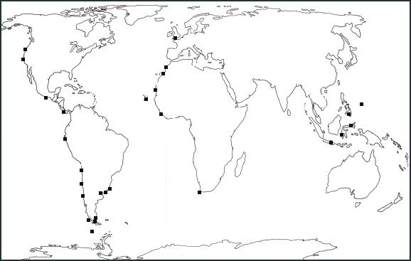

Where was the most northerly point of the journey?

What do you think were the three most dangerous points in the journey?

During which 3 month period did Drake cover the biggest distance?

Which place on the route would you recommend as
(a) A holiday destination;

(b) A convict colony?

It is 1580. Drake has just returned to Plymouth.
EITHER:
Construct a speech from Drake to Queen Elizabeth, outlining the most exciting parts of the journey and trying to convince her that you deserve a Knighthood. Try to include details about
the food, the people, the climate and so on.
OR:
Construct a letter from the King of Spain to Queen Elizabeth, trying to convince her that Drake is a violent pirate who deserves to be executed for his crimes.
Your completed speech / letter should be between 300-500 words.

