Drake’s Circumnavigation: Making your own Google Earth Tour!

Task
• Listed below are the main places which Drake visited during his circumnavigation of the globe.
• Your job is to plot each one of these onto Google Earth using the placemark function. When you have finished, you will be able to watch the entire journey as a “Flyover”!

Tips on using Google Earth

Clearing your workspace
On the left-hand side of the screen, you will see a list of “places”. Scroll down to the “Temporary Places” folder, right click over it, and choose “delete” to empty it out.
This is important, because all your placemarks will be put into that folder and you need to make sure they don’t get jumbled up with other placemarks.
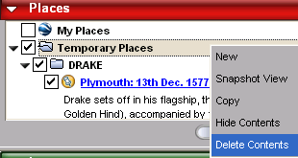

Getting to a place
Use the “Fly To” function to get to the place you want. You can type in the name of the place (“Portsmouth, England”) but this does not always work for more obscure locations – so if you can, copy and paste the latitude and longitude co-ordinates in:
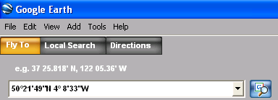
When you press ENTER, Google Earth will zoom into the place.

Adding the placemark
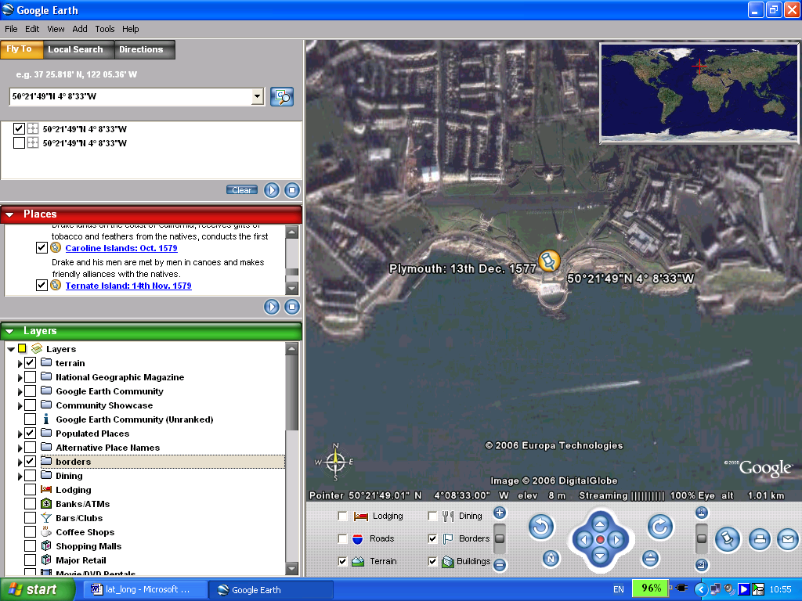
Google Earth will zoom quite close to the location. You may wish to change the viewpoint using the “Zoom” and “Tilt” tools.

Zoom | Tilt

Then, Add the placemark by clicking this icon and choosing “placemark” from the menu.

The placemark will now appear on your map, and in your list of “temporary places”. The contents of this list can be “dragged and dropped” so that they appear in the correct date order.

Viewing the Flyover
Simply double click on each of the placemarks in your list of “temporary places” in turn, or (even easier) click the “Play” icon at the bottom of the “Places” window!

Drake’s Circumnavigation: Data Sheet

• Some latitude and longitude co-ordinates have been deliberately left out.
• Use an atlas to fill these in before putting together your tour in Google Earth.

• There is also a link to an account by one of the sailors, Francis Petty, about each separate location. You can add bits of these into the “details” box of your Google Earth placemarks if you are feeling ambitious!

Location / Date | Latitude | Longitude | Petty’s Account
Plymouth: 13th Dec. 1577 |  |  | Click Here
Essaouira Mogador: 27th Dec. 1577 | 32° 6'47"N | 9°19'42"W | Click Here
Cape Blanco: 17th Jan. 1578 | 20°50'14"N | 17° 6'3"W | Click Here
Mayo, Cape Verde Islands: 27th Jan. 1588 | 15°19'33"N | 23°10'26"W | Click Here
St. Tiago: 31st Jan. 1588 | 17° 5'3"N | 25°21'35"W | Click Here
Equator: March 1578 | 0° 9'29"N | 26° 3'12"W | Click Here
Rio Grande, Brazil: 5th Apr. 1578 |  |  | Click Here
Cape Santa Maria: 18th Apr. 1578 | 34°53'32"S | 56°17'56"W | Click Here
White Bay: 18th May 1578 | 38°54'6"S | 61°59'19"W | Click Here
Port St. Julian: 20th June 1578 | 48°56'36"S | 67°28'17"W | Click Here
Strait of Magellan: 20th Aug. 1578 | 52°26'46"S | 69° 4'14"W | Click Here
Strait of Magellan: 6th Sep. 1578 | 54°34'32"S | 72°53'56"W | Click Here
Bay of Severing Friends: 15th Sep. 1578 | 55°51'30"S | 68° 5'52"W | Click Here
Lost at Sea: Oct. 1578 | 59°46'4"S | 70°19'5"W | Click Here
Mocha Island: 29th Nov. 1578 | 38°19'45"S | 73°55'57"W | Click Here
Valpraiso: December 1578 |  |  | Click Here
Santiago: Dec. 1578 | 33°26'58"S | 70°39'11"W | Click Here
Coquimbo: Jan. 1579 | 29°57'53"S | 71°19'59"W | Click Here
Tarapaca / Arica: Jan. 1579 | 18°28'51"S | 70°19'55"W | Click Here
Lima: 13th Feb. 1579 | 12° 3'48"S | 77° 9'10"W | Click Here
South of Panama: 1st March 1579 | 5° 6'48"N | 79°22'29"W | Click Here
Guatulco: Apr. 1579 | 15°46'56"N | 96°33'50"W | Click Here
Cano Island: Apr. 1579 | 8°38'58"N | 83°55'40"W | Click Here
43 degrees North: 5th June 1579 | 43°35'46"N | 128°10'4"W | Click Here
"Nova Albion": June 1579 | 38°35'34"N | 123°25'30"W | Click Here
Caroline Islands: Oct. 1579 | 1°16'1"S | 147° 2'22"E | Click Here
Ternate Island: 14th Nov. 1579 | 4°33'31"N | 126°44'26"E | Click Here
Celebes: Jan. 1580 | 1°30'34"N | 120°52'10"E | Click Here
Java: Feb. 1580 | 6° 8'7"S | 110°42'55"E | Click Here
Cape of Good Hope: 18th June 1580 |  |  | Click Here
Sierra Leone: July 1580 | 8° 6'55"N | 13°17'36"W | Click Here
Plymouth: Nov. 1580 |  |  | Click Here

