Drake’s Circumnavigation: Working with Primary Sources

Introduction
• The details of Drake’s voyage were kept Top Secret by Queen Elizabeth, who did not want other countries to take advantage of Drake’s discoveries.
• Drake kept a detailed log of the journey which was illustrated with pictures, and presented this to the Queen when he returned to England, but this has never been found.
• The other sailors were sworn to secrecy about the details of the journey, but Francis Petty later recorded his experiences in a valuable book.

Tasks
Listed below are all the main points on the journey, along with a link to Petty’s account of that part of the voyage.
The final column has been left blank. You should use this to record one of more of the following:
a. Goods which Drake stole from the Spanish at this point
b. Goods which Drake was given by the local inhabitants
c. Appearance / Customs of the local inhabitants
d. Particularly interesting events which happened at that stage of the voyage.
You do NOT need to fill in details for every single point in the journey.

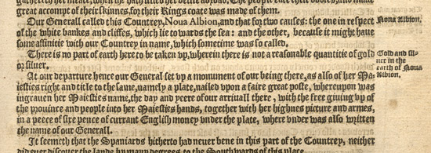
An extract from the original book. Can you work out which part of the journey is described in it?

Location / Date | Petty’s Account
Plymouth: 13th Dec. 1577 | Click Here
Essaouira Mogador: 27th Dec. 1577 | Click Here
Cape Blanco: 17th Jan. 1578 | Click Here
Mayo, Cape Verde Islands: 27th Jan. 1588 | Click Here
St. Tiago: 31st Jan. 1588 | Click Here
Equator: March 1578 | Click Here
Rio Grande, Brazil: 5th Apr. 1578 | Click Here
Cape Santa Maria: 18th Apr. 1578 | Click Here
White Bay: 18th May 1578 | Click Here
Port St. Julian: 20th June 1578 | Click Here
Strait of Magellan: 20th Aug. 1578 | Click Here
Strait of Magellan: 6th Sep. 1578 | Click Here
Bay of Severing Friends: 15th Sep. 1578 | Click Here
Lost at Sea: Oct. 1578 | Click Here
Mocha Island: 29th Nov. 1578 | Click Here
Valpraiso: December 1578 | Click Here
Santiago: Dec. 1578 | Click Here
Coquimbo: Jan. 1579 | Click Here
Tarapaca / Arica: Jan. 1579 | Click Here
Lima: 13th Feb. 1579 | Click Here
South of Panama: 1st March 1579 | Click Here
Guatulco: Apr. 1579 | Click Here
Cano Island: Apr. 1579 | Click Here
43 degrees North: 5th June 1579 | Click Here
"Nova Albion": June 1579 | Click Here
Caroline Islands: Oct. 1579 | Click Here
Ternate Island: 14th Nov. 1579 | Click Here
Celebes: Jan. 1580 | Click Here
Java: Feb. 1580 | Click Here
Cape of Good Hope: 18th June 1580 | Click Here
Sierra Leone: July 1580 | Click Here
Plymouth: Nov. 1580 | Click Here

