Who was Jack the Ripper?
• Four of the most popular suspects are shown here.
• There is also space for you to choose a fifth suspect yourself.
• By clicking on the pictures, or going to www.casebook.org directly, you can complete each column in as much detail as you can.
• When you have finished, you should produce a “WANTED” poster for your top suspect explaining why you think they were the Whitechapel Murderer.

NAME | Joseph Barnett | Montague Druitt | George Chapman | Francis Tumblety | [your choice!]
PHOTOGRAPH  (if available) | 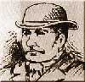 | 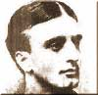 | 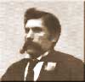 | 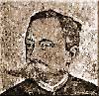 | e.g. Jill the Ripper, Dr. Cream, Michael Ostrog etc etc!
Physical appearance
Was he in his mid-30s in 1888?
(most witnesses think he was – give his age!)
Was he "foreign looking"?
(most witnesses think he was)
Did he come from a wealthy background?
(most witnesses commented that he was sharply dressed)
Did he have any training in surgery / medicine?
(the coroner's reports suggested that the wounds resembled surgical incisions)
Psychological Factors
Is there any evidence of an unbalanced / violent attitudes to women?
(the murderer clearly hated women and prostitutes in particular)
Any evidence of dramatic / literary skills?
(the "Dear Boss" letter suggests someone with a flair for melodrama!)
Why might he have stopped murdering after November 1888?
(the murders stopped very suddenly; there must be a reason for this)
Other evidence of guilt
Other evidence of innocence

