Who were the women of Jack the Ripper’s London?

Introduction

• The women who were killed by Jack the Ripper are often treated as mere ‘victims’ of the killer rather than real, living people who had families, histories, hopes and fears.

• In this activity, students will try to empathise with their experiences by recreating a fictional but typical life story of a working-class woman drawn to London – and to tragedy.

• They will then convert their notes into a letter to the Central News Agency highlighting the plight of ordinary women trying to survive in the East End of London in 1888.

Teacher instructions

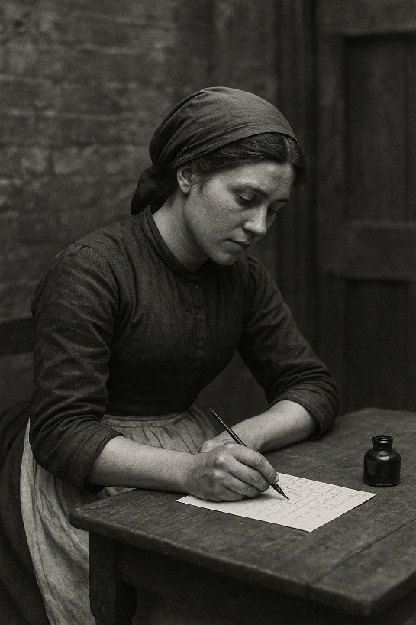
• The accompanying PowerPoint presentation provides instructions about how to conduct the activity. Students will need to be provided with paper to take notes. Ideally, they should each also be given a six-sided die (failing this, they will just randomly choose a number 1-6 for each ‘chapter’ of the story).

• In essence, students copy down the introductory text for each chapter provided in the PowerPoint. They then roll their die (or choose their random number) and move to the desk(s) in the room upon which is the information slip corresponding to their number. They copy this down and use remaining time to compare their stories with other people.

• When everyone has finished writing, the teacher might roll the die and hear one student read out the corresponding chapter for that number. The process is repeated for the remaining chapters.

• At the end of the exercise, students are required to convert their notes into a letter to the Central News Agency to highlight the plight of women in the East End through the example of this character’s life story thus far.



A. Why Women Came to London
A1. Your family orders you to leave home
Your mother has just given birth to yet another sibling. Your father makes it clear that your family can no longer afford to feed you and that it is time that your leave home. London seems the only hope for wages.
A2. Fields Without Farmers
Large farms use fewer labourers now. You watch neighbours leave as threshing machines take their place. Hunger and debt grow - the city calls because the countryside has stopped providing.
A3. No Dowry, No Marriage
Without money or prospects, no local man will marry you. In rural parishes, “spinsters” face gossip and shame. You go to London hoping work will bring respect or independence.
A4. Wages for Women
You hear that London’s workshops, factories, and laundries hire women for pennies a day. The pay is low but yours alone - a rare promise of independence in a world ruled by men’s earnings.
A5. Service in the City
You hear middle-class families in London need maids, cooks, and seamstresses. Domestic service offers food, lodgings, and steady work - safer than the fields, and maybe a step toward a better life!
A6. The Dream of Freedom
As a young, ambitious woman trapped in the countryside, you crave the excitement of London — music halls, shops, crowds! In the city, no one knows your name, and for the first time, your choices might be your own!

B. Early Promise in London

B1. Factory Girl
You arrive in London and find steady work in a match factory. You take pride in earning your own money. You rise early to the factory bell and find satisfaction in belonging to a bustling workplace.

B2. Domestic Servant
You are taken on as a housemaid in a respectable home. You wear a clean apron and sleep in a real bed — better than many lodgings in the East End! Service is tiring, but your mistress praises your diligence.

B3. Dressmaker’s Apprentice
You are apprenticed to a dressmaker in Whitechapel. Your fingers ache from long hours of stitching, but you are learning a trade — one that might, in time, earn you enough to set up a room of your own!

B4. Flower Seller
You find work selling flowers on the street near Covent Garden. The work brings small coins and the sense of being part of London’s daily rhythm. You are admired for your good humour, and quickly make friends!

B5. Barmaid
You take on a job as a barmaid in a local pub, and rent a small room in a lodging house, with a bed and a washbasin of your own. It feels like freedom after years of sharing space with your large family.

B6. Market Trader
You find companionship among other women, working in the local market. You share meals, laughter, and stories. You even earn enough money to rent a small room above the local pub.

C. The Promise of a Husband / Provider

C1. Harry, the preacher
One Sunday, you meet a local preacher called Harry at church. He seems gentle and attentive. He walks you home, calls you his “dear girl,” and speaks of a future together.

C2. John, the fishmonger
You begin living with a fishmonger called John who earns enough to pay for your shared room. It feels almost like marriage (which you don’t have the money to afford), and neighbours treat you as husband and wife.

C3. Edward, the Market Trader
You fall in love with a market trader called Edward. He tells you he’ll look after you, shielding you from the unwanted attentions of men in the street and the other dangers of the city.

C4. Arthur, the street cleaner
You marry a street cleaner called Arthur, believing life will now be easier. Friends congratulate you; your ring gleams as proof of respectability.

C5. Benjamin, the soldier
You fall in love with a soldier called Benjamin. He speaks of travel, and good wages, and you believe him. For now, your future feels bright and you even enjoy the occasional night out at the local music hall.

C6. Frederick, the dock worker
You meet and fall in love with Frederick, a local dock worker. You talk of saving enough to rent a small house, maybe even with a garden. You dream of nice curtains in the windows, a warm fire, children and safety.

D. When the Man is Gone

D1. Bereaved
Your partner falls ill and dies from cholera, a terrible disease spread through infected drinking water. There’s no widow’s pension and no savings to bury him with dignity.

D2. Deserted
One morning, after a violent argument, your partner disappears, taking all of your money with him. You go the police but they tell you there is nothing they can do to help.

D3. Beaten
Your relationship with your partner breaks down due to alcohol, poverty, and despair. He beats you, and you flee for your own safety. This means instant poverty: no legal rights, no income, no home.

D4. Abandoned
Your partner finds better-paid work far away as a ‘navvy’ helping to build the new railways. He promises to send you money – but instead he simply disappears and leaves you abandoned.

D5. Betrayed
You are heartbroken to discover that your partner has been having a long-term affair with another woman. When you confront him, he throws you onto the streets and tells you never to return.

D6. Jailed
After getting into a violent fight with a neighbour, your partner is imprisoned for murder, and you are left alone. Without his wages, you will have to work every spare moment just to pay your rent.

E. Your bad luck continues

E1. The unwanted pregnancy
Shortly after discovering that you are expecting a baby, you suffer a miscarriage. You slide into a sickness and depression which leaves you unable to work and even more desperate than before.

E2. Factory Dismissal
You lose your factory job after missing work due to a machine accident which cuts off three of your fingers. There’s no compensation, no safety net, and another girl takes your place by morning.

E3. The Landlord’s Knock
Your landlord raises the rent on your room. You can’t keep up the payments, and despite begging for sympathy, the landlord throws you at a moment’s notice, straight onto the street.

E4. Illness
You catch a fever from damp bedding, and your strength fails. Without steady meals or rest, you can’t work, and without work, you can’t eat, which sends you into a cycle of sickness and despair.

E5. Lost Reputation
A neighbour spreads gossip — that you and your partner quarrelled, drunk, or lived “improperly.” Employers and lodging-house keepers turn you away, saying you are a “fallen woman”.

E6. Family Cut You Off
You write home for help, but your family says they cannot - or will not - assist you. Perhaps they disapprove of your choices, or they simply have nothing to give.

F. Struggling to Stay Afloat

F1. Charwoman’s Grind
You find occasional, humiliating work scrubbing floors, carrying water, or washing laundry for wealthier families as a “charwoman”. It’s backbreaking and badly paid, but at least it’s honest.

F2. Lodging-House Shuffle
You move constantly from one cheap room to another, always chasing a nastier place you can afford. Each move means more strangers, more danger, and less privacy.

F3. Pawnbroker’s Regular
Your few possessions become your income - a blanket, a shawl, even your boots. You pawn them on Monday and buy them back on Friday, if you can. Pawnshops lined the East End of London.

F4. Costermonger
You take to the streets as a “Costermonger”, with a tray of matches, flowers, or apples to sell. It’s cold, the police regularly bully you to move on, and profits are tiny, but you are trying to keep your pride.

F5. Casual Ward
When there’s no money for rent, you queue outside the workhouse for a space in the “casual ward.” You’re searched, given bread and soup, then turned out at dawn to walk the streets again.

F6. The Bottle
You begin to rely on gin — first for warmth, then for courage, then because life feels empty without it. Drink dulls the hunger, and for a few hours you can laugh with the other women in the lodging-house kitchen.

G. The Bottle and the Escape from Pain

G1. Gin Becomes a Comfort
You are drinking more and more alcohol to warm yourself after long, lonely nights outside. It dulls the hunger and fear - and for a little while, makes the world seem softer.

G2. Drunkenness and Disgrace
Things briefly improve when you get a job as a live-in maid. But your life experiences and your alcohol addiction make you unreliable, angry and abusive, and you are soon fired and back on the streets.

G3. The Lodging-House Drinker
You spend most cold evenings now in the communal kitchens of the doss-houses, sharing bottles of gin and conversation with the other women. It’s noisy, rough, smelly and dirty, but at least you are not lonely.

G4. Arrested for Drunkenness
You’re caught drunk in the street and taken to the cells for the night. The police show no interest in your story: a grim reminder of how women’s pain is criminalised, not treated.

G5. The Bottle Over Bread
Rather than buy food, your few coins are spent down the pub on alcohol. You know it’s wrong and you feel guilty and ashamed, but it numbs the gnawing emptiness better than stale crusts of bread.

G6. Infection
You catch a serious chest infection, but you can’t afford a doctor or rest. Each cough weakens you, and your body begins to fail. Victorian hospitals rarely accepted destitute women unless they were near death.

H. You hit rock bottom

H1. Begging
You start begging on the streets, standing for hours in the cold. Some men even offer you coins in return for sexual favours. Respectable” people look at you with disgust and tell you to “get a job”.

H2. Sex for sale
There’s nothing left to pawn — no shawl, no shoes, not even a blanket. You now own nothing more than the clothes you are wearing – and nothing to sell except your own body to strange men on the night streets…

H3. Out in the cold
There is no space left at the workhouse. You wander the streets being approached by men offering you “coins for kisses” and trying to keep warm until the sun rises on another sad day.

H4. Sex for sale
Desperately hungry and cold, you finally sell your body one night to a man you meet in a pub. This gets you a few pennies for some hot soup and a cheap bed for the night, but you feel ashamed and dirty.

H5. A night in the cells
On bitter nights, you deliberately cause a disturbance just to be arrested - a night in a cell is safer than accepting “coins for kisses” from strange men. The constables call you “drunk and disorderly”.

H6. The Body Gives Out
Drink, hunger, and homelessness combine until you sometimes even resort to selling your body to predatory men offering you a few coins. You can’t even think straight any more. People look at you with pity and disgust.

