Why did it take so long for Britain to Abolish the Slave Trade?
Starter Activity
▪ Read this extract from the "Gentleman's Magazine" of 1789. As you do so, note all the arguments the writer puts forward in defence of the slave trade and how you would respond.
Extract | Summarise his argument | Write a response
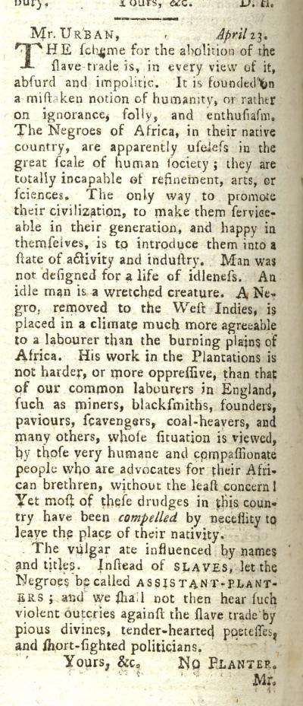

Why did it take so long for the British to abolish the Slave Trade?

By the beginning of the 19th Century, some people were campaigning for the slave trade to be abolished. It took them a very long time to succeed. Why?

Task 1
▪ Imagine you are an "abolitionist" campaigning to abolish the slave trade.
▪ Read through each of the following arguments made by people who supported the slave trade. For each one, write a counter-argument from your point of view.

ARGUMENT | COUNTER-ARGUMENT
Matthew Gregson
If we abolish our slave trade, other countries will simply move in and take it over. The Spanish, the French, the Brazilians and the Americans treat the Africans much more brutally than the British do.
Sir John Gladstone
The more slaves that come to the West Indies, the less work there is for each one to do. So the best way to improve the conditions of the slaves is to increase the slave trade, not abolish it!
Anonymous author of "A Plain Man"
The conditions of workers here in the UK are just as bad as that of the slaves on the plantations. If the abolitionists want social reform, why not start with the English people first?

