Teacher Notes: Final Round / Individual Outcomes

▪ The first “Apprentice” session ends with ‘firing’ all but one person from each team.
▪ In the next lesson, these ‘losers’ then form the teams of the ‘finalists’.
▪ Each finalist will choose one person from the ‘losers’ to join them in their new team.
▪ They will then choose a second, and a third, person and so on depending on the size of the class, until there are just two people left: these will become Lord Sugartrader’s assistants.

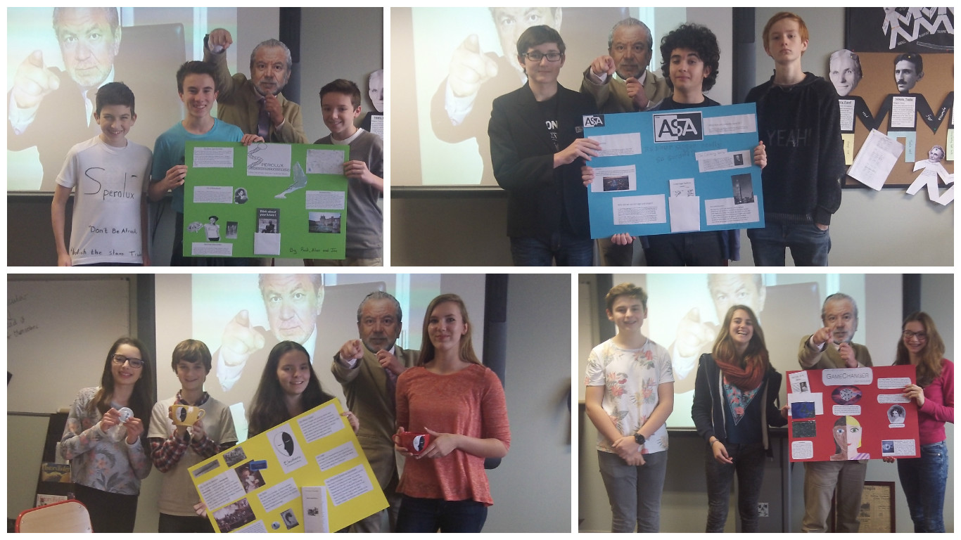

Task 1: Research and Preparation
▪ Each finalist will have the job of identifying what they consider the TWO most important reasons why the slave trade was abolished.
▪ To do this, they will consult two websites. It is up to them how to get their team mates to help them approach this task best in the 10 minutes available.
▪ At the end of the ten minutes, each finalist in turn nominates their first option. Then each finalist in turn chooses their second. NOTE: no repeat choices are allowed, so make sure you have some ‘reserve’ choices.

The websites:
http://www.bbc.co.uk/history/british/abolition/abolition_tools_gallery.shtml
http://abolition.e2bn.org/campaign.html

Task 2: Delivery of the speeches
▪ Each finalist will have some time to prepare a short speech about their two chosen factors. When these speeches are delivered, the rest of the class need to take notes on the factors as they are explained.
▪ When the talks are over, Lord Sugartrader will nominate the overall winner of this year’s “Apprentice” based on the quality of their presentations.

Task 3: Individual Conclusion (overleaf)

Why was the slave trade abolished?

Choose 9 factors that you think explain why the slave trade was abolished. Arrange them in this Diamond9 diagram with the most important at the top. Explain each choice carefully so it is obvious why you think it is more / less important.

