What were the main causes of the American Civil War?

Introduction
▪ Using the teacher PowerPoint, complete these tasks.
▪ Then watch the first video clip and add extra notes.
▪ Finally, add pictures of key figures / flags using the web.

Side | Nickname | Economy | Political Leader | States | Military Leaders | Flag
The North (The United States of America) | “Yankees” of “The Union” | ??? | ??? | ??? | ??? | ???
The South (The Confederate States of America) | “Rebels” of “Dixieland” | ??? | ??? | ??? | ??? | ???

Tasks
1. Read through the following information carefully. Find EITHER a picture OR an extra point of information about as many of the events as you can.
2. At what point did the civil war become inevitable? Explain your answer.

Task 2
1. You will then be given a ‘timeline challenge’ in teams to see how much you have learned.
2. If you had to divide 100% of blame for the outbreak of the civil war between the slave states and the free states, what percentage would you allocate to each side? Explain your answer.
Task 3
1. Produce two brief speeches of no more than 150 words each: one from the Northern "free" states blaming the Southern "slave" states for the war, and one doing the opposite. Use as many 'bias words' (adjectives) to make your side sound innocent, and your opponents sound guilty.

Date | Event | Picture | Extra point of information
1776 | In 1776, the American Declaration of Independence united all the separate states of America. It said each state in “The United States” could decide whether to allow slavery. Half the states became “slave” states, the other half became “free” states. | 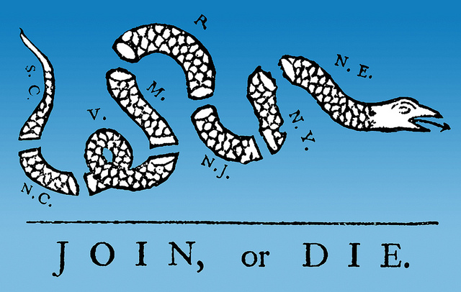
1780 | The “slave” states were based around the cotton plantations of the south. The “free” states were based around the factories of the north.
1790 | The “slave” states wanted the US government to respect the customs of each state (a loose “Confederacy”). The “free” states wanted the US government to forge a national identity (a tight “Union”).
 | Video Clip from Episode 1 of Ken Burns
1793 | The invention of a new machine, the “Cotton Gin”, made the cotton plantations in the South very profitable. As the cotton plantations grew, so did the number of slaves – and their conditions became increasingly unpleasant.
1820 | The “Missouri Compromise”, kept a voting balance of a slave state (Missouri) and a free state (Maine). In this way it was hoped that conflict between North and South would be avoided.
1850 | California (taken from Mexico in 1848) joined the Union as a “Free State”. To keep the Southern “Slave States” happy, the “Fugitive Slave Act” said that all slaves who had fled to the North for protection should now be returned to the South. Thousands of black former slaves who had sought safety in the North fled to Canada (“the underground railroad”).
 | Video Clip from Episode 1 of Ken Burns
1850s | The Fugitive Slave Act persuades many people in the North to join a growing abolitionist movement led by William Lloyd Garrison, Harriet Tubman, Frederick Douglass, John Brown and others
 | Video Clip from Episode 1 of Ken Burns
1852 | “Uncle Tom’s Cabin” became a bestseller. This novel (by Harriet Beecher Stowe) highlighted the terrible conditions which slaves lived in. It angered many Northerners against the slave-owning Southerners.
1854 | The newly created state of Kansas was allowed to decide whether it wanted be free or slave. Debates and demonstrations on the issue spilled into violence, earning the state the nickname of ‘Bleeding Kansas’. This sharpened tension between the “Free States” of the North and “Slave States” of the South.
1856 | In the American Congress (Parliament), the pro-slavery politician Preston Brooks attacked the anti-slavery politician Charles Sumner with a cane during a debate about the future of Kansas.
1857 | The black slave Dred Scott lost his legal campaign to get his freedom. The judge said openly that blacks could never hope to have equal rights with whites. This was a very shocking statement for many people and divided the country in two.
1858 | The newly created state of Kansas decided to become a Free State. This meant that the Free States now outnumbered the Slave States in Congress (Parliament). The Slave States felt they would have to break away from the Union to preserve their way of life.
1858 | Abraham Lincoln announced he planned to stand for election as President. In his “House Divided” speech he said that “A house divided against itself cannot stand” – meaning that the tension between North and South had to be resolved.
 | Video Clip from Episode 1 of Ken Burns
1859 | The Northern anti-slavery campaigner John Brown tried to start a slave rebellion by seizing army supplies at Harpers Ferry, Virginia. The Southerners were outraged. They had him executed and started forming their own independent army.
 | Video Clip from Episode 1 of Ken Burns
1860 | Washington, DC: Abraham Lincoln was elected President of the United States. He promised that no new Slave States would be allowed into the Union. | 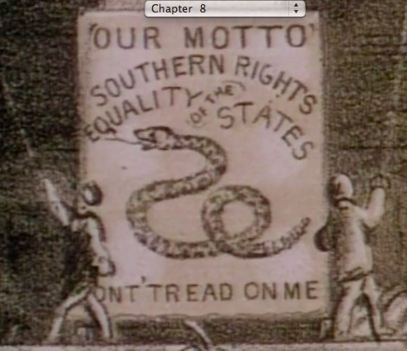
1860 | Richmond, Virginia: Seven of the Southern Slave States broke away from the Union calling themselves “The Confederacy” and elected their own President, Jefferson Davis.  (note: some slave states did NOT join The Confederacy, but remained loyal to The Union. Can you name them?) | 