Head2Head Interview Challenge
Winston Churchill: Hero or Villain?

Task 1: Photos of Churchill
What impression is created of Churchill in each of the following photographs? Record your thoughts to the right of each picture. Compare your ideas with a partner, then with the class.
TIP: To help you analyse each picture, you might want to consider such things as: What has just happened? What is he doing? What’s his mood and why? What is he thinking? What will happen next?

 | Positive impressions? | Negative Impressions?
 | He looks like he takes pride in his appearance. He looks focused. | He looks a bit full of himself? Or maybe he’s a bit sulky and a bit of a bad student?
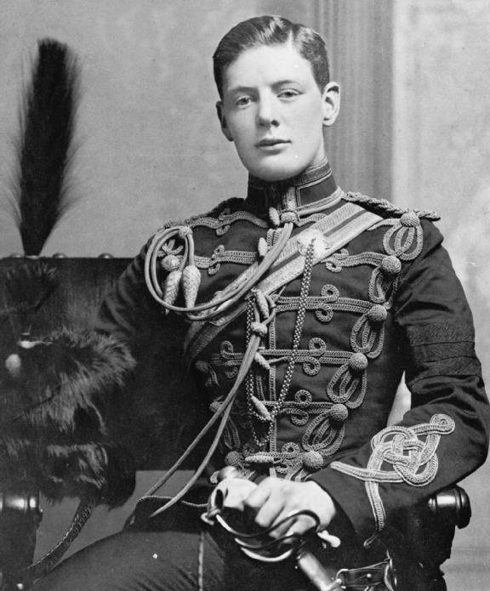
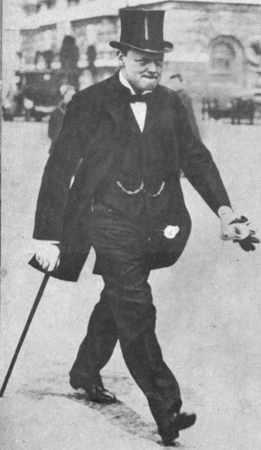
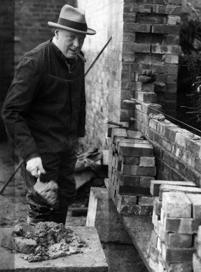
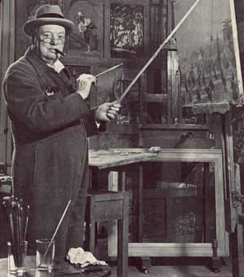

Task 2: Write-up
Use what you have now learned to write a second paragraph about Churchill answering the question “Do photographs of Winston Churchill create the impression that he was a hero, or a villain?”. Suggested structure:
• In some ways, photographs of Churchill create a positive impression…
• In other ways, they suggest that he had some less attractive qualities…
• As historians, we must remember though that photographs are not always reliable as evidence because…

