**Design a Historical Trip!**

**Overview**

• Your task is to design a historical trip, complete with an advertising brochure and Google Earth itinerary. This will follow one of two formats:

|  |  |  |  |
| --- | --- | --- | --- |
|  | **Area** | **Distance** | **Time available** |
| **Walking Tour** | One City / Town | 10 locations within a 5km radius | One day |
| **Driving Tour** | One Country / region | 10 places within a 500km radius | Ten days |

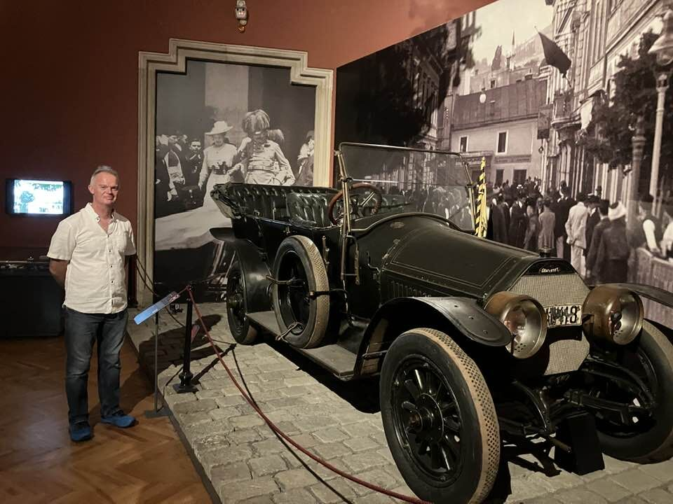

Vienna Day Tour, 2024

European Road Trip, Summer 2024

**Instructions**

• Your first task is to choose your favoured location (city, country, region). This might be based on somewhere you have already visited or would like to visit. Ideally, each person in the class should choose a different location for variation.

• Then you will need to identify 10 places around which to construct your trip. These should be arranged in a numbered ‘loop’ so that the tourist can start and end in the same place.

• To do this, you will need to research the most important events, people, monuments, museums and so on in this area’s history.

• You will then convert this into a final outcome with each of the locations explained carefully (maybe in the style of ‘TripAdvisor’ reviews) such as:

• Paper Map

• Travel Brochure

• Google Earth Tour

• …or something else!

• The best of these projects will include a timeline which will provide an introductory overview, in chronological order, of the history of the area, drawing upon each of the places in your tour. In this way the visitor will understand how all the places connect together to provide an overall ‘story’.