A Victorian Christmas

A Christmas Carol: The Original Story

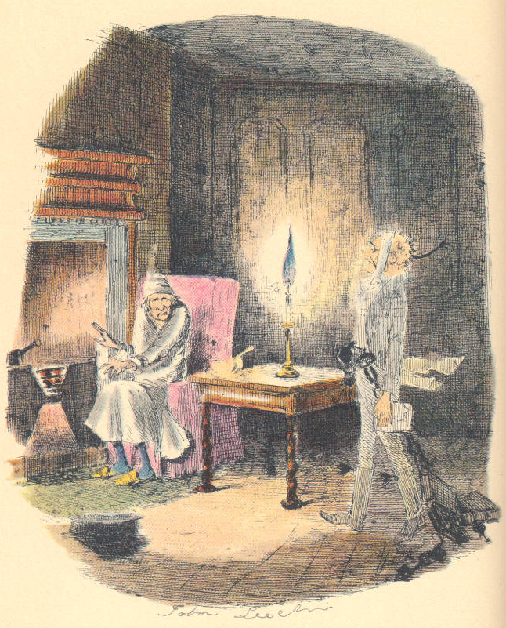 | 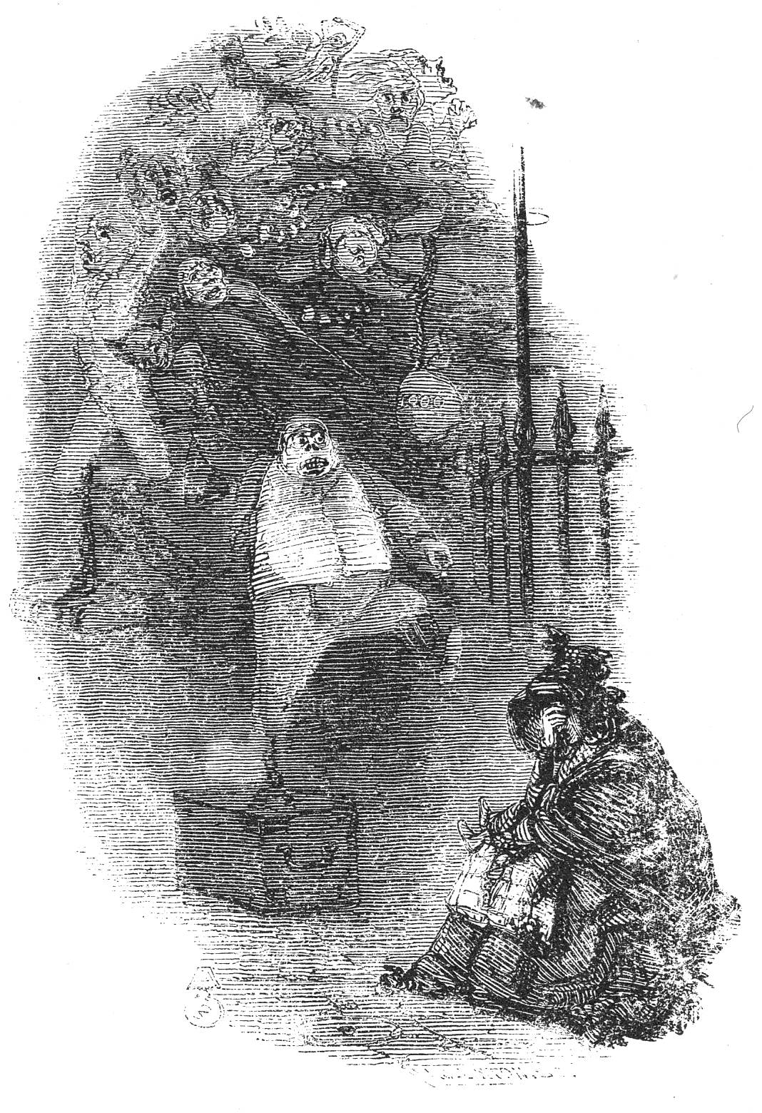
Marley's Ghost  This shows the moment when the miser, in nightgown and sitting down before his fitful fire to enjoy a bowl of gruel, encounters the ghost of his dead partner. | The Ghosts of Departed Usurers, or, The Phantoms  Leech's illustration reveals to Scrooge what he will become after death, a mere spectre, unable to intervene for good in the lives of homeless people less fortunate than himself.
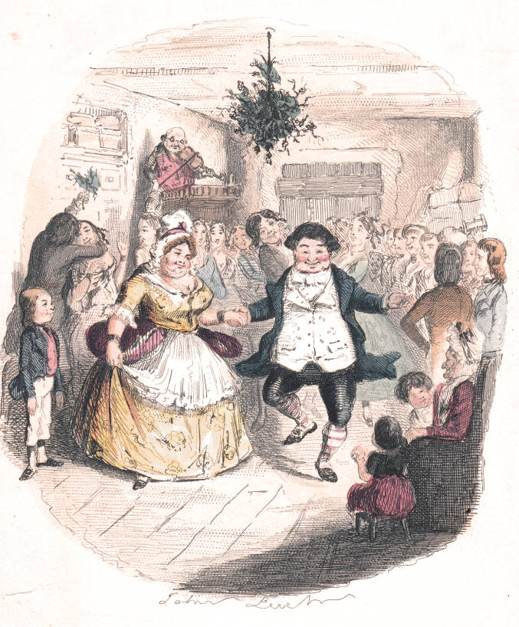 | 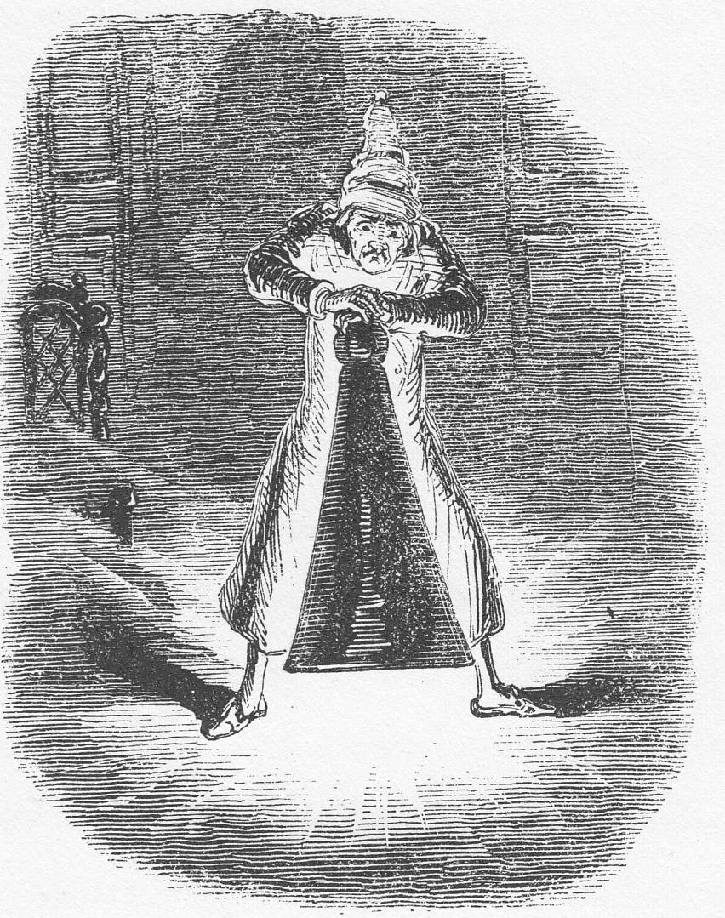
Mr. Fezziwig's Ball  A positive light appeared to issue from Fezziwig's calves. They shone in every part of the dance like moons. You couldn't have predicted, at any given time, what would have become of them next | Scrooge Extinguishes the First  of the Three Spirits  The fourth illustration is John Leech's realisation of what Freudians might term "suppression" of painful memories.
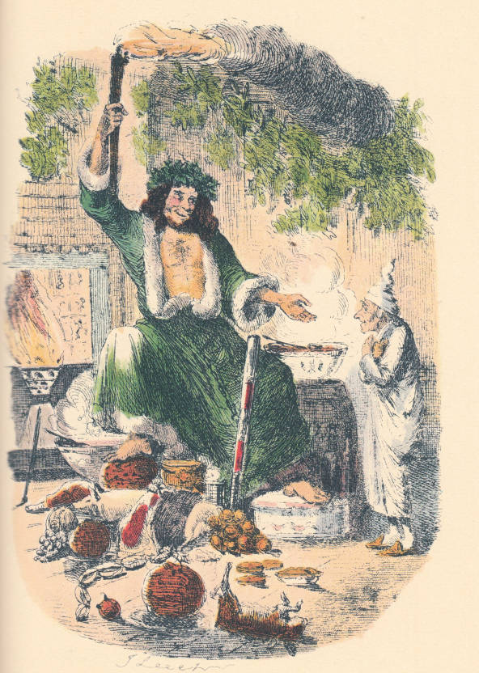 | 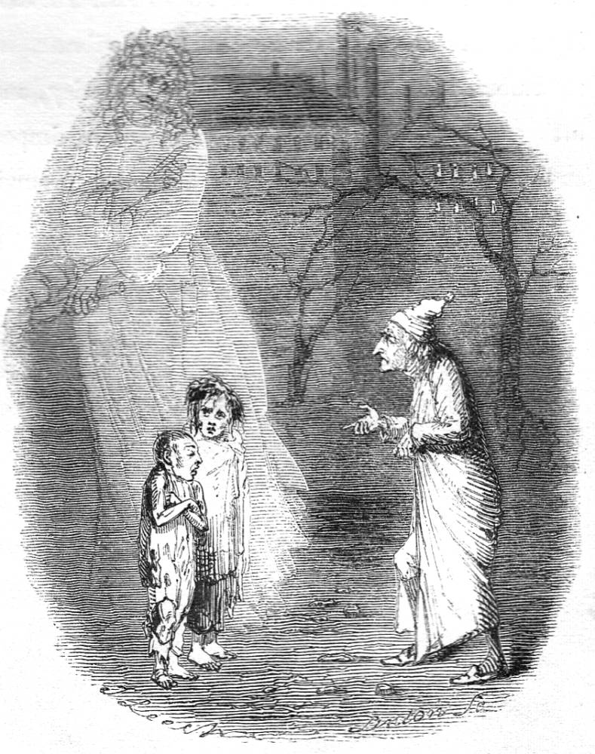
The Second of The Three Spirits"  The fifth illustration is a "pre-Father Christmas" figure, the Spirit of Christmas Present, "a jolly Giant, glorious to see; who [bears] a glowing torch, in shape not unlike Plenty's horn" | Ignorance and Want  Scrooge must confront the social consequences of his unbridled capitalism.
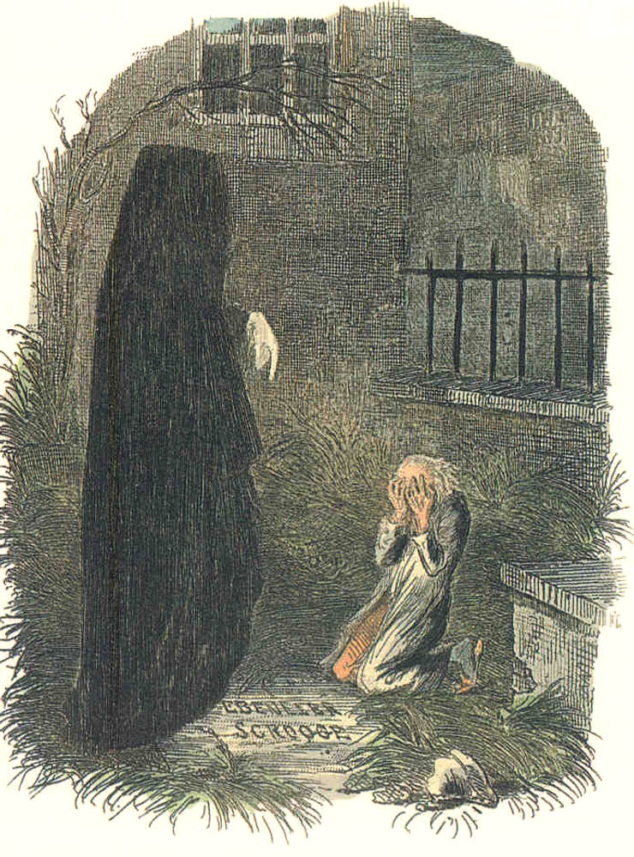 | 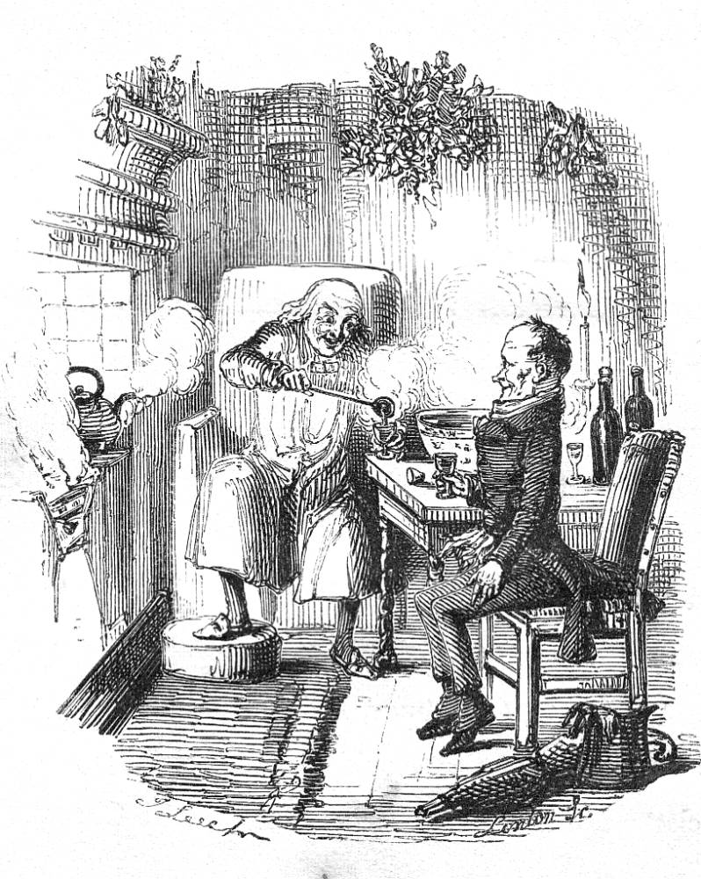
"The Last of the Spirits" — The Pointing Finger  Scrooge's journey with the Ghost of Christmas Yet to Come ends in a graveyard. A man has died, alone and unloved, and Ebenezer wants to know: Who is this man? The Spirit forces Scrooge to discover the answer in a terrible way. | "Scrooge and Bob Cratchit," or "The Christmas Bowl"  This last illustration reinforces the notion that mutual goodwill between man and master should replace the attitude that "business is business".

