Berlin Walking Tour

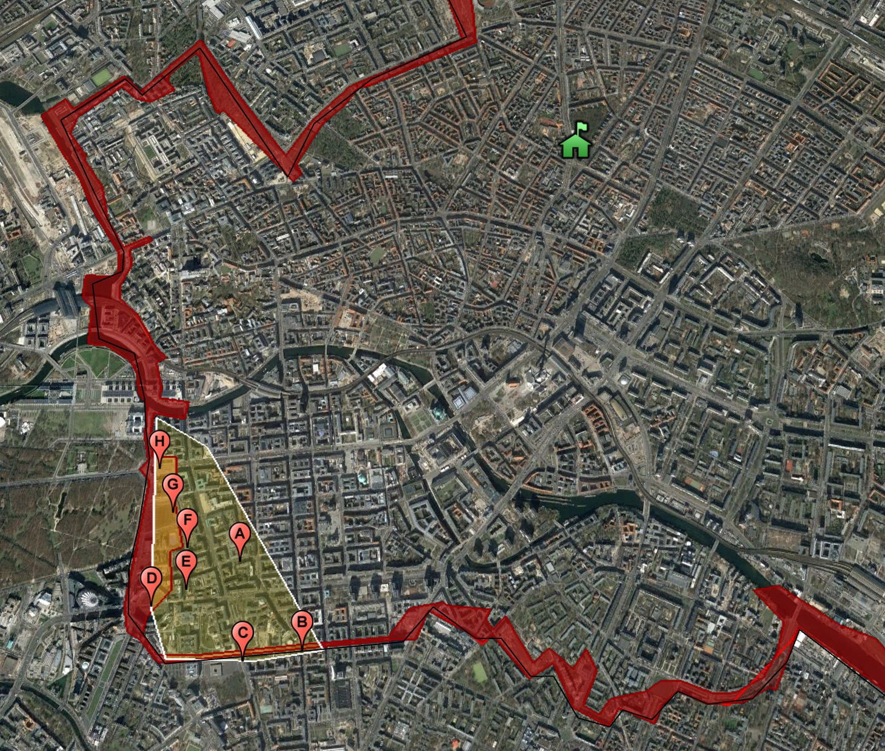
Some (but not all!) of the sites we will visit: A. Mohrenstrasse | B. Checkpoint Charlie | C. Topography of Terror | D. Leipziger Platz | E. Hitler’s Bunker | F. Memorial to the Murdered Jews of Europe | G. Brandenburg Gate | H. Reichstag

Mohrenstraße U-Bahn Station
• The deep-red marble lining the walls and columns of Berlin's Mohrenstraße U-Bahn once adorned Hitler's Reich Chancellery designed by Albert Speer.
• The chancellery was dismantled by Soviet occupying forces and used to rebuild the Mohrenstraße U-Bahn station!
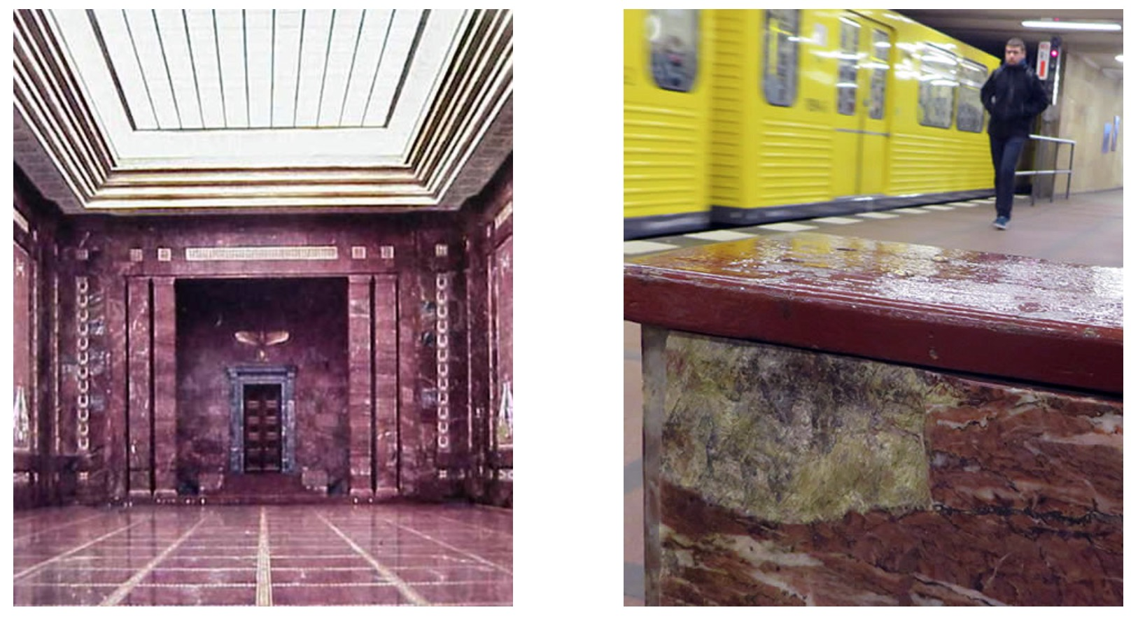
Hitler’s chancellery (left) and Mohrenstraße today (right)

Checkpoint Charlie

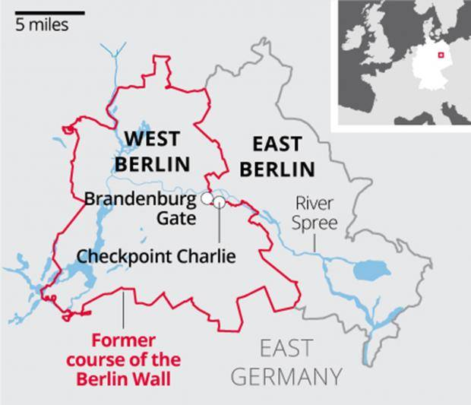
• After the division of Berlin after World War Two, a number of crossing points were established all around the border of West Berlin. Most of these were simply customs points for bringing supplies into West Berlin.
• Checkpoint Charlie was special because it was the crossing point between between East and West Berlin, used mainly by diplomats and military figures from both sides. It quickly became a potent symbol of the division between East and West.

The Berlin Crisis of 1961
• In October 1961, after Soviets refused entry to a western diplomat, US General Lucius Clay ordered American M48 tanks to roll ominously in front of Checkpoint Charlie. In retaliation, Moscow sent an equal number of Russian T55 tanks rumbling to face down the Americans.
• US president Kennedy and Soviet premier Khrushchev defused the crisis by giving both tank crews the order to retreat inch by inch so that neither side appeared to be backing down.
• The checkpoint is now highlighted by two photographs of soldiers. Looking out into East Berlin is an American soldier, whilst looking into West Berlin is a Soviet one.

The debate about Checkpoint Charlie
• For many, Berliners have argued that there needs to be a some sort of official memorial, museum or exhibit here beyond actors in fake uniforms and food stalls (hence its local nickname of "Snackpoint Charlie").

Q. Why do you think it has been so difficult to reach agreement on the message of any memorial to be placed here?

Q. What do you think could be placed here? (note: your teacher will explain what used to be the main memorial before it was closed down in 2005 due to finance issues)

The Peter Fechter Memorial
• If you face the American soldier peering out at you from West Berlin, the Wall ran from left to right across your field of vision. Head left down the road and you will come to the Peter Fechter monument (about a block and a half away). It was at this spot that an 18-year old bricklayer was shot by East German border guards whilst attempting to flee to the West. He had got over the inner wall, but was gunned down right against the outer wall. He died over an hour later from blood loss in the ‘death strip’. Guards on neither side were prepared to risk entering the death strip to provide him with medical assistance.
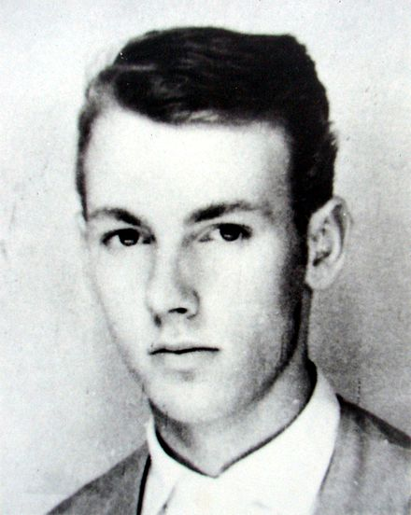
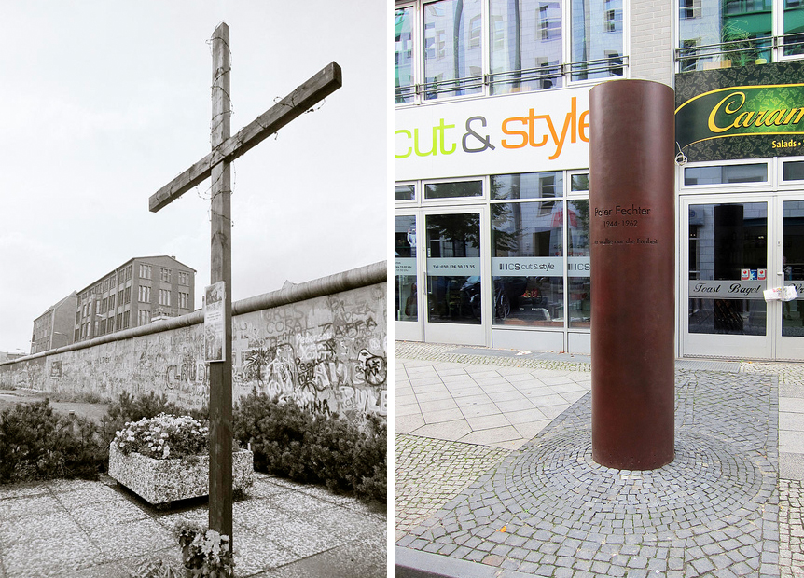
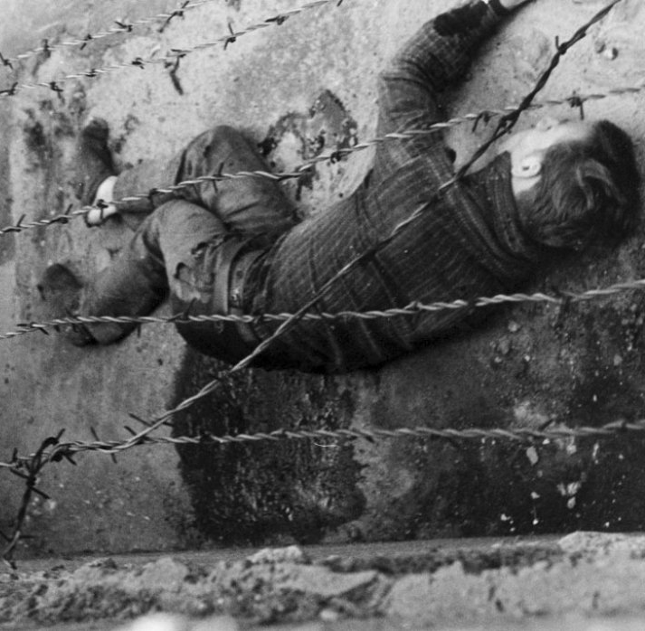
Peter Fechter lies bleeding to death against the Berlin Wall in August 1961. On the right, the memorial marking the spot.

Q. The border guards responsible for firing the fatal shots were put on trial for their actions and given a 21 month suspended sentence. Do you think was fair, too harsh, or too lenient?

SS Headquarters (Topgraphy of Terror) / Nazi Air Ministry / Berlin Wall
• A short walk away from Checkpoint Charlie, following the line of the Wall in the opposite direction to the Fechter memorial, is a spot particularly rich in history.
• The Topography of Terror is an museum on the site of the former headquarters of the SS – the notorious instrument of Terror in Nazi Germany. The building was methodically demolished after World War Two, but its foundations are still clearly visible.
• Across from this is the largest surviving monument to Nazi Germany: the Reich Air Ministry. This large, imposing building was formerly the headquarters of Goering’s Luftwaffe.

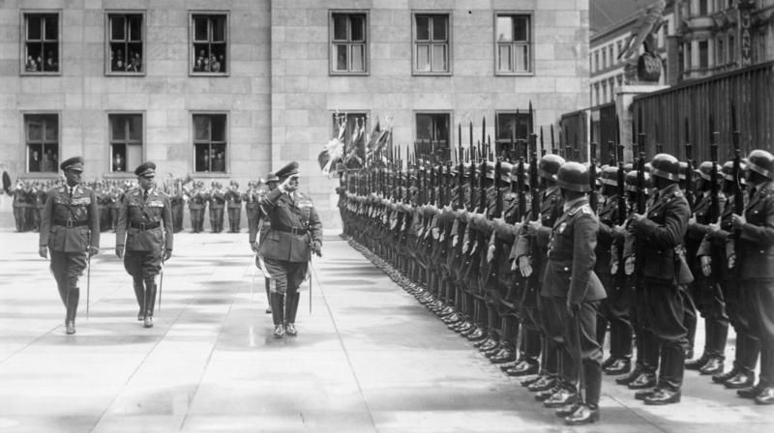
Hermann Goering inspecting troops at the Reich Air Ministry (now the Finance Ministry)

• During the DDR it was the “House of the Ministeries” and it was from here that Walter Ulbricht, its leader, announced “Nobody has any intention of building a wall”: then did so!

• Inbetween the Topography of Terror and the Reich Air Ministry lies the largest surviving section of the Berlin Wall. It was over this very spot that one of the most daring escapes into West Berlin took place in 1965.

Q. Outline the story of the escape as described by your teacher.
Video: The Air Ministry (3m) https://vimeo.com/266345384

Discussion Point: Take some time to explore the Topography of Terror. Be prepared to explain what you think of it when you meet up again as a group.

Leipziger Platz
This square (named after the Battle of 1813 which saw a Prussian-led coalition defeat Napoleon) was completely divided in two by the Berlin Wall. At the nearby train station is a surviving segment of the outer wall; in the square itself are a couple of segments of the inner wall; and between the two the ‘death strip’ was originally situated.

Hitler’s Bunker
• Some distance behind Leipziger Platz and “The Mall” (Berlin’s biggest shopping center) is the site of Hitler’s bunker. It was here that the Nazi dictator retreated as Soviet troops moved ever closer and Allied bombing reduced Berlin to a smouldering ruin.
• Finally, he committed suicide and his body was burned in these grounds so that it could not be paraded as a trophy by Stalin.

Q. There is an ongoing debate about whether there should be any form of reminder at this place about its historical significance. What is your opinion on this matter?
Q. Describe what you actually found at the site when you arrived. Is this appropriate?

The Memorial to the Murdered Jews of Europe
• This memorial lies just a few minutes away from Hitler’s bunker and was built in 2005 from over 2700 concrete blocks.
• The entire memorial covers the exact area of the death strip in this part of the Berlin Wall.

Q1. During the construction of the memorial, the remains of the bunker of Josef Goebbels were discovered. A debate took place on whether or not to incorporate these into the memorial. What would you have recommended and why?

Q2. Another question was whether the memorial should also be a tribute to homsexuals and gypsies killed by the Nazis. Again, what would you have recommended and why?

Q3. Your teacher will now tell you what was actually decided with regard to Q1 and Q2 and why. Write your notes here.

Q4. Explore the museum and then the memorial. Do you find this more or less effective than the Topography of Terror? Why?

The Brandenburg Gate
• The Brandenburg Gate has been a site of many major historical events. it was originally built in the late 1700s, as a representation of peace, commissioned by Frederick William II. The twelve columns form five passageways, and only members of the royal family were allowed to go through the central arch. On the top sits the Quadriga, a chariot holding the goddess of peace, drawn by four horses.
• When Napoleon defeated the city in 1806, he made a triumphal entry through the Brandenburg Gate and then took its Quadriga back to France. Berlin reclaimed it in 1814, turning their gate and the goddess atop it into a triumphal arch as they decorated her lance with an iron cross and an eagle.
• The Nazis then used the gate as a party symbol when they ascended to power. At the end of WWII the gate was still standing, though badly damaged.
• During the Cold War, the Brandenburg Gate was situated in the middle of one of the widest sections of the “Death Strip” between the outer and inner zones of the Berlin Wall. It therefore became one of the most powerful symbols of the divided city. In 1989 when the wall came down, the gate again symbolized freedom and the unification of Berlin.
Video: Brandenburg Gate (3m) https://vimeo.com/266466123

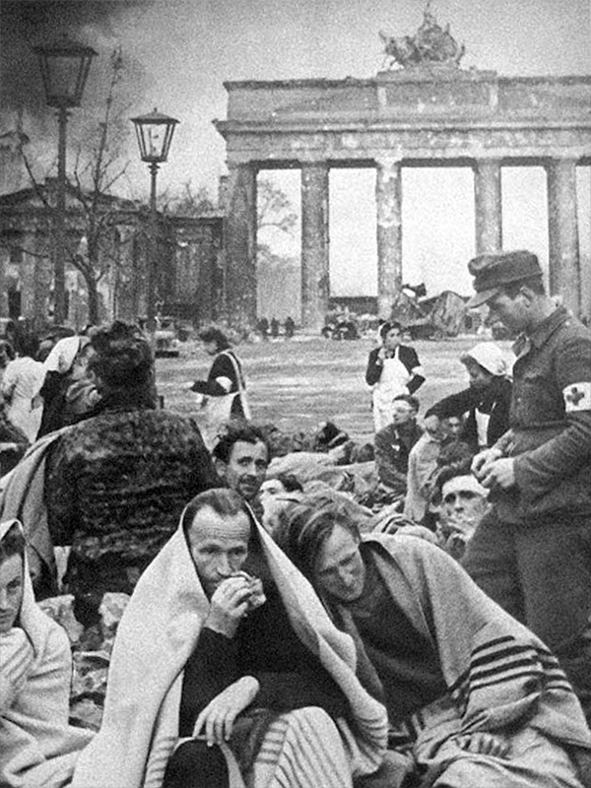 | 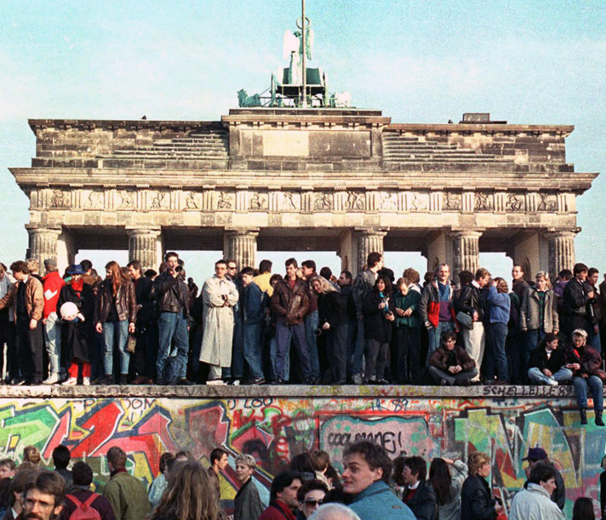
German prisoners of war, 1945 | The Berlin Wall comes down, 1989

The Reichstag
• The Reichstag building was completed in 1894. Kaiser Wilhelm II declared it the “Reich’s monkey house” and prevented the dedication “to the German people”, from being inscribed. It was later added in 1916.
• In 1918, Philipp Scheidemann proclaimed the creation of the Weimar Republic from the balcony but in 1933, the Reichstag mysteriously caught on fire, allowing Hitler to declare a state of emergency and turn himself into a dictator.
• Under the Third Reich the building was not used nor restored, but in 1945 Stalin insisted the Red Flag be planted on its roof in time for the May Day celebrations. Even today, graffiti left behind by Soviet soldiers is formally incorporated into the building, serving to remind the government that not so long ago the country was in a state of chaos and foreign occupation.

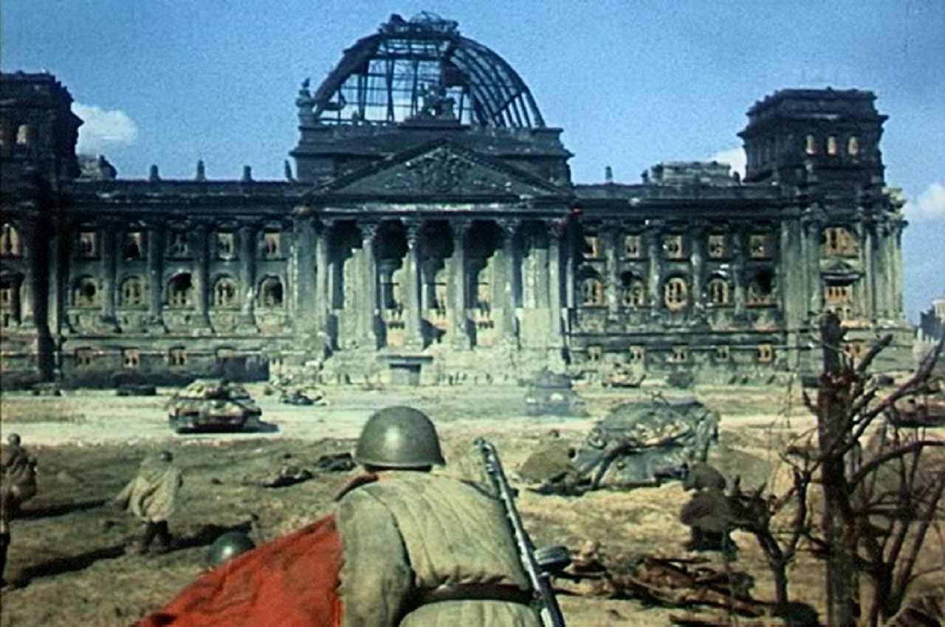
The Reichstag during the Battle of Berlin, 1945

• The Reichstag then lay neglected until after German reunification, when the building was fully restored and redesigned as a modern Parliament building. The glass dome cupola gives an impressive view of the city, especially at night. Visitors can also look straight down into the Parliament chamber – a powerful symbol of open democracy.

Q. Explore this area (and maybe try to locate the spots where the pictures on the previous page were taken) prior to our afternoon’s activities!

Sachsenhausen Concentration Camp
• The Sachsenhausen Concentration Camp in the town of Oranienburg was built in the summer of 1936. As a model for other camps, and in view of its location just outside the Reich capital, Sachsenhausen acquired a special role. This was reinforced in 1938 when the Concentration Camp Inspection Office was transferred from Berlin to Oranienburg.
• More than 200,000 people were imprisoned in Sachsenhausen between 1936 and 1945 (including Stalin’s son Yakov, who probably died there). Tens of thousands died of starvation, disease, forced labour, mistreatment and extermination.
• In August 1945, the Soviets took over the camp for their own purposes. By 1948 Sachsenhausen was the largest of three special camps in the Soviet Zone of Occupation. By the closing of the camp in the spring of 1950, there had been 60,000 people imprisoned there, 12,000 of whom died of malnutrition and disease.
• In 1961 the camp was converted into Sachsenhausen National Memorial. After German reunification, the camp was entrusted to a foundation that opened a museum on the site.

