Berlin Walking Tour

Bernauer Strasse
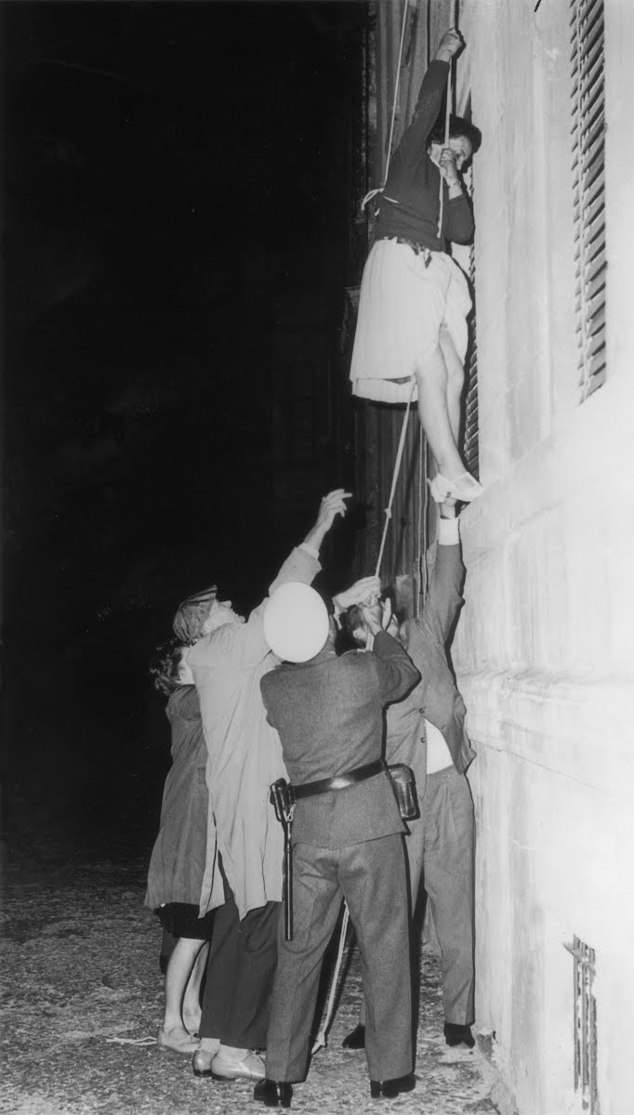
• The Berlin Wall ran directly along this street. When it was first being constructed, the entrances and lower windows of the houses in the Soviet zone which faced the border were blocked up to serve as part of the wall itself.
• Bernauer Straße nevertheless became famous for escapes from high windows of these apartment blocks, so eventually all access points to these buildings were blocked up and then finally they were completely demolished in 1963 to create the ‘death strip’.
• At this point, desperate East Berliners started building numerous escape tunnels under the wall in the Bernauer Straße. The most famous of these was Tunnel 57: over two nights in October 1964, 57 East Germans managed to escape before it was discovered.
• Since the fall of the Berlin Wall, Bernauer Straße has become the site of one of the most impressive memorials to the period.
• Altogether, 29 people died attempting to escape across Bernauer Straße.
• Just two days after the first barriers were erected, the border soldier Conrad Schumann fled to the West by leaping over the barbed wire fence. This is commemorated in a sculpture called the Mauerspringer (Wall jumper) marking the spot.

Nordbahnhof: Ghost Station

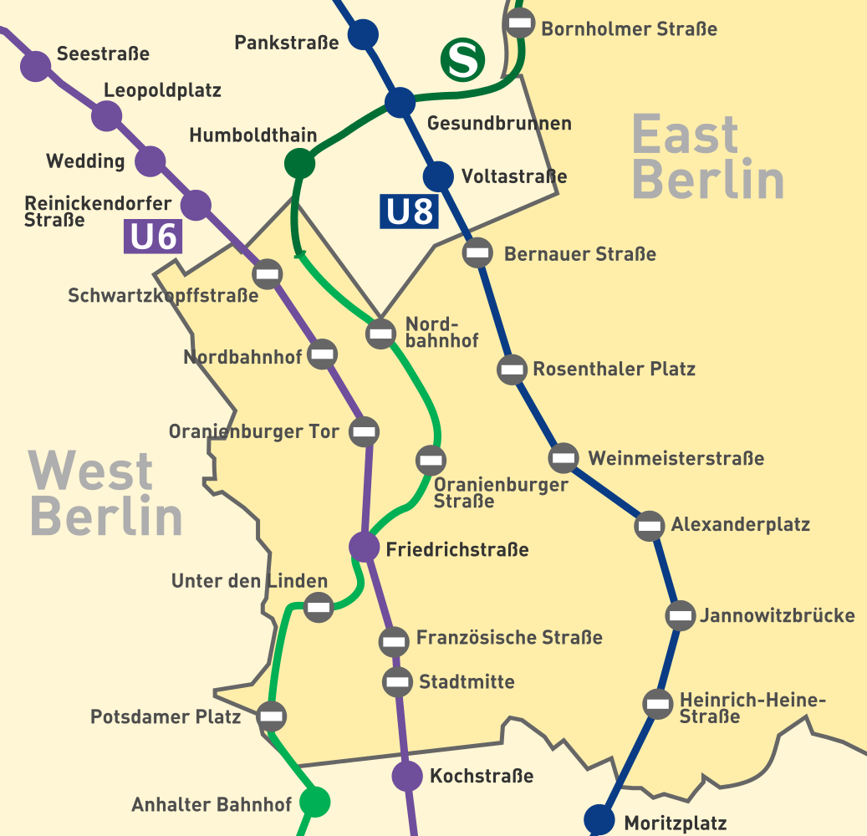
Ghost stations in East Berlin – closed down for access as they came from West Berlin.

The Gedachtniskirche
• The Kaiser Wilhelm Memorial Church was badly bombed during World War Two.
• After the war, it was preserved as a memorial to the destruction of the war.
• Inside is the Cross of Coventry, made of recovered nails from the bombed Church from the UK.

The Story of Berlin / Cold War Bunker
• The Story of Berlin at the Kurfürstendamm is the interactive museum of the capital. Spread over 6.000 square meters visitors can explore 800 years of Berlin history. In 23 theme rooms – each of them designed individually and equipped with modern multimedia technology – everyone can experience everyday life of the people of Berlin during different eras.
• One highlight of the exhibition is a guided tour through an original nuclear bomb shelter from the Cold War below the Kurfürstendamm which still can be used by 3,600 persons in case of an emergency.

