Timeline of my Birthday [DATE GOES HERE]

Date | Events | Births | Deaths
<1000
1000-1099
1100-1199
1200-1299
1300-1399
1400-1499
1500-1599
1600-1699
1700-1799
1800-1899
1900-1999
2000-NOW | [put a picture of yourself here] | [put your name and the year of your birth in this box, along with the name of the town or city where you were born] | [put a picture of the town or city where you were born here. Put a caption underneath saying where it is]

Instructions
1. Replace [DATE GOES HERE] with the month / day of your birthday (e.g. “November 30th”).
2. Go to https://www.activehistory.co.uk/birthdayTimeline and input your birthday. It will provide a list of events, births and deaths that took place across a wide range of time on the day you were born.
3. Select AT LEAST FIVE of these entries to put into your timeline, following these rules:
a. At least one ‘event’, one ‘birth’ and one ‘death’ must be included
b. No more than one entry in each row (=century)
c. Put a picture relating to this entry in a cell next to it, with a caption.
4. Complete the final row with information about yourself.

NOTE: your completed timeline MUST fit onto one just one page.

Extra credit will be given to students who add more detail about each event/birth/death by (a) using the hyperlinks from ActiveHistory and / or (b) add more than five events.

A simple example is given overleaf to give you some basic ideas to get started!

Timeline of my Birthday: November 30th

Date | Events | Births | Deaths
<1000 | 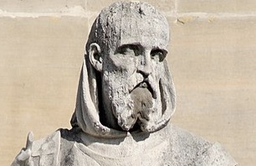 | 0539 - Birth of Gregory of Tours, French bishop and saint
1000-1099 |  | 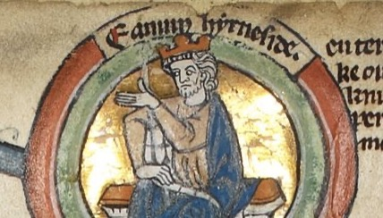 | 1016 - Death of Edmund Ironside, English king (b. 993)
1100-1199
1200-1299
1300-1399
1400-1499 | 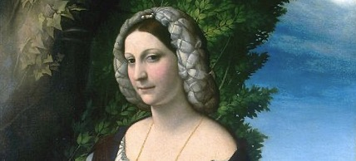 | 1485 - Birth of Veronica Gambara, Italian poet and stateswoman (d. 1550)
1500-1599 |  | 1508 - Birth of Andrea Palladio, Italian architect and theoretician, designed the Church of San Giorgio Maggiore and Teatro Olimpico (d. 1580) | 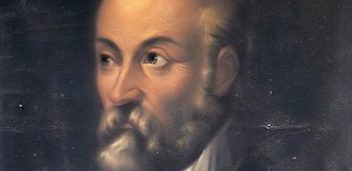
1600-1699
1700-1799
1800-1899 | 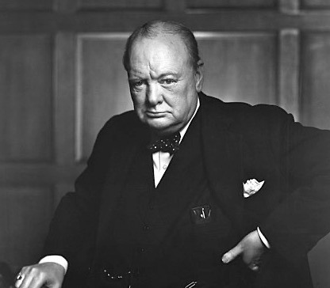 | 1874 - Birth of Winston Churchill, English colonel, journalist, and politician, Prime Minister of the United Kingdom, Nobel Prize laureate (d. 1965)
1900-1999
2000-NOW |  | Russel Tarr, 1971, Wednesbury UK | 