Romans Escape Room

Pre-Class Preparation
• Print out the missions (some are on slips that need to be cut out, some are on dedicated sheets of paper) and hide these around the room in the suggested places.
• Print out the timeline and cut it into ten slips ready to hand out as ‘rewards’ for completing separate missions.
• Print out the hint questions (either in plain English or encoded as QR codes as an additional ‘twist’) and keep these to one side for later in the activity if they are needed.
• Print and cut out the “random trivia” slips and place these all over the room (some of these are needed to answer the ‘hint’ questions; others are just for general interest).
• Print out the essential sources (those used to complete the missions and those needed to answer the hint questions) and place these all over the room in various places.
• Print out the additional sources (which are not essential but generate more interest and provide more information) and place these around the room too.
• Prepare additional props and the “Final Mission” as listed below:

Special props needed for this particular Escape Room (note – if you don’t have any of these, simply remove the mission/question that refers to them or add another one of your own choice).
- Dice with Roman numerals (available from Amazon).
- Books – Horrible Histories book on the Romans and Ancient Rome: The Rise and Fall of an Empire by Simon Baker (or adjust the missions to use different books containing the answers to different questions).
- Gladiator helmet
- UV Pen / Torch
- Roman coins (or similar ‘treasure’ as the final prize), locked in a box with six padlocks (with the code for each padlock reflecting a different one of the 6 events described in the key).
- Cut up the family tree of Roman Gods/Goddesses and put the bits in various places (reconstructing this is one of the missions).

Scenario
“You are a team of famous archaeologists preparing an exhibition about the Roman Empire which is due to open in just 45 minutes. The prize exhibit has been locked away safely by your team leader, but he has now been kidnapped by a group of art thieves who are asking for a ransom. Your task is to crack the codes on the locks which will allow you to open the box, recover the priceless exhibit, and start charging people to visit your exhibition. If you fail to do so then you will not be able to raise the money for the ransom and your team leader will be lost forever…!”

Give students a minute or two to explore the room, in silence and without touching anything.

Then, outline the procedure through which they should aim to complete the mission:
- Find a mission: The class needs to locate the numerous “missions” hidden around the room which are written on pieces of paper. Whenever one is found, the teacher halts the class and reads out the mission. It is up to the class to decide who should complete this mission and who should carry on looking for the remaining mission slips.
- Complete the mission: Each time students feel a 'mission' is completed, they should alert the teacher. The teacher asks all students to pay attention as the mission is read out and the answer provided. If the answer is correct, the next piece of the timeline (starting with the earliest) is then read out and given to the class on a slip of paper.
- Escape the room: Once the class has the final piece of the timeline, a clue is provided which enables them to solve the final mission and "escape"!

Outline of the “Final Mission”
• Students use the hint on the final slip of the completed timeine to open the case and get the Roman coins.
• There are 6 locks on the case. The 4-digit combination for each one is the date of an event which is described on a tag attached to the padlock (alternatively, each padlock can be labelled with a number, and then a key is provided which gives a list of events next to each padlock number). It is up to the students to make this deduction. The dates of some of these events might be traceable using the sources; but all will be mentioned on the timeline, pieces of which are given to the students as rewards for completing separate missions. In particular the final event in the timeline gives the essential hint that makes it clear that the event described against each padlock can be converted into a date which will unlock it.

Timeline of key events
• Each time a mission is completed, give the students another piece of the timeline.
• When the final mission is completed, the final piece of the timeline tells them how to unlock the case and complete their mission.

0753 BC | Rome is founded as a monarchy. Legend has it that the twin sons of Mars, the god of war, named Romulus and Remus founded the city. Romulus killed Remus and became ruler of Rome and named the city after himself.
0509 BC | Rome becomes a republic: the last king is overthrown and Rome is now ruled by elected officials called senators.
0218 BC | Hannibal invades Italy. Hannibal leads the Carthage army in his famous crossing of the Alps (using elephants!) to attack Rome.
0073 BC | Spartacus the gladiator leads the slaves in an uprising against Roman rule.
0049 BC | Caesar becomes the first dictator of Rome. He is murdered 5 years later by his enemies.
0027 BC | Augustus becomes the first Roman Emperor. The Roman Empire begins.
0061 AD | Boudicca, the leader of the Iceni tribe, leads a rebellion against Roman rule in Britain.
0064 AD | The Great Fire of Rome: the city burns down during the reign of Emperor Nero.
0080 AD | The Colosseum is built by the Emperor Vespasian. It can seat 50,000 spectators.
0117 AD | The Emperor Trajan expands the Roman Empire to its largest extent. Trajan’s Column in Rome commemorates his achievements.
0122 AD | Emperor Hadrian builds Hadrian’s Wall across northern England, marking the northernmost limit of the Roman Empire.  FINAL TIP - THE TIMELINE DATES IN BOLD WILL UNLOCK THE CASE!

Key to place next to the padlocked case
You can place a number on each padlock, on some of them, or on none of them, depending on how difficult you want the mission to be!

1 | Rome is founded.
2 | Hannibal invades Italy.
3 | Augustus becomes Emperor.
4 | The Great Fire of Rome.
5 | Trajan’s column is built.
6 | Hadrian’s Wall is finished!

Random trivia
Cut these slips out and place them around the room along with the various other sources. Some of these can be used to answer the ‘hint’ questions.

The Capitoline Hill, where the most important gods were, lent its name to the word “capitol.” While the Palatine Hill, where the emperors made their palaces, lent its name to the word “palace.” | The Romans originally had ten months in their year. January to June were named after their Gods and Goddesses. The final four months were named after numbers (September = seventh month, October = eighth month, and so on). Later, two months were inserted after June (July and August, in honour of Julius Ceasar and Augustus), which means that the final four months no longer make numerical sense!
From the end of the first century AD, Roman emperors had adopted the daily habit of taking a small amount of every known poison in an attempt to gain immunity. The mixture was known as the Mithridatium, after the originator of the practice, Mithridates the Great, king of Pontus. | People would socialize at communal toilets. Rome had over 140 public toilets. They also spent a lot of time in public baths, which were supplied by water brought from the mountains by aqueducts.
In the first century A.D., Emperor Vespasian enacted what came to be known as the urine tax. At the time, urine wasused for laundry (although it was a medicine for them too) because the ammonia in the urine bleached their clothes. So urine was collected from the public bathhouses and given a special tax. | Hair dying was popular among women, with red and blonde being the most popular colors. Dye colors were achieved through different ingredients, like goat fat, beech wood ashes, henna, saffron, and bleach.
The word “sinister” meant “left” in Latin, but in English now means “evil” or “unlucky” because early Christians thought that left-handed people were controlled by the devil! | Roman statesman Cato the Elder urged that babies should be bathed in the warmed-up urine produced by an adult who had eaten cabbage. If a child would not settle to sleep, he recommended placing goat dung in its nappy!
Girls were expected to marry at the age of 13 or 14 in arranged marriages. Strewing nuts, symbolic of the casting off of childish toys and of fertility, was an important part of the wedding. The bride wore a bright yellow wedding gown with a flame-red veil over her hair. | The abbreviation SPQR can be found on many Roman statues, buildings, and military standards. It stands for “senatus populusque romanus.” meaning “The senate and people of Rome”
A person found guilty of parricide (killing his father) was sewn up in a sack with a dog, a rooster, a viper, and a monkey, and thrown into the sea. | By the early fourth century, the Romans had built a road network of 53,000 miles throughout the empire. Each Roman mile was about 1,000 paces (about 4,800 feet) and was marked by a milestone.

Hint Questions
• At any point during the last 15 minutes of the activity, students can ask for a hint to help them locate one of the remaining missions. To obtain a hint, they first have to answer a question correctly. The questions can all be answered using the sources in the room. It’s a good way of keeping the activity moving as the number of remaining missions dwindles.
• TIP: As an added twist, these hint questions could be provided in the form of QR codes using the “QR Code Treasure Hunt Generator” at www.classtools.net.

Who were the five “Good Emperors”? | Nerva, Trajan, Hadrian, Antoninus Pius, Marcus Aurelius.
How many kilometres long is Hadrian’s Wall? | 117km
What name was given to the woollen cloak worn by Roman women? | Palla
The abbreviation “SPQR” is often found on Roman sites. What does it stand for (in Latin, and in English, please!) | SPQR is an initialism of a Latin phrase Senātus Populusque Rōmānus ("The Roman Senate and People", or more freely as "The Senate and People of Rome").
What did Roman women use as makeup when they wanted to whiten their skin? | Powdered chalk.
Why did Romans place a coin in the mouth of people after they died? | It paid the ferryboat fare for Hades to take them across the river Styx to the underworld.
The Romans invented the central heating system, which they called the…? | Hypocaust

Missions
(note – completing eleven of these will lead to the completion of the timeline. I have created more than 11 missions though so there is some flexibility for students in terms of finding / completing missions).

Mission Slips (cut out the cells in this column and hide them in the place described) |  | Answer | Location | Location Hint
Mission Augustus  Find the 15 anachronisms in the bathroom and give the results to your teacher. | > | (worksheet task correctly completed) | Pinned to a wall. | Look on the walls…
Mission Tiberius  (Roman numerals task on separate sheet) | > | (worksheet task correctly completed) | Underneath the classroom bin. | The location of this mission is rubbish.
Mission Caligula  “Romance” languages are those which come from Roman. What is the name of the “Romance” language which developed in Toulouse? | > | Occitan | Taped on the underside of a desk. | You will need to look upwards to find this mission.
Mission Claudius  If you want to “Eat Like a Roman”, what is the name of the large, two-handled vessel used for mixing wine? | > | Krater | Inside a locked box (with the key for this hidden somewhere else in the room e.g. taped to the ceiling). | This mission is boxed up.
Mission Nero  (Harry Potter translation exercise on separate worksheet) | > | (completed properly) | Under a plant pot. | This mission is planted somewhere obvious.
Mission Vespasian  How exactly was Saturnin, the bishop of Toulouse, executed by the Romans? | > | Killed by a bull (teacher should elaborate and they take notes after they provide the answer). | On the globe of the world from the Geography room, stuck onto Italy. | You’ll have to go all around the world to find this mission.
Mission Titus  Which Emperor first invaded England? | > | Claudius | Written in UV pen on a laminated surface / transparency. | You’ll need to be quite bright to find this mission.
Mission Domitian  Who was the Emperor who divided the Roman Empire into two pieces in 0286AD? | > | Diocletian | Underneath a mouse mat next to the teacher computer. | The mission is under a mat.
Mission Trajan  Chart a course through the Roman town in the correct order (see dedicated sheet) | > | (completed properly) | Inside the printer tray. | This mission still needs to be printed out.
Mission Hadrian  According to the bar chart, who were the three longest-reigning Roman Emperors? | > | Augustus, Contantine I, Constantinus II | Taped to the ceiling. | Look on the ceiling…
Mission Antoninus  Use this book to find out what was so unusual about Emperor Caligula’s decision to make Incitatus a consul (powerful politician). | > | Incitatus was a horse (see p.65 – hopefully students will use the index to quickly locate this). | Hidden inside the cover of the “Horrible Histories” book on the Romans (note – easy to change this to another book) | The location of this mission is rather horrible.
Mission Marcus Aurelius  (picture questions based on images in the Simon Baker book – see separate sheet). | > | Baker  Jesus Christ  Vercingetorix | Folded inside the Simon Baker book on the Romans (note – easy to change this to another book) | Simon Baker holds this mission.
Mission Commodus  Put on the gladiator’s helmet. Stand on a desk and then loudly read out, in both Latin and then English, the traditional salute that Gladiators gave to the Emperor before their battles. | > | 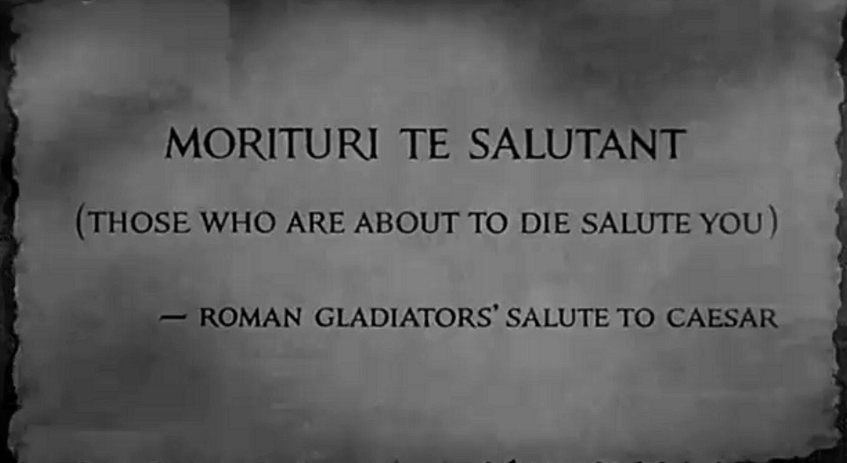 | On a shelf in a cupboard. | This mission has been shelved.
Mission Septimus Severus  (reconstruct family tree of Gods and Goddesses and answer questions). | > | Jupiter  Neptune  Venus  Mars  Cupid | Behing a poster. | Some of the posters in the room have more behind them than you think.

Mission Augustus

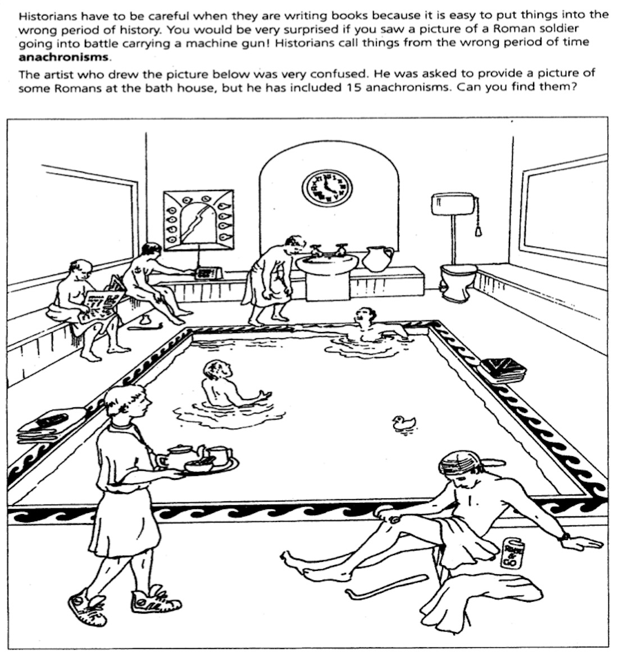
Historians call things placed in the wrong time period anachronisms.
In this picture, circle off 10 anachronisms (things which did not actually exist in Roman times).

Mission Septimus Severus

Around the room are pieces of a chopped up image. Reconstruct this to obtain a family tree of Roman Gods and Goddesses. Use this completed image to answer the following questions:

Who was King of the Gods?
Who was God of the Sea?
Who was Vulcan’s daughter?
Who was the God of war?
Who was the God of love?

Mission Nero
Harry Potter – Latin Spells
Latin was the language spoken by the Romans. The spells used at Hogwarts all come from Latin. In the final row of this table, provide English translations of each of the missing words.
A spell to mend Harry’s glasses |  | A spell to keep enemies away |  | A spell to get rid of your enemy’s weapons |  | A spell to move an unconscious person
 |  | 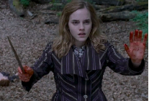 |  | 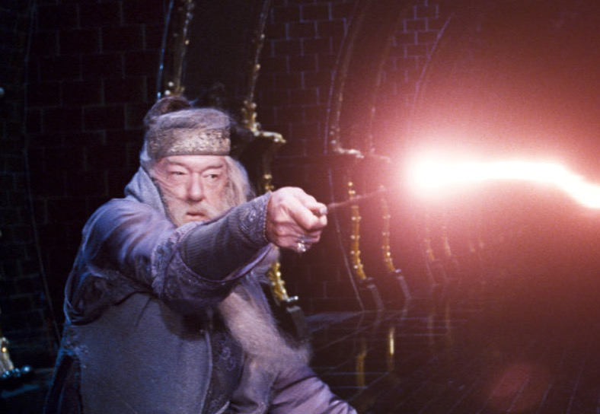 |  | 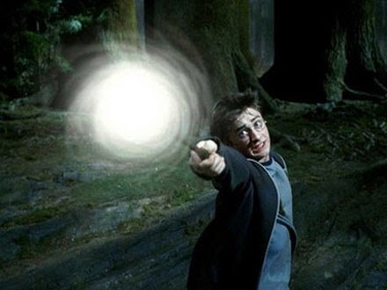
Occulus | Reparo | Cave | Inimicum | Expelli | Armus | Mobili | Corpus

Mission Trajan

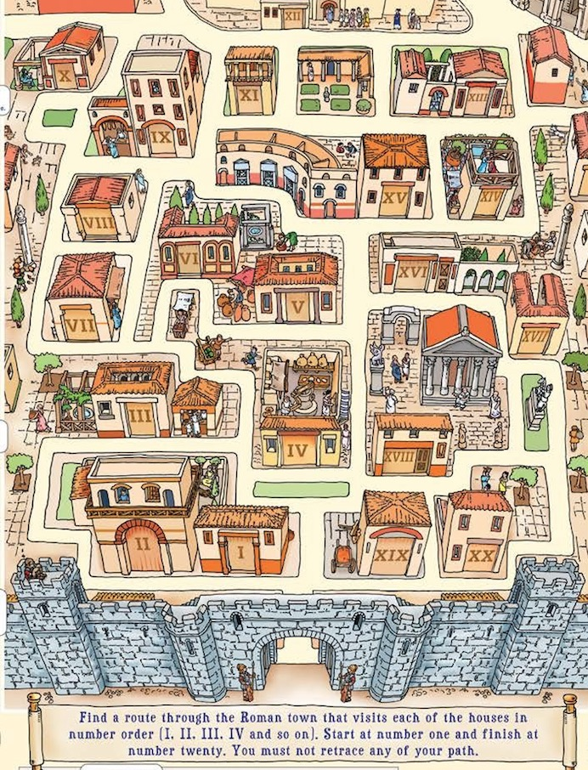

Draw a route onto this map that visits each of the houses in number order. Start at number one and finish at number 20.

Mission Tiberius

Complete both tables by rolling the dice two times.

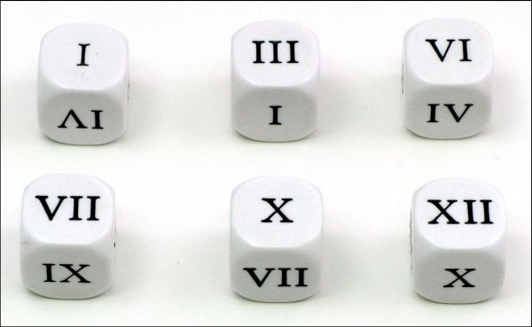

1. Roll two Roman dice and then copy the two numbers here > |  | 2. Convert these two numbers into modern-day numbers  > |  | 3. Add them together and write the answer IN ROMAN NUMERALS  >

1. Roll two Roman dice and then copy the two numbers here > |  | 2. Convert these two numbers into modern-day numbers  > |  | 3. Add them together and write the answer IN ROMAN NUMERALS  >

Mission Marcus Aurelius

Simon Baker will help you answer these three questions.

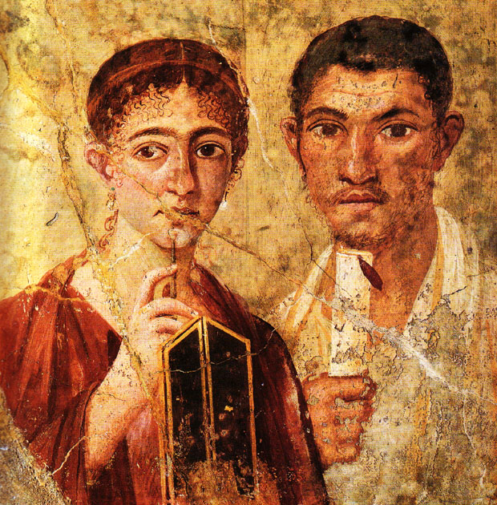 | What is the profession of the man shown here with his wife?
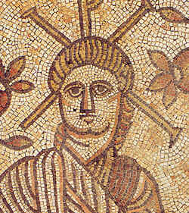 | Who is this an image of?
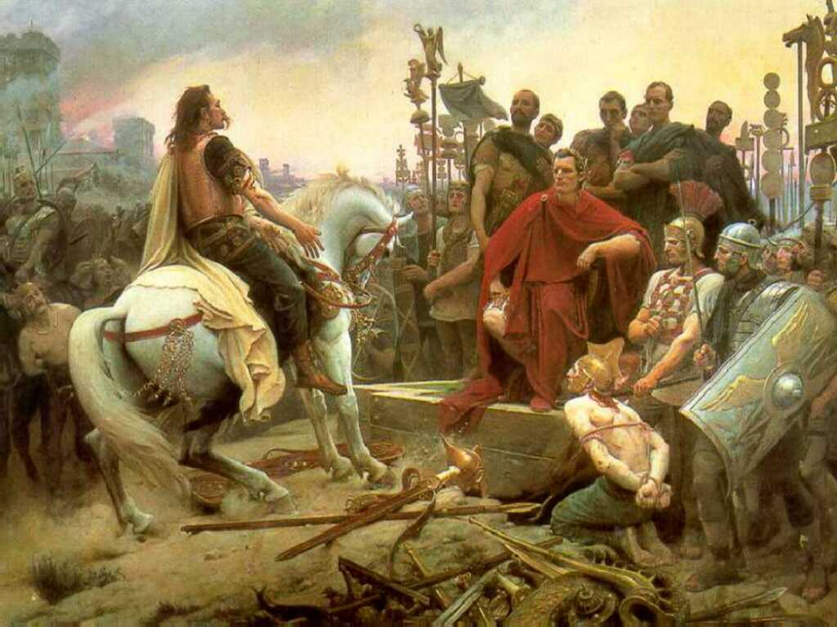 | What is the name of the French leader shown surrendering here to Caesar?

