Escape Room – The Origins of the Cold War

Note: for full instructions on the concept of the “Escape Room” format, consult www.activehistory.co.uk/escape_room

SPECIFIC Pre-Class Preparation
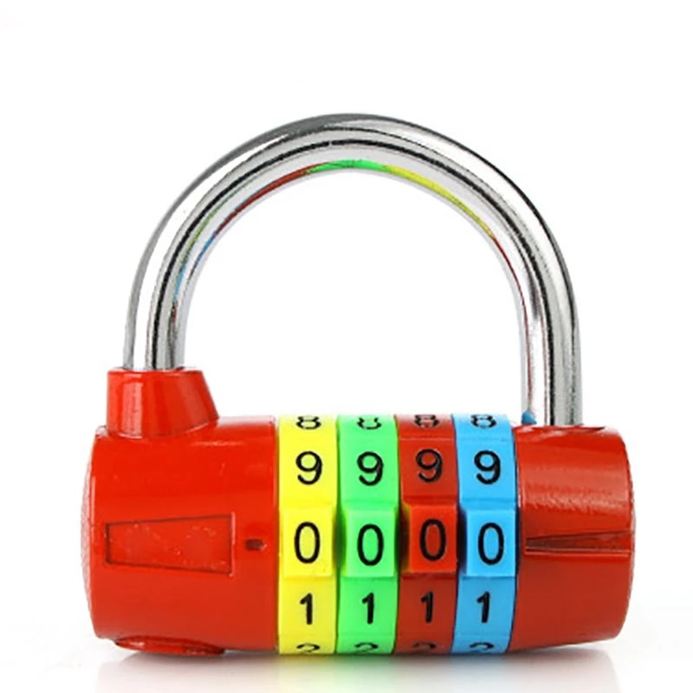
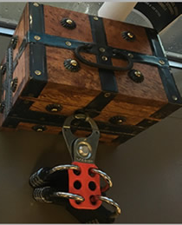
Props needed for the current missions (adapt as necessary if some of these are not available).
• Lockable chest; lock hasp, which can be used to add four “4-digit padlocks” (note: it’s a good idea to put a different coloured sticker on each one if possible).

GENERIC Pre-Class Preparation
• Prepare the “Final Mission” as listed later in this document; put this into the lockable chest; lock the chest with four “4-digit padlocks” set to the timeline dates overleaf.
• Print out the missions (these are on slips that need to be cut) and hide these around the room in the suggested places.
▪ Print off a second copy of the missions for teacher reference.
• Print out the essential sources (those used to complete the missions and those needed to answer the hint questions) and place these all over the room in various places.
• Print out the timeline ready ready to read out as ‘rewards’ for completing missions.
• Print out the additional sources (which are not essential but generate more interest and provide more information) and place these around the room too.
• Print out the hint questions and keep these to one side for later in the activity if they are needed.

Scenario (available as a powerpoint starter slide)
• Show the powerpoint slide and then talk through it.

Timeline of key events
• Each time a mission is completed, READ OUT another piece of the timeline.
▪ ALL students should make notes of this, because the padlocks are set to key dates in this timeline and the clues will be given at the end and only nominated students will be able to try unlocking a padlock each time.
• When the final mission is completed, tell students that to unlock the four padlocks they must provide four dates (highlighted here).

Slip 1  (note to teacher – blue padlock) | 1917 | The Russian Revolution  The Communists seize power and pull Russia out of the war against Germany. Lenin was smuggled into Russia in a German train. Churchill describes him as a "plague virus"
Slip 2 | 1918 | Russian Civil War  Following the defeat of Germany, troops are sent by Britain, France and USA into Russia in an unsuccessful attempt to overthrow the communists. Winston Churchill says "Communism must be strangled in its cradle"
Slip 3 | 1919 | Comintern Established  Lenin sets up the Comintern ("Communist International") designed to undermine capitalist governments in the West to create a "World Revolution" of communism.
Slip 4  (note to teacher – red padlock) | 1920 | League of Nations  Britain and France refuse to allow the USSR to join the new League of Nations; the USSR denounces the League as a “club for capitalists”.
Slip 5 | 1924 | Zinoviev Letter  UK breaks off diplomatic relations with USSR after finding a letter suggesting the Comintern is organising a communist revolution in the UK. The letter later proves to be a forgery.
Slip 6 | 1928 | The Five-Year-Plans  Stalin, the USSR's leader, starts modernising the country: "We are 50 to 100 years behind the West…either we make good the difference in 10 years, or they crush us"
Slip 7  (note to teacher – green padlock) | 1934 | The Great Purges  Stalin begins exterminating rivals within and outside of his party in a horrifying show of bloodletting. Up to 20 million Russians are tortured and executed.
Slip 8 | 1938 | Munich Conference  The USSR is not invited, and Britain and France give the Sudetenland over to Hitler: even though the USSR is an ally of Czechoslovakia! The USSR now gives up on the West and turns its attention to reaching a deal with Hitler.
Slip 9 | 1939 | Nazi-Soviet Pact  Molotov replaces Litvinov, the USSR’s Jewish foreign minister. Then, the USSR signs an alliance with Germany. Days later, they invade Poland from opposite directions and carve it up between themselves. World War Two begins.
Slip 10  (note to teacher – yellow padlock) | 1940 | The Baltic Campaigns  Stalin invaded the Baltic States (Lithuania, Latvia, Estonia) and absorbed them into the Soviet Union.

Missions (i.e. questions!)
TEACHER NOTE 1: Completing ten of these, using the sources around the room to find the answers, will lead to the completion of the timeline and thereby gain access to the “final mission”. You can create more than 10 though if you wish, so there is some flexibility for students in terms of finding / completing missions).
TEACHER NOTE 2: The “Location of this mission slip” is for teacher reference – and will need be adjusted to the layout of, and materials in, your particular classroom.

Mission Slips (cut out the cells in this column and hide them in the place described) | Answer | Location of this mission slip | Location Hint (if you wish to give them a clue as they run out of momentum)
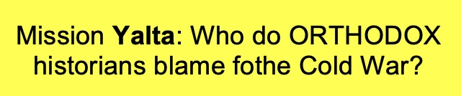 | Stalin / USSR | Under the classroom whiteboard eraser | Cleaning the board might help you find this mission.
Mission Potsdam: In the cartoon about the wartime alliance of the USSR and the USA, what is (cupid) Hitler called? | “The common danger” | Above the classroom clock. | Finding this mission is just a question of time.
Mission Teheran: Where exactly in London was there a propaganda piece Saying the USSR and the US was US (and even U!) | Trafalgar Square | On the ceiling | You’ll need to aim high to find this mission slip.
Mission Moscow: In the notorous ‘percentages agreement’ between Churchill and Stalin, how much of Greece was promised to Stalin? | 10% | Inside a locked security box | The key to unlocking this mission is rubbish
Mission Roosevelt: According to the infographic, when and where did the largest nuclear test in history take place? | 1961, USSR | Under a table | You’ll need to look upwards to find this mission slip.
Mission Stalin: Polish land each of which “line” was annexed by Russia after 1945? | Curzon | Behind the classroom window blinds | You’d have to be blind to find this mission.
Mission Churchill: Whose honeymoon does the cartoonist think probably won’t last long? | Hitler and Stalin’s | Under the computer mouse of the teacher’s computer | A mouse has got hold of this mission slip
Mission Truman: In which country did President Truman serve during World War One? | France | Inside a relevant textbook left around the room with the sources | You’ll have to read carefully to find this mission slip.
Mission Molotov: Which clothing company produced an advert describing Yalta as “the first modern conference”? | Diesel | ??? (decide for yourself based on your classroom!)
Mission Kennan: Who opened the Yalta Conference by stating “I propose a toast to the frankness of the three-power alliance”? | Stalin | ??? (decide for yourself based on your classroom!)

TEACHER NOTE: for various other ideas about how you can encode the missions, or creative ways of hding them around your room to add extra interest (e.g. using Mexican code wheels, ultraviolet pens and so on!) consult www.activehistory.co.uk/escape_room.

Hint Questions (OPTIONAL)

TEACHER NOTE 1: At any point during the last 15 minutes of the activity, students can ask for a hint to help them locate one of the remaining missions. To obtain a hint, they first have to answer a question correctly.
TEACHER NOTE 1: These questions can all be answered using the sources in the room. It’s a good way of keeping the activity moving as the number of remaining missions dwindles.

Question | Answer
Who was the first leader of the Soviet Union? | Lenin
What was President Roosevelt’s first name? | Franklin
Provide ONE of Winston Churchill’s middle names | Leonard, Spencer
What operation name was given to Hitler’s invasion of Russia? | Barbarossa
Name TWO countries which were divided into capitalist and communist zones after WW2 | Germany, Korea, Vietnam
Who took over as US President after the death of President Roosevelt in 1945? | Truman
What were the two Japanese cities targeted by atomic bombs by the USA at the end of WW2? | Hiroshima, Nagasaki
Who was King of England at the end of World War Two? | George VI

Final mission: The TIME MACHINE OPERATOR telephone number

057*?&90+0

* = Final digit of the year in which World War One ended

? = Number of atomic bombs dropped on Japan in 1945

& = Number of letters in Churchill’s last name

+ = Number of letters in Truman’s first name

- Once you have decoded the number, you should ring it!
- You will be asked three security questions to test your historical knowledge.
- If you answer all three successfully, you will be rescued.
- If not, the phone will be put down and it will not be answered again for another five minutes: at which point three fresh questions may be asked…

Teacher note
The idea of this fun ‘final mission’ is that the students have to decode a phone number and ring it. If they do so, the teacher at the end of the line will ask three security questions before coming into the room to “free” them!
Obviously this can only be used if you’re happy sharing a phone number. So if not, simply put a key in the box instead and the simple act of opening the box and obtaining the key represents their “successful escape”.

Reference:
* = Final digit of the year in which World War One ended [8]
? = Number of atomic bombs dropped on Japan in 1945 [2]
& = Number of letters in Churchill’s last name [7]
+ = Number of letters in Truman’s first name [5]

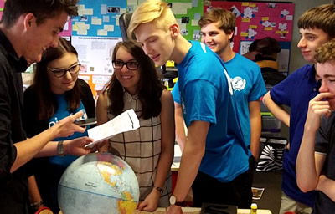

Questions for teacher to ask students if they call the number
• Who was the author of the “Communist Manifesto”? Karl Marx
• What city was closest to the city of Potsdam? Berlin
• Clement Attlee replaced which British leader half way through the Potsdam conference? Churchill

(teacher note – adjust to your own classroom).
(teacher note – put the key under the classroom bin).

