Theory of Knowledge in History: Introduction

A. Why is history so important to society?
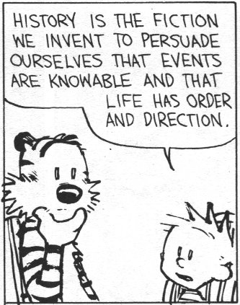
▪ History is to society what memory is to the individual.
▪ An individual without memory finds the world confusing; a society with no sense of history is unaware where it has come from or where it is going.
▪ Historians provide society with:
▪ A sense of identity
▪ An understanding of the world as it is today
▪ Lessons in right and wrong
• Because the world never stands still, the historian’s job is never finished: each generation will revisit and rewrite history with fresh questions and come up with fresh answers based on its particular preoccupations.

B. How is History produced?
▪ "History" is not "What happened in the past" or even "The surviving evidence of what happened in the past".
• It means "What historians choose to interpret from the surviving evidence of the past"

• To reduce this to a formula, we might say:

Sources (‘Facts’) + Historians (‘Opinions’) = Histories

▪ So it is important to consider what the nature of the surviving evidence is, and how historians then choose to select and present it.

In these three TOK sessions, we will therefore investigate three ways in which we gain a "knowledge" of History:

 | Main Question | Subquestion
a. The Sources: | What are the limitations of the surviving evidence? | Is History a science (based on facts)?
b. The Historians: | What are the limitations of the historians using that evidence? | Is History an art (based on opinions)?
c. The Histories: | What, therefore, are the limitations of the histories produced? | Is History a humanity (a blend of science and art?)

Task 3: "The past is not dead; it is not even the past"
Your teacher will now explain (through reference to the solar system) the meaning of this quote. Summarise the essential argument here.

Theory of Knowledge in History
Sources + Historians = Histories

Introduction
The first way in which we gain knowledge of the past is through historical evidence ("sources"). Two questions raise themselves:
a. How can we extract knowledge from the sources?
b. How useful is the knowledge that we extract in this way?

A. How can we extract knowledge from the sources?

1/3: Quantity: How complete is the historical record? – Teacher Examples
• For Medieval historians, one problem is that there aren't enough sources.
• For Modern historians, one problem is that there are too many sources.
• For all historians, the main problem is that all surviving sources are, by definition, untypical.
• Every historical record is incomplete because important sources have been lost or destroyed.

2/3: Quality: How trustworthy is the historical record? – Video / Powerpoint Slides
• Another problem is that the sources which do survive are not only rather unrepresentative and uninformed, but are often deliberately misleading.
• To assess reliability, Historians use what I summarise as PACT:
Purpose  Why was the source produced? | Author  Do we know anything about the person who produced the source?
Context  Is the evidence backed up by what we know from other sources? | Tone  Is the source dry and factual (=reliable) or emotional and opinionated (=unreliable)?

Task 1: Complete this table through class discussion

Image from the Bayeux Tapestry | Point it illustrates
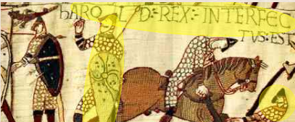 | Incomplete:
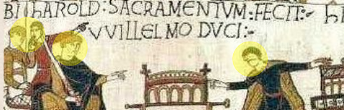 | Untrustworthy:

Task 2
Make extra notes about the strengths and limitations of photographs as historical evidence from the online presentation (www.activehistory.co.uk/l/tok3)

Problem 1 = | Problem 2 =
Problem 3 = | Problem 4 =

3/3: Clarity: How comprehensible is the historical record? ("The Humpty Factor")
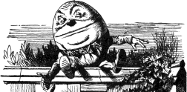 | "When I use a word," Humpty Dumpty said, in rather a scornful tone, "it means just what I choose it to mean - neither more nor less."  "The question is," said Alice, "whether you can make words mean so many different things."  "The question is," said Humpty Dumpty, "which is to be master - that's all."  - Alice in Wonderland, Chapter 6

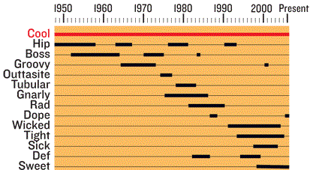
Deficiencies in the quality and quantity of the historical record are compounded by the fact that language itself changes over time: not only do new words appear and old ones fall from use, but (more confusingly) surviving words change or even invert their meaning (see image to right – what does it show?)

This is illustrated to comic effect in the sketch by Armstrong and Miller in which the comedy is generated by the ludicrous juxtaposition of World War Two pilots using modern slang (http://activehistory.co.uk/l/tok1 - 2m).

• This criticism of language itself strikes at the very heart of the historical process: if we cannot even fully understand the words being used, how can we begin to decide how complete and trustworthy they are?
• To take some examples, the current use of words such as "incredible", "gay" and "awful" are very different to how they were used just a few generations ago.
• Other words, such as "democracy" and "socialism" have been interpreted in so many different ways by so many different regimes that they have lost all real meaning.
• The fact is compounded whenever historians have to translate sources from other languages.

• The debate about whether historical sources can ever bring us closer to a "true understanding of the past" can be summarised as follows:

"Sources CAN be used to reconstruct the past" | Historicism  (late 19thC) | Empiricism (History as a science)  "Historical sources can provide an accurate and complete vision of the past". | Leopold von Ranke pioneered a scientific approach to the study of history based on the objective analysis of primary sources. He hoped to show History "as it really was". | 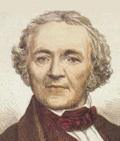
"Sources CANNOT be used to reconstruct the past" | Postmodernism  (late 20thC) | Philology (History as an art)  "Historical sources are too incomplete, biased and incomprehensible to serve any useful purpose". | Foucault argued that because historical sources are biased, incomplete, and language itself has no fixed meaning, the past will always be essentially unknowable. | 

Task 2: The Postmodernist Point Illustrated
You will now be shown a short comedy clip about The Great Train Robbery by Peter Cook (one of the greatest masters of wordplay). Whilst watching the sketch, complete this table.

Word | Meaning of this word according to the interviewer | Meaning of this word according to the interviewee
Train Robbery
Responsible
Appreciate
Behind
Pieced together

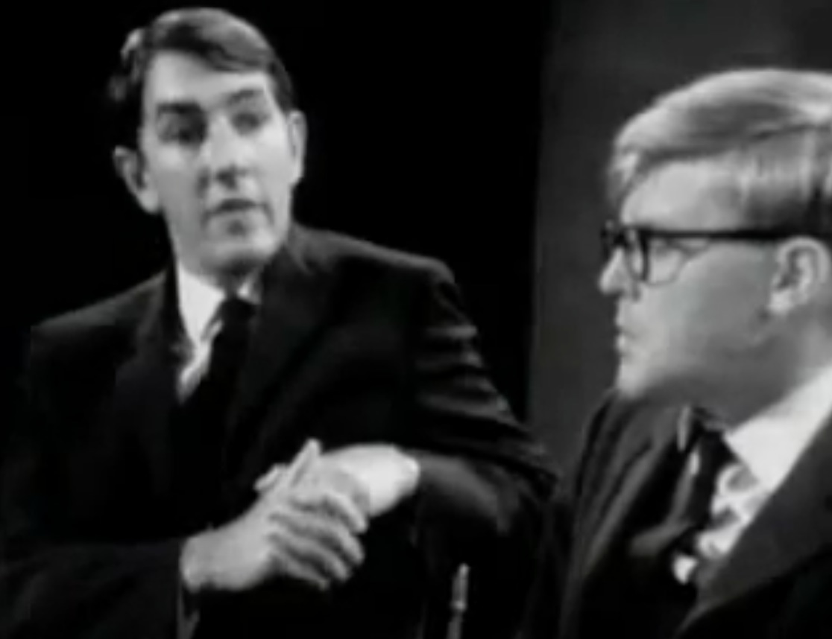
Video Link for the “Great Train Robbery” Sketch (5m)
www.activehistory.co.uk/l/tok2

