Theory of Knowledge in History: Introduction

A. Why is history so important to society?
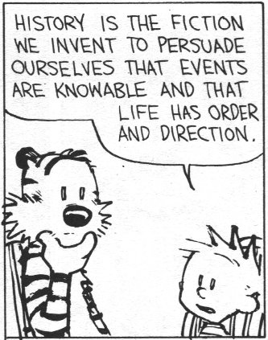
▪ History is to society what memory is to the individual.
▪ An individual without memory finds the world confusing; a society with no sense of history is unaware where it has come from or where it is going.
▪ Historians provide society with:
▪ A sense of identity
▪ An understanding of the world as it is today
▪ Lessons in right and wrong
• Because the world never stands still, the historian’s job is never finished: each generation will revisit and rewrite history with fresh questions and come up with fresh answers based on its particular preoccupations.

B. How is History produced?
▪ "History" is not "What happened in the past" or even "The surviving evidence of what happened in the past".
• It means "What historians choose to interpret from the surviving evidence of the past"
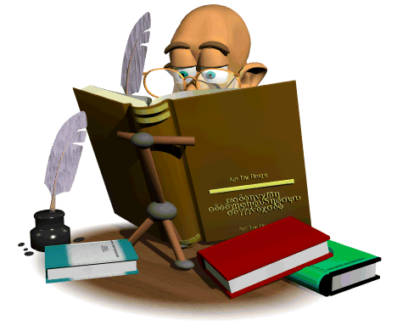
• To reduce this to a formula, we might say:

Sources (‘Facts’) + Historians (‘Opinions’) = Histories

▪ So it is important to consider what the nature of the surviving evidence is, and how historians then choose to select and present it.

In these three TOK sessions, we will therefore investigate three ways in which we gain a "knowledge" of History:

 | Main Question | Subquestion
a. The Sources: | What are the limitations of the surviving evidence? | Is History a science (based on facts)?
b. The Historians: | What are the limitations of the historians using that evidence? | Is History an art (based on opinions)?
c. The Histories: | What, therefore, are the limitations of the histories produced? | Is History a humanity (a blend of science and art?)

Task 3: "The past is not dead; it is not even the past"
Your teacher will now explain (through reference to the solar system) the meaning of this quote. Summarise the essential argument here.

The stars are described in terms of how many "light years" they are away. In other words, how long in takes the light from those stars to reach us; in other words, when we look at a star which is 25 light years away, we are looking at it as it was 25 years ago. When we then turn our eyes a fraction to a dimmer star maybe 100 light years away, we are looking into the past 100 years. If that star exploded into a supernova 99 years ago, we would start watching this happen next year. By the same logic, a planet circling a star 1000 light
years away might have the technology to film what is going on in earth. But if they are doing that right now, they would not see us, but rather our ancestors from 1000 years ago. Maybe even the Battle of Hastings is being filmed at this very moment by alien life forms!

Theory of Knowledge in History
Sources + Historians = Histories

Introduction
The first way in which we gain knowledge of the past is through historical evidence ("sources"). Two questions raise themselves:
a. How can we extract knowledge from the sources?
b. How useful is the knowledge that we extract in this way?

A. How can we extract knowledge from the sources?

1/3: Quantity: How complete is the historical record? – Teacher Examples
• For Medieval historians, one problem is that there aren't enough sources.
• For Modern historians, one problem is that there are too many sources.
• For all historians, the main problem is that all surviving sources are, by definition, untypical.
• Every historical record is incomplete because important sources have been lost or destroyed.

2/3: Quality: How trustworthy is the historical record? – Video / Powerpoint Slides
• Another problem is that the sources which do survive are not only rather unrepresentative and uninformed, but are often deliberately misleading.
• To assess reliability, Historians use what I summarise as PACT:
Purpose  Why was the source produced? | Author  Do we know anything about the person who produced the source?
Context  Is the evidence backed up by what we know from other sources? | Tone  Is the source dry and factual (=reliable) or emotional and opinionated (=unreliable)?

Task 1: Complete this table through class discussion

Image from the Bayeux Tapestry | Point it illustrates
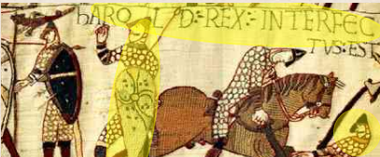 | Incomplete:  We don't actually know what happened to Harold.  This is the only source which suggests he was shot in the eye.  Any other sources making reference to this have got the story from the tapestry itself.
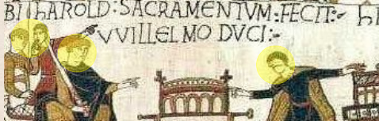 | Untrustworthy:  This source shows Harold swearing to support Duke William's claim to the throne in 1064.  But we don't know why Harold was in Normandy, and neither do we know if he really made this vow, or why.

