Theory of Knowledge in History
Sources + Historians = Histories

Recap: The problem of Sources
• Sources are incomplete, untypical and unreliable, as we found out in our last session.
• Moreover, sources in themselves provide nothing other than a pointless list of dates, names and places: ‘knowledge’ of the most basic kind.

Today’s focus: The role of the Historian
• True ‘Historical’ knowledge requires the intervention of the Historian, who will:
• Decide what questions need answering, often determined by current affairs
▪ Select sources to use, based on what questions need answering
▪ Interpret those sources and make deductions from them;
▪ Organise and present their main conclusions to the public.

All of this sounds scientific, but overlooks the fact that good historians are opinionated individuals who don’t come to the sources with an open mind but rather with the intention of arguing a particular case before they even begin. History is therefore an endless process of debate, discussion, reassessment based around conflicting interpretations.

Key question: How does this definition of ‘knowledge’ in history compare to that in other subjects? Is it even ‘knowledge’ at all?

Case Study of History as Persuasion: 1. History in the Newspapers
· The most powerful of all sources through which citizens obtain their knowledge is perhaps the daily media. Each of these newspapers covered the same historic event, but can you spot how they differ? Highlight one newspaper which is interpreting the historical record in Thatcher’s favour, and one which interprets the historical record show her in a negative light.

Margaret Thatcher
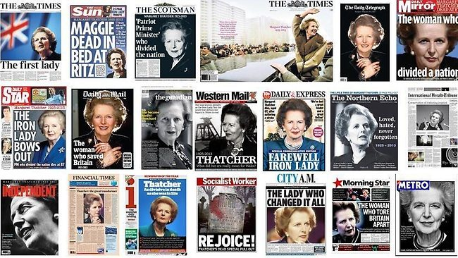
Discussion points:
Why do people’s judgements of Thatcher in particular differ so sharply?
She was a conviction politician on the right of British politics whose policies continue to divide opinion strongly. Newspapers reflect this.

Method 1: Oversimplifying issues

“The World at War: Hitler’s Foreign Policy”
▪ The example you have just seen could be dismissed as being rather extreme; however very well-respected documentaries arguably do much the same thing, as this video shows everything relating to Hitler has to have a nefarious purpose, and Eva Braun is described habitually as his ‘mistress’ for no discernable reason).
www.activehistory.co.uk/l/worldatwar_hitler

Other Examples
Those wishing to pursue or accelerate change will use history to stress how such developments are a long-term trend - nothing to be worried about. | Nazism (“Third Reich”)  Hitler deliberately presented his regime as a “Third” Empire after that of Charlemagne and the Kaisers to stress a sense of continuity.
Those wishing to avoid or delay change will use history to stress how such developments are dangerously radical departures from tradition. | Royalism (‘Windsor’ family name)  The real name of the Royal family was Saxe-Coburg-Gotha. It was changed after ideas were brainstormed for a new name in the royal circle. It was never changed, even when the Queen took the throne and married a Greek (named Mountbatten). Hence – when will the royal family name ever change again?!

