Theory of Knowledge in History
The "Why?" of History: Causation

Introduction
▪ In theory, History should be 'knowable'. Historians should be able to use the sources to tell us 'what happened'.
▪ In reality, History is not 'knowable' in this way. Historians must select and interpret the sources, which themselves are incomplete and unreliable.
▪ Moreover, the most important job of the historian is not to tell us 'what' happened, but rather 'why': only in this way can we hope to make sense of the present and prepare for the future.
• So in this session we will investigate how different “schools of history” (groups of historians) have sought to explain the nature of historical change.

Outcome
• At the end of the session you will then decide on whether you are a Whig Historian, a Marxist Historian, or an Annales Historian: which broadly boils down to the (big!) philosophical question of how far you believe in fate (determinism) rather than free will.

Starter Task
Have a read through each of these quotes. Which one do you agree with most?
1. “Man is a being with free will; therefore, each man is potentially good or evil, and it's up to him and only him (through his reasoning mind) to decide which he wants to be.” - Ayn Rand

2. “If you believe in free will you do not believe in causation. If you have no appreciation of causation, you are nothing more than a dumb animal” – Anon.

3. “You must believe in free will; there is no choice” - Isaac Bashevis Singer

4. "We like to forget that in fact everything in our life is chance, from our genesis out of the encounter of spermatozoon and egg onward." - Sigmund Freud

5. "A man can surely do what he wills to do, but cannot determine what he wills."
- Schopenhauer

6. "In the mind there is no absolute or free will; but the mind is determined to wish this or that by a cause, which has also been determined by another cause, and this last by another cause, and so on to infinity." - Baruch Spinoza
8. “Free will does not mean acting randomly, but choosing how to act. But the choices you make are determined by heredity and experience” – Roy Baumeister

8. "I am a determinist. ...The real issue, so far as the will is concerned, is not whether we can do what we choose to do, but whether we can choose our own choice" - Brand Blanshard

Causation in History – Why do things happen?

All history is contemporary history  (Croce) | History says more about the person writing it than about the people being written about (Carr).
History is a hard kernel of fact surrounded by a disputable pulp of opinion (Acton) | History is a hard kernel of opinion surrounded by a disputable selection of facts (Carr)

• Historians help us plan for the future by explaining the present through reference to the past.
• Identifying the causes of events enables us to decide how to deal with them.
• Every historical investigation therefore begins with the question: ‘Why?’

• HOWEVER…History is the flawed product of problematic sources, selected and interpreted by historians with their own values and preoccupations.
• THEREFORE…historians answer the question ‘Why?’ in different ways, based on the questions they ask, the evidence they work with, and the conclusions they draw from it.

• These works of history in turn become sources for later historians (historians who chart how historians have reinterpreted the past are called “historiographers”).

The Sad Case of Billy Elliot, Part 1
Read through the following account as a class, then answer the questions which follow.


Billy Elliot (35) finished his last can of super-strength beer and reflected on his predicament. He had been unemployed since the last coal pit in his area closed down a few years earlier after Margaret Thatcher shut them down claiming that they were no longer profitable and that the unions were ‘holding the country to ransom’. Like his father before him, he had taken to drink. Just recently, his wife had left him after finding out about the fling he'd had with Tasha Slappa down the road at a mate's party. He told his wife that the summer heat had made him drink too much, but she told him to shove it and ended the relationship.
He decided to get another 6-pack from the local off-licence. The government had recently cut back on unemployment benefits, but the bloke behind the counter, Akaash, had promised him a discount for being such a good customer lately. So, he grabbed his coat and put his shoes on.
Just as he was leaving, his mother rang up to give him some family news. He had a quick chat with her, then left the house. As he strolled down the road, a boy came round the corner on a bicycle in a panic. Billy, who was still reflecting on what his mother had told him, was taken by surprise and leapt into the road.
Sadly for Billy, a steam roller was passing at just this moment, resurfacing the road after it had buckled in the hot summer weather. The driver was still tired because his baby had been crying all night and so he didn't see Billy. As a result, Billy was squelched into the shape of a pancake.

Questions: The Inquest into Billy's Death
1. What factor would you pick out as being the most important causes of the tragedy?

2. What one further question could you ask to deepen your understanding about the tragedy?

3. Here are three verdicts on the death of Billy Elliot. Take a class vote on which verdict you each find most convincing. Each person has two votes: raise both hands for your top choice; one had for your second choice. Record the totals for each verdict in column [c].
A | B | C | D
‘Death by Free Will’. | Billy's death was a freak accident that has no meaningful cause
‘Death by Marxist Dialectic’. | Billy was a sad victim of economic forces
‘Death by Determinism’. | Billy was the victim of an inevitable chain of circumstance traceable right back to climate and geography

4. Discussion Point - Are any other verdicts possible in this case (e.g. death by feminism...)?

The Historiographical View of Causation
You will now learn a bit more about how historians have approached the thorny issue of causation. Complete the final box in each row by making notes from the teacher seminar (www.activehistory.co.uk/p/annales).

Whig Historians | Great Men | Short Term Factors | Where have we come from? | Peaceful, evolutionary progress | Suggested Clip: AJP Taylor on WW1 Origins  http://www.youtube.com/watch?v=CqT2kmKPqeM
Marxist Historians | Economics | Mid-Term | Where are we going? | Violent, revolutionary progress
  Suggested Clip: Mark Steel on Marxism
  http://www.youtube.com/watch?v=g5_yppUbRd0 (focuses on difficulty of people to spot gradual change)
Annales Historians | Geography | Long-Term | Are we going anywhere? | Question whole notion of progress
  Suggested image: “man on the moon” diary entry (www.activehistory.co.uk/l/moon)

Billy Elliot – The Alternative Version, Part 2
• Take a second vote on the death of Billy Elliot and record your findings in column [d] on the previous page. You should be able to spot how each of the three verdicts broadly matches each of these historiographical schools of thought!

Case study in causation: Why was the Berlin Wall built?

At the end of World War Two, the wartime Allies (France, Britain, USA, USSR) divided Germany into four zones and took control of one each. Berlin was deep inside the Soviet zone of occupation. However, due to its special status, it too was divided into four zones. This created a bizarre situation where the Western Allies had to travel far into Soviet territory to reach their zones of Berlin.
As Cold War rivalries between East and West began to emerge, this became a source of friction. The Soviet dictator Stalin was embarrassed when tens of thousands of East Europeans behind the “Iron Curtain” crossed the open border into West Berlin, and then flew to freedom. This ‘brain drain’ accelerated when the USA poured millions of dollars into Western Europe in the “Marshall Aid” Recovery Programme.
Two crises over Berlin almost sparked World War Three. Firstly, in 1949, the Western Allies introduced a joint currency into their three zones in Germany and in Berlin. Stalin saw this as the first move towards creating a unified West German state. So he blocked all road and rail routes into West Berlin, creating a siege. The allies organised the “Berlin Airlift”, flying in supply planes one ever three minutes for the next nine months, correctly guessing that Stalin would back down rather than risk war by shooting them down.
The second crisis came in 1961. By now Stalin was dead and had been succeeded by Nikita Khrushchev, a bombastic character who described Berlin as “The testicles of the West: every time I want the West to scream, I squeeze on Berlin!”. The new US President, John F. Kennedy, was young and inexperienced so Khrushchev authorised the leader of East Germany, Walter Ulbricht, to build a wall around West Berlin to stop the “brain drain” crippling the economy. JFK later visited Berlin to declare “Ich bin ein Berliner!”, but privately declared that “A wall is a hell of a lot better than a war”.
Overnight on August 13th 1961 the plan was executed. Barbed wire was placed around the perimeter of West Berlin by armed soldiers. It was now impossible for East Berliners to go to West Berlin without special permission, so families were split apart. In the weeks that followed, the wire was replaced by a concrete wall with tightly controlled checkpoints (the most famous of which was situated in the city center – Checkpoint Charlie). Berlin was now divided and would remain so for almost 30 years.

Task 1: Why was the Wall built?
Read carefully through the above account. Working alone or with a partner, identify the political, economic and geographical causes for the building of the Berlin Wall which reflect the “Annales” approach to “Total History”. Add notes in the appropriate column of the table below.

Task 2: Why did the Wall fall?
Following this you will watch a 10m video clip (www.activehistory.co.uk/v/265626056) about the fall of The Wall. As you watch, consider which of the three “schools” of history it seems to support most by making notes in the final column of the table.

 |  |  | Why was the wall BUILT? | Why did the wall FALL?
Short term  “Whig” Theory | Political, personal,  accidental | History
Mid term  “Marxist” theory | Economic, financial | Business
Long term  “Annales” theory | Physical, geographical | Geography

Case study in causation: Why does the USA have such a serious race problem?

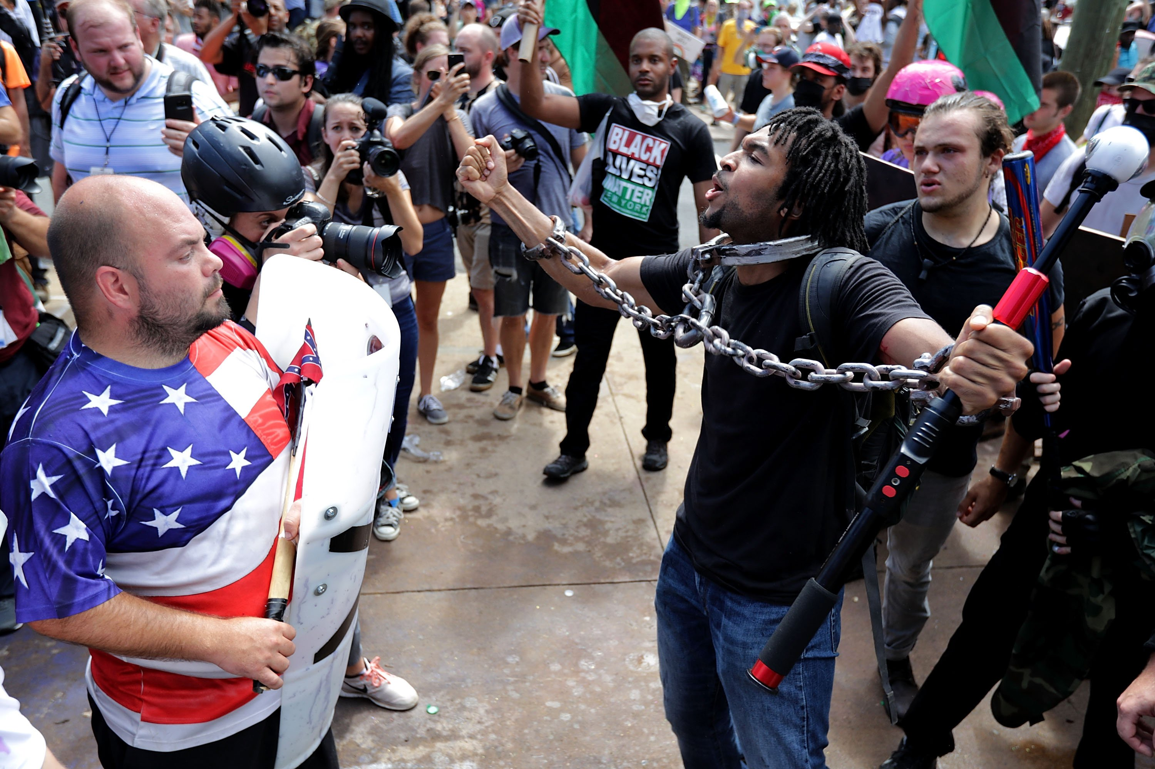

Video Task
Watch the 10m video clip (www.activehistory.co.uk/v/117626056). As you watch, consider which of the three “schools” of history it seems to support most by making notes in this table:

Short term  “Whig” Theory | Political, personal,  accidental | History
Mid term  “Marxist” theory | Economic, financial | Business
Long term  “Annales” theory | Physical, geographical | Geography

Extension Material: The Philosophical View of Causation
• The three positions you have learned about are sandwiched between two extremes which reject the idea that human beings can influence the world around them in any meaningful way, whether they try to learn from the past or not.

Task
Read through the two extreme positions below, and then complete the question which follows.

(a) Accidentalism – the idea that everything is simply down to chance events over which we have no real control.
Example: Stalin rose to power in the USSR because Trotsky, his key rival, didn’t mount an effective challenge. The reason for this is that Trotsky had malaria at the time of the struggle for power. Therefore, Stalin’s Russia – including the Purges of 20 million people and the defeat of Hitler in WW2 thanks to Stalin’s policies – would not have happened had it not been for a mosquito.

Key Quote: ‘Nothing is inevitable until it happens’ (AJP Taylor).
Detail: This is known as the ‘Cleopatra's Nose’ theory after the French historian Pascal, who attributed the development of the Roman Empire to the failure of Mark Anthony to defeat the Romans in battle, because he was infatuated with Cleopatra, and in particular her distinctive nose. Similarly, a well respected historian such as AJP Taylor made a whole career making statements such as ‘World War One was the result of bad railway timetables’; again, the division of the Christian Church into Protestant and Catholic can be pinned on the revolt of Martin Luther against the Pope, and Luther himself only became a monk after pledging to devote his life to God after being caught unexpectedly in a terrifying thunderstorm. According to this interpretation, the Northern Ireland Conflict was caused by a thunderstorm in 1517.

(b) Determinism – the idea that everything is the inescapable result of what went before.
Example: The French Revolution occurred because King Louis refused to give power to Parliament, because he thought he was appointed by God, because that is what the Bible said, because that is God’s will. Therefore, he was killed because it was God’s will.

Key Quote: ‘What we call chaos is just patterns we haven't recognized. What we call random is just patterns we cant decipher. There is no free will. There are no variables. There is only the inevitable.’ – Chuck Palahniuck

Detail: Although individuals think they have freedom of action, this is only because they are ignorant of how the various forces acting upon them (climate, society, family, upbringing, previous experience, genetics, and so on) have led them to make decisions. A man on a raft in the middle of the Atlantic ocean may congratulate himself on having the free will to paddle this way or that – or not to paddle at all. His ripples, however, make no impact upon the waves and the tides he remains at the mercy of.

Question
Can you formulate a theory about causation that you think both schools of historians would be happy to accept?
Record your synthesis here. Your teacher will share a conclusion later.

Gaining Knowledge through counterfactual history

▪ Counterfactual history can be described instead as the “What if…?” approach. For example:
▪ What if Germany’s Schlieffen Plan had succeeded in 1914?
▪ What if Hitler had been killed during the Munich Putsch of 1923?
▪ What if the Wall Street Crash didn’t happen in 1929?
▪ What if the Nazis had developed the nuclear bomb before the allies?
▪ What if Khrushchev had refused to remove nuclear missiles from Cuba?

▪ Some historians have dismissed counterfactual history as a parlour game with no serious use to the historians genuinely aiming to acquire knowledge and understanding – after all, it means dealing in hypotheses which can never be proven.

▪ However, counterfactual history in fact serves a very valuable purpose in testing how cogent historical explanations are – as long as the hypothetical situations are feasible and realistic. For example, take an analysis of what caused the First World War and reflect on the new questions which then arise as a result:

 | Theory | Historian | Possible question | Possible insights
Whig Historian | The war was caused by the assassination of Franz Ferdinand. | Taylor | “What if Franz Ferdinand had survived the assassination attempt of 1914?” | ▪ Austria would have had no excuse for war with Serbia  ▪ BUT – couldn’t they have found another excuse sooner or later?  ▪ SO – did the assassination accelerate, or actually cause, the outbreak of the war?
Marxist Historian | The war was caused by capitalism – a struggle for colonies and resources that spilled into outright violence | Lenin | “What if the Euro had been invented in 1914?” | ▪ The bitterness of France’s loss of Alsace-Lorraine would have evaporated  ▪ BUT – the scramble for colonies was as much about prestige as economics  ▪ SO – should the issue of colonies be seen as an issue as much related to national prestige as economics?
Annales Historian | The war was caused by a Germany who was resource-rich, but landlocked and therefore threatened, frustrated and aggressive. | Fritz Fischer | “What if Germany had renewed the Reinsurance Treaty with Russia in 1892?” | ▪ Russia would not have formed an alliance with France, so Germany would not then have formed the Schlieffen Plan which sparked the war  ▪ BUT an alliance with Russia arguably would have made Germany even more aggressive, not less  ▪ SO – was Germany’s foreign policy caused by fear, or ambition, before 1914?

Read through the information on this page and then answer this question:
How would (a) An accidentalist and (b) A determinist explain the way in which your parents conceived you?!

“The further back you look, the further forward you are able to see” – Churchill.
Voltaire once said "Judge a man not by his answers, but his questions".
There are even some historians who study the development of historiography – but that’s when it starts getting really complicated – historians who study how historians have interpreted historians…!)
Although this example may seem a bit silly, you should bear in mind that every inquest and inquiry has to pass a judgement on causation, which determines where responsibility ultimately lies, which has massive implications for the individuals and authorities involved.

