Theory of Knowledge in History
The "Meaning" of History: Interpretations and Judgements

Recap: The problem of Sources
• Sources are incomplete, untypical and unreliable, as we found out in our last session.
• Moreover, sources in themselves provide nothing other than a pointless list of dates, names and places: ‘knowledge’ of the most basic kind.

Today’s focus: The role of the Historian
• True ‘Historical’ knowledge requires the intervention of the Historian, who will:
• Decide what questions need answering, often determined by current affairs
▪ Select sources to use, based on what questions need answering
▪ Interpret those sources and make deductions from them;
▪ Organise and present their main conclusions to the public.

All of this sounds scientific, but overlooks the fact that good historians are opinionated individuals who don’t come to the sources with an open mind but rather with the intention of arguing a particular case before they even begin. History is therefore an endless process of debate, discussion, reassessment based around conflicting interpretations.

Key question: How does this definition of ‘knowledge’ in history compare to that in other subjects? Is it even ‘knowledge’ at all?

Case Study of History as Persuasion: 1. History in the Newspapers
· The most powerful of all sources through which citizens obtain their knowledge is perhaps the daily media. Each of these newspapers covered the same historic event, but can you spot how they differ? Highlight one newspaper which is interpreting the historical record in Thatcher’s favour, and one which interprets the historical record show her in a negative light.

Margaret Thatcher
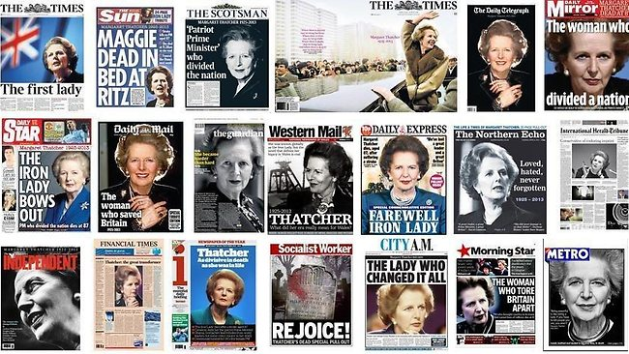
Discussion points:
Why do people’s judgements of Thatcher in particular differ so sharply?

Osama Bin Laden
Here’s another brilliant example of how documentary, headline ‘facts’ can quickly go out of date as circumstances change: Osama bin Laden presented in the late 1980s as an anti-Soviet crusader (Al Q’aeda was of course trained and equipped by the CIA on this basis):

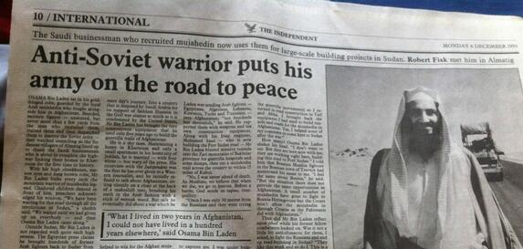

Case Study of History as Persuasion: 2. History in TV Documentaries

“The Day Today: World War Two”
· You will be shown a short video clip from a documentary about World War Two produced by the BBC in 1994 for use with Year 9 History students (www.activehistory.co.uk/l/daytoday).
· Use it to answer these questions prior to discussion.

▪ What did people have to eat due to the shortages of wartime?

▪ How did people deal with the lack of electricity during the ‘Blitz’ by German bombers?

▪ What was the famous “Hibernation Year” and why was it considered important?

Follow-up Questions
List here all the techniques used in this news report to give it a sense of authority.
What important point do you think that this clip makes about "Television History"?

Method 1: Oversimplifying issues

“The World at War: Hitler’s Foreign Policy”
▪ The example you have just seen could be dismissed as being rather extreme; however very well-respected documentaries arguably do much the same thing, as this video shows everything relating to Hitler has to have a nefarious purpose, and Eva Braun is described habitually as his ‘mistress’ for no discernable reason).
www.activehistory.co.uk/l/worldatwar_hitler

Other Examples
Those wishing to pursue or accelerate change will use history to stress how such developments are a long-term trend - nothing to be worried about. | Nazism (“Third Reich”)
Those wishing to avoid or delay change will use history to stress how such developments are dangerously radical departures from tradition. | Royalism (‘Windsor’ family name)

Method 2: Complicating Issues – Memorial Days
▪ Too little history is a bad thing; but so is too much. History can be used to keep wounds open, to perpetuate the mistakes and prejudices of the past rather than move on from them.
▪ There are now a whole range of “Memorial Days” on the calendar. They arguably create more confusion than they are worth.

Task: Discuss each of the following three memorial days, and take a class vote about the purpose of each one after discussion.

 |  | Possible Purpose 1 | Possible Purpose 2
Armistice Day | 11th November | To honour the war dead and admire the sacrifices they made for their countries | To pity the war dead and reflect on the utter futility of war
Holocaust Memorial Day | 27th January | To reflect on the suffering of all victims of racial persecution | To stress the unique suffering of Jews and therefore their right to be in Israel
Slavery Memorial Day | 25th March | To celebrate the abolition of slavery in the British Empire | To highlight the collective guilt of the British people for slavery

Extension Task: Can you find out WHY these memorials are held on those particular days?

Extension Materials: “Matchstick Wars” provides a great example of a PSHCE video from the 1980s from behind the Iron Curtain subtitled “Why Wars Happen”.
www.activehistory.co.uk/l/why_wars_happen

