Theory of Knowledge in History
The "What" of History: Sources

"The past is not dead; it is not even the past"

The stars are described in terms of how many "light years" they are away. In other words, how long in takes the light from those stars to reach us; in other words, when we look at a star which is 25 light years away, we are looking at it as it was 25 years ago. When we then turn our eyes a fraction to a dimmer star maybe 100 light years away, we are looking into the past 100 years. If that star exploded into a supernova 99 years ago, we would start watching this happen next year. By the same logic, a planet circling a star 1000 light years away might have the technology to film what is going on in earth. But if they are doing that right now, they would not see us, but rather our ancestors from 1000 years ago. Maybe even the Battle of Hastings is being filmed at this very moment by alien life forms!

You could end the anecdote about the stars by getting them to guess how many light years back hubble can see (ie, how many years back in time it can look): answer = 13 billion!!!

Image from the Bayeux Tapestry | Point it illustrates
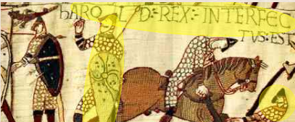 | Incomplete:  We don't actually know what happened to Harold.  This is the only source which suggests he was shot in the eye.  Any other sources making reference to this have got the story from the tapestry itself.
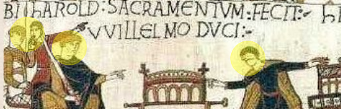 | Untrustworthy:  This source shows Harold swearing to support Duke William's claim to the throne in 1064.  But we don't know why Harold was in Normandy, and neither do we know if he really made this vow, or why.

NOTE:
After the Norman Conquest, the Anglo-Saxons became the underclass and reared the animals. The Normans were the rulers and ate the animals. This is why in English we have different words to describe the animal (Anglo-Saxon) and the meat which comes from it (Norman).

Name of ANIMAL |  | Name of MEAT
English  (from Anglo-Saxon) | Modern German | English  (from Norman) | Modern French
Cow | Kuh | Beef | Boeuf
Calf | Kalb | Veal | Veau
Swine | Schwein | Pork | Porc
Sheep | Schaf | Mutton | Mouton

