I Am a Bird Now • Antony and the Johnsons (2005)
IB HISTORY: ALBUM COVER DETECTIVE
Researched by: Your Name
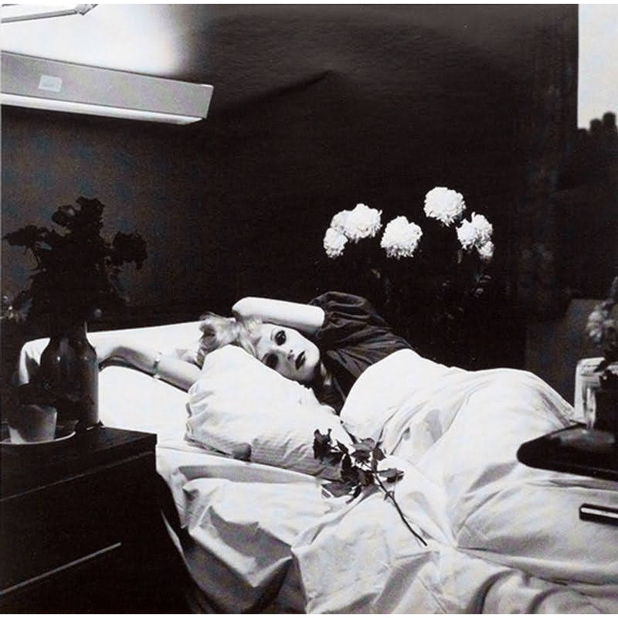 | THE HISTORY BEHIND THE COVER  IDENTIFY The title of this album is … by the band …  DATE It was released in …  WHAT I SEE The cover shows / appears to show …  THE DISCOVERY I discovered that the image actually shows …  ORIGINAL SOURCE The original image came from …  THE STORY The image was originally created / used for …  THE CONNECTION The reason this image was chosen for the album was …  WHY IT MATTERS The cover became famous / memorable because …  MY REACTION What I find most interesting about this story is …  MY OPINION The single track I would recommend listening to from this album is … because …

