The History of Face Masks

Introduction
• Since the COVID pandemic, face masks have become familiar to all of us.
• In this investigation, we will learn how face masks have been used throughout history, all over the world, for all sorts of weird and wonderful reasons.
• You might start this lesson by watching the short (4m) video clip about the history of surgical masks which can be found at www.activehistory.co.uk/masks.

Individual Task – Research one mask in detail
• Each student will be allocated one of the masks in the list that follows (this could be done using the random name picker here: https://www.classtools.net/random-name-picker/17_ALf2c7).
• Once you have been allocated a mask, you need to find an image of it and use it to complete the PowerPoint slide template provided by your teacher. This consists of two slides: the first is the name of your mask and an image of it; the second is where you provide an explanation about when and where it comes from, and why it was used.
• Print off your completed two slides on two sheets of paper when you are finished ready for the next task.

- “The Isolator” Mask
- 1918 Flu Mask
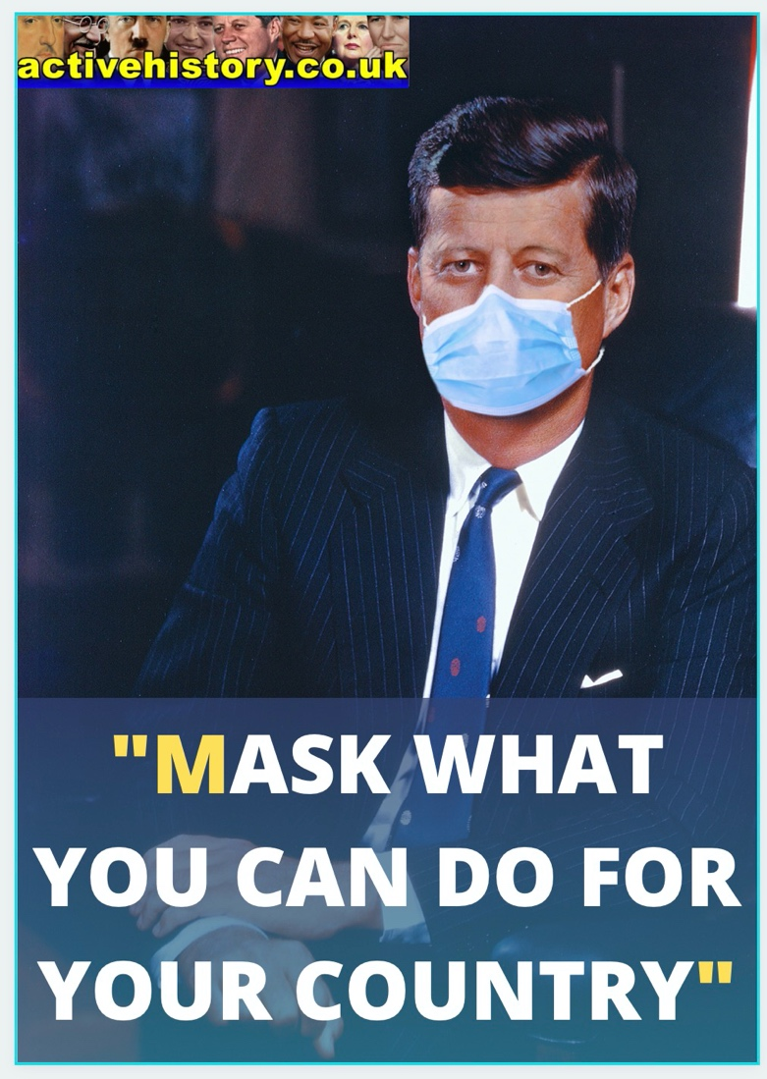
- African Tribal Masks
- Alexander Peden’s Mask
- Balaclavas
- Canadian Tsimshian Mask
- Carnival of Venice Masks
- COVID Masks
- Crosby Garrett Helmet
- Fastnacht Festival Masks
- Gas Masks
- Gold Mask Of Teres
- Greek Theatre Masks
- Guy Fawkes Masks
- Iroquois False Face Society Masks
- Japanese Noh Masks
- Kanaga Funeral Masks
- Korean Hahoetal Masks
- Kwakwaka’wakw Transformation Mask
- Life/Death Masks
- Lucha Libre Wrestling Masks
- Man In Iron Mask
- Mask Of Agamenmon
- Mask Of Tutankhamun
- Men-Yoroi Samurai Masks
- Nijmegen Helmet
- Pascola Masks
- Plague Masks
- Schandmaskes (“Shame Masks“)
- Scold’s Bridle / Branks Masks
- Slavery Iron Muzzle
- Turquoise Mask Of Xiuhtecuhtli
- Visards
- WW1 Splatter Mask

Group Task – Decide how to organise these masks for a classroom exhibition
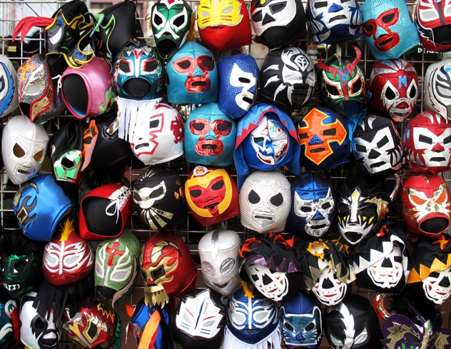
• The class will now be divided into groups of 6-8 people.
• Each group member needs their two PowerPoint slides printed off ready for discussion.
• The members of each group should place the ‘image’ slide from their presentation onto the table, then use the ‘explanation’ slide to outline where, when and why it was used (these must be read out, not placed on the table and copied).
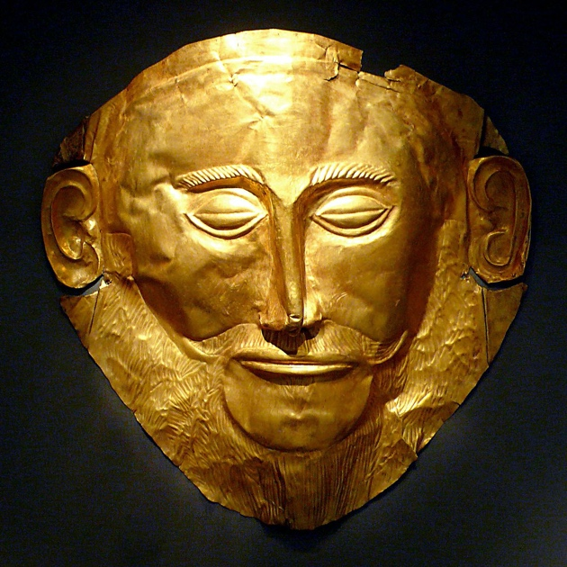
• NOTE: Everyone should take notes, because one student will later be chosen at random to summarise the group’s research!
• When the discussion is over, discuss as a group on how the masks you have learnt about could be categorised (e.g. in terms of time, place, purpose). Shift the ‘image’ slides around the table to help you do this.

• When this process is finished, your teacher will ask each group to present its findings: one member of each group may be nominated by the teacher to do this. As a class, you now need to decide how best to arrange your work (image and explanation slides) as a classroom exhibition. Use blu-tack to put your work up at first so it can be moved around if necessary; glue it down once you’re all happy with the arrangement.

Extension / Homework Task
1. Choose ten masks you personally found interesting (or ten facts about your allocated mask if you prefer) and use this to create a 3D Virtual Museum Exhibition here: www.classtools.net/3D.

2. Watch the 11-minute video about the history of masks which can be found at www.activehistory.co.uk/masks

