Anniversaries for Educators
September 2022 – August 2023

A calendar providing anniversaries for classroom discussion / assemblies for research, discussion, assemblies and personal projects!
To customize this calendar with additional anniversaries, visit: www.activehistory.co.uk/calendar
Russel Tarr, 2022

Disclaimer: all anniversaries have been selected purely at the discretion of the author

September 2022
Anniversaries for classroom discussion / assemblies |  | Find more anniversaries at www.activehistory.co.uk/calendar

Sunday | Monday | Tuesday | Wednesday | Thursday | Friday | Saturday
 |  |  |  | 1 | 2 | 3
4 | 5 | 6 | 7 | 8 | 9 | 10
 | 1972 - Munich massacre: A Palestinian terrorist group called "Black September" attacks and takes hostage 11 Israeli athletes at the Munich Olympic Games. Two die in the attack and nine are murdered the following day. (50 years ago today) | 1522 - The Victoria returns to Sanlúcar de Barrameda in Spain, the only surviving ship of Ferdinand Magellan's expedition and the first known ship to circumnavigate the world. (500 years ago today) | 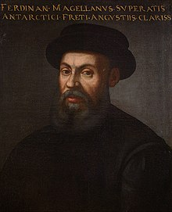
11 | 12 | 13 | 14 | 15 | 16 | 17
18 | 19 | 20 | 21 | 22 | 23 | 24
 |  |  | 1972 - Philippine President Ferdinand Marcos begins authoritarian rule by declaring martial law. (50 years ago today) |  |  | 1572 - Death of Túpac Amaru, last of the Incas (450 years ago today)
25 | 26 | 27 | 28 | 29 | 30

October 2022
Anniversaries for classroom discussion / assemblies |  | Find more anniversaries at www.activehistory.co.uk/calendar

Sunday | Monday | Tuesday | Wednesday | Thursday | Friday | Saturday
 |  |  |  |  |  | 1
2 | 3 | 4 | 5 | 6 | 7 | 8
 |  | 1822 - Birth of Rutherford B. Hayes, American general, lawyer, and politician, 19th President of the United States (d. 1893) (200 years ago today)
9 | 10 | 11 | 12 | 13 | 14 | 15
 | 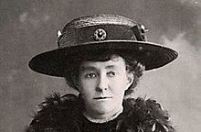 | 1872 - Birth of Emily Davison, English educator and activist (d. 1913) (150 years ago today) | 1872 - Birth of Ralph Vaughan Williams, English composer and educator (d. 1958) (150 years ago today) | 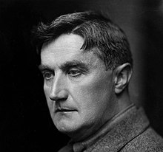
16 | 17 | 18 | 19 | 20 | 21 | 22
 |  | 1922 - The British Broadcasting Company is founded to provide a national  broadcasting service. (100 years ago today) | 1922 - British Conservative MPs vote to terminate the coalition government with the Liberal Party. (100 years ago today) |  | 1772 - Birth of Samuel Taylor Coleridge, English poet, philosopher, and critic (d. 1834) (250 years ago today)
23 | 24 | 25 | 26 | 27 | 28 | 29
1972 - Vietnam War: Operation Linebacker, a US bombing campaign against North Vietnam in response to its Easter Offensive, ends after five months. (50 years ago today) | 1972 - Death of Jackie Robinson, American baseball player and sportscaster (b. 1919) (50 years ago today) | 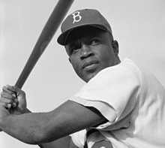 |  |  | 1922 - Italian fascists led by Benito Mussolini march on Rome and take over the Italian government. (100 years ago today) | 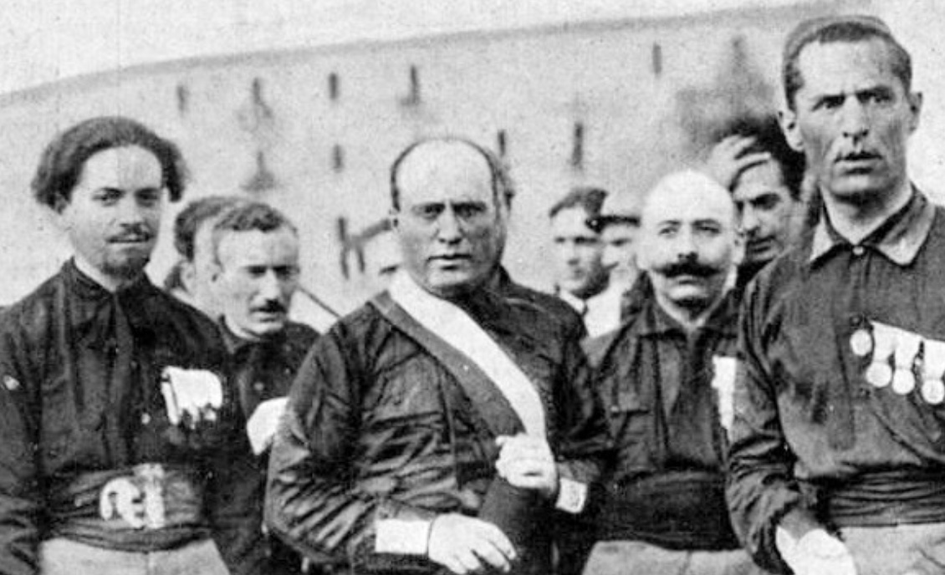
30 | 31

November 2022
Anniversaries for classroom discussion / assemblies |  | Find more anniversaries at www.activehistory.co.uk/calendar

Sunday | Monday | Tuesday | Wednesday | Thursday | Friday | Saturday
 |  | 1 | 2 | 3 | 4 | 5
 |  |  |  | 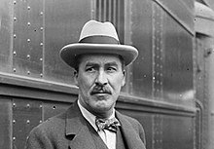 | 1922 - In Egypt, British archaeologist Howard Carter and his men find the entrance to Tutankhamun's tomb in the Valley of the Kings. (100 years ago today) | 1872 - Women's suffrage in the United States: In defiance of the law, suffragist Susan B. Anthony votes for the first time, and is later fined $100. (150 years ago today)
6 | 7 | 8 | 9 | 10 | 11 | 12
 | 1972 - US President Richard Nixon is re-elected President. (50 years ago today) | 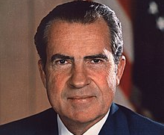 |  |  | 1922 - Birth of Kurt Vonnegut, American novelist, short story writer, and essayist (d. 2007) (100 years ago today) | 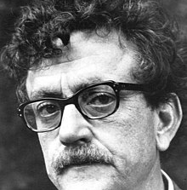
13 | 14 | 15 | 16 | 17 | 18 | 19
 |  |  |  |  | 1922 - Death of Marcel Proust, French author and critic (b. 1871) (100 years ago today)
20 | 21 | 22 | 23 | 24 | 25 | 26
 |  |  |  | 1922 - Death of Erskine Childers, Irish soldier, journalist, and author (b. 1870) (100 years ago today) |  | 1922 - Birth of Charles M. Schulz, American cartoonist, created Peanuts (d. 2000) (100 years ago today)
27 | 28 | 29 | 30
 |  |  | 1872 - Birth of John McCrae, Canadian physician, soldier, and poet (d. 1918) (150 years ago today)

December 2022
Anniversaries for classroom discussion / assemblies |  | Find more anniversaries at www.activehistory.co.uk/calendar

Sunday | Monday | Tuesday | Wednesday | Thursday | Friday | Saturday
 |  |  |  | 1 | 2 | 3
4 | 5 | 6 | 7 | 8 | 9 | 10
1872 - The crewless American brigantine Mary Celeste, drifting in the Atlantic, is discovered by the Canadian brig Dei Gratia. | 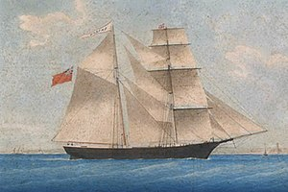 |  |  | 1922 - Birth of Lucian Freud, German-English painter and illustrator (d. 2011) (100 years ago today) | 1972 - Death of Louella Parsons, American writer and columnist (b. 1881) (50 years ago today)
11 | 12 | 13 | 14 | 15 | 15 | 16
 | The International Day Of Heavy Metal
17 | 18 | 19 | 20 | 21 | 22 | 23
24 | 25 | 26 | 27 | 28 | 29 | 30
 | 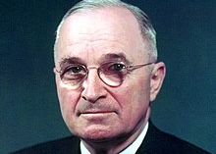 | 1972 - Death of Harry S. Truman, American colonel and politician, 33rd President of the United States (b. 1884) (50 years ago today) | 1822 - Birth of Louis Pasteur, French chemist and microbiologist (d. 1895) (200 years ago today) |  |  | 1922 - The Union of Soviet Socialist Republics is formed. (100 years ago today)

January 2023
Anniversaries for classroom discussion / assemblies |  | Find more anniversaries at www.activehistory.co.uk/calendar

Sunday | Monday | Tuesday | Wednesday | Thursday | Friday | Saturday
1 | 2 | 3 | 4 | 5 | 6 | 7
 |  |  |  | 1923 - Birth of Sam Phillips, American radio host and producer, founded Sun Records (d. 2003) (100 years ago today)
8 | 9 | 10 | 11 | 12 | 13 | 14
1823 - Birth of Alfred Russel Wallace, Welsh-English geographer, biologist, and explorer (d. 1913) (200 years ago today) | 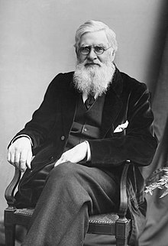 |  |  |  |  | 1973 - Elvis Presley's concert Aloha from Hawaii is broadcast live via satellite, and sets the record as the most watched broadcast by an individual entertainer in television history. (50 years ago today)
15 | 16 | 17 | 18 | 19 | 20 | 21
1923 - Birth of Ivor Cutler, Scottish pianist, songwriter, and poet (d. 2006) (100 years ago today) |  | 1773 - Captain James Cook commands the first expedition to sail south of the Antarctic Circle. (250 years ago today) | 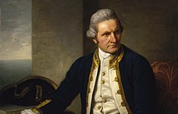 |  | 1923 - Birth of Slim Whitman, American country and western singer-songwriter and musician (d. 2013) (100 years ago today)
22 | 23 | 24 | 25 | 26 | 27 | 28
1973 - Death of Lyndon B. Johnson, American lieutenant and politician, 36th President of the United States (b. 1908) (50 years ago today) | 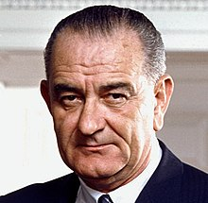 |  |  | 1973 - Death of Edward G. Robinson, Romanian-American actor (b. 1893) (50 years ago today) | 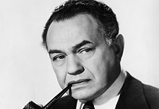
29 | 30 | 31

February 2023
Anniversaries for classroom discussion / assemblies |  | Find more anniversaries at www.activehistory.co.uk/calendar

Sunday | Monday | Tuesday | Wednesday | Thursday | Friday | Saturday
 |  |  | 1 | 2 | 3 | 4
5 | 6 | 7 | 8 | 9 | 10 | 11
12 | 13 | 14 | 15 | 15 | 16 | 17
1923 - Birth of Franco Zeffirelli, Italian director, producer, and politician (d. 2019) (100 years ago today) | 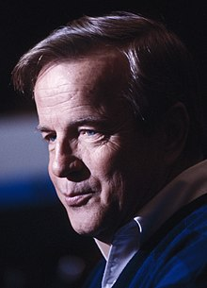 |  |  |  |  | 1673 - Death of Molière, French actor and playwright (b. 1622) (350 years ago today)
18 | 19 | 20 | 21 | 22 | 23 | 24
 | 1473 - Birth of Nicolaus Copernicus, Polish mathematician and astronomer (d. 1543) (550 years ago today) | 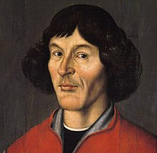
25 | 26 | 27 | 28
1723 - Death of Christopher Wren, English architect, designed St Paul's Cathedral (b. 1632) (300 years ago today) | 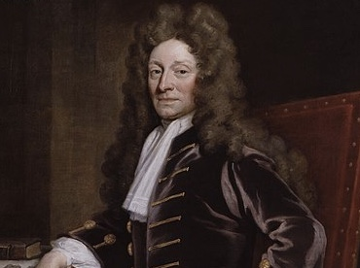

March 2023
Anniversaries for classroom discussion / assemblies |  | Find more anniversaries at www.activehistory.co.uk/calendar

Sunday | Monday | Tuesday | Wednesday | Thursday | Friday | Saturday
 |  |  | 1 | 2 | 3 | 4
5 | 6 | 7 | 8 | 9 | 10 | 11
 |  |  | International Women's Day
12 | 13 | 14 | 15 | 15 | 16 | 17
 |  |  | 1673 - Death of Salvator Rosa, Italian painter and poet (b. 1615) (350 years ago today) |  | 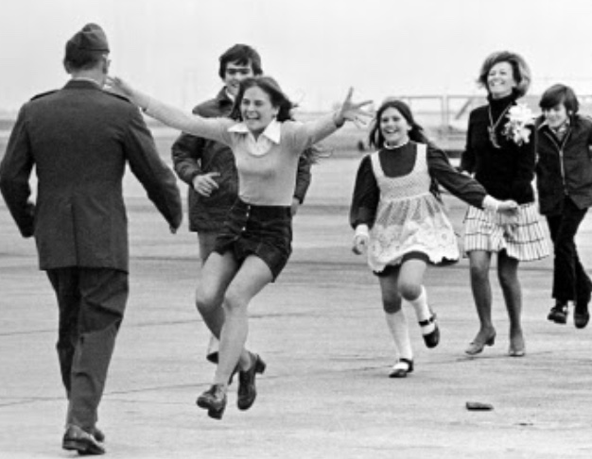 | 1973 - The Pulitzer Prize-winning photograph Burst of Joy is taken, which came to symbolize the end of United States involvement in the Vietnam War. (50 years ago today)
18 | 19 | 20 | 21 | 22 | 23 | 24
 |  |  |  | 1923 - Birth of Marcel Marceau, French mime and actor (d. 2007) (100 years ago today) | 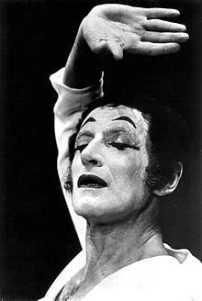
25 | 26 | 27 | 28 | 29 | 30 | 31
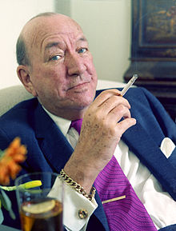 | 1973 - Death of Noël Coward, English playwright, actor, and composer (b. 1899) (50 years ago today) |  |  | 1973 - Vietnam War: The last United States combat soldiers leave South Vietnam. (50 years ago today)

April 2023
Anniversaries for classroom discussion / assemblies |  | Find more anniversaries at www.activehistory.co.uk/calendar

Sunday | Monday | Tuesday | Wednesday | Thursday | Friday | Saturday
 |  |  |  |  |  | 1
 |  |  |  |  | 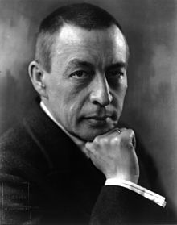 | 1873 - Birth of Sergei Rachmaninoff, Russian pianist, composer, and conductor (d. 1943) (150 years ago today)
2 | 3 | 4 | 5 | 6 | 7 | 8
 |  | 1973 - The Twin Towers of the World Trade Center in New York City are officially dedicated. (50 years ago today) | 1923 - Death of George Herbert, 5th Earl of Carnarvon, English archaeologist and businessman (b. 1866) (100 years ago today) |  | 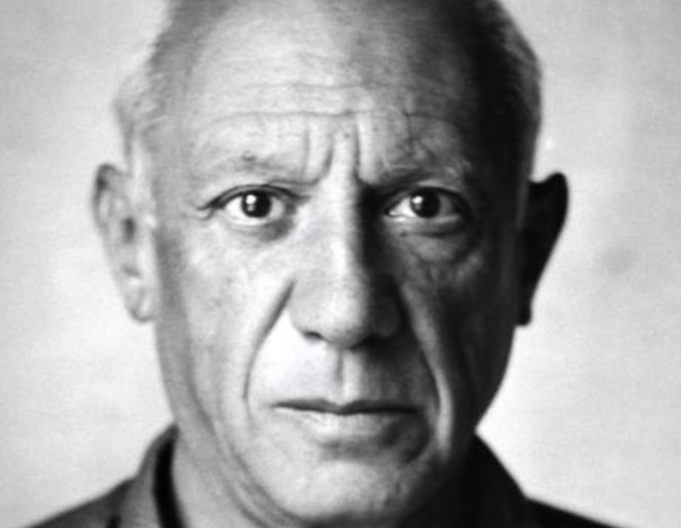 | 1973 - Death of Pablo Picasso, Spanish painter and sculptor (b. 1881) (50 years ago today)
9 | 10 | 11 | 12 | 13 | 14 | 15
16 | 17 | 18 | 19 | 20 | 21 | 22
23 | 24 | 25 | 26 | 27 | 28 | 29
 | 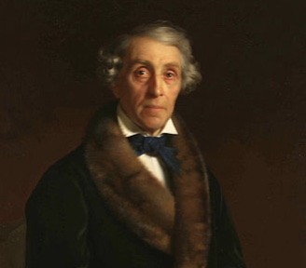 | 1873 - Death of Fyodor Petrovich Tolstoy, Russian painter and sculptor (b. 1783) (150 years ago today) |  | 1973 - The Dark Side of the Moon by Pink Floyd goes to number one on the US Billboard chart, beginning a record-breaking 741-week chart run. (50 years ago today) | 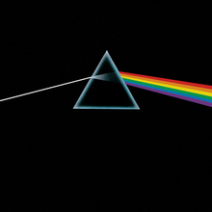
30

May 2023
Anniversaries for classroom discussion / assemblies |  | Find more anniversaries at www.activehistory.co.uk/calendar

Sunday | Monday | Tuesday | Wednesday | Thursday | Friday | Saturday
 | 1 | 2 | 3 | 4 | 5 | 6
 | 1873 - Death of David Livingstone, Scottish-English missionary and explorer (b. 1813) (150 years ago today) | 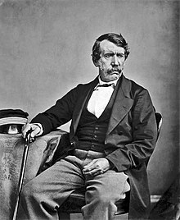
7 | 8 | 9 | 10 | 11 | 12 | 13
1523 - Death of Franz von Sickingen, German knight (b. 1481) (500 years ago today) | 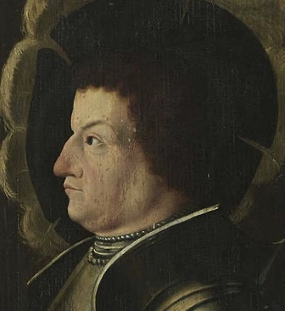
14 | 15 | 16 | 17 | 18 | 19 | 20
 | 1773 - Birth of Klemens von Metternich, German-Austrian politician | 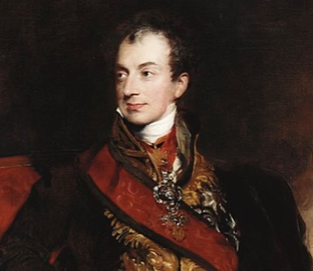 |  |  | 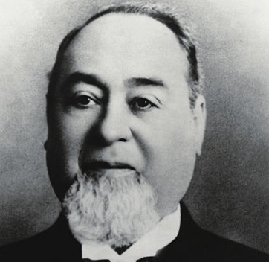 | 1873 - Levi Strauss and Jacob Davis receive a U.S. patent for blue jeans with copper rivets.
21 | 22 | 23 | 24 | 25 | 26 | 27
 |  |  |  |  | 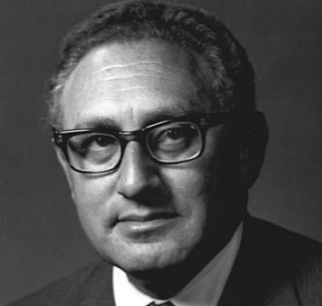 | 1923 - Birth of Henry Kissinger, German-American political scientist and politician
28 | 29 | 30

June 2023
Anniversaries for classroom discussion / assemblies |  | Find more anniversaries at www.activehistory.co.uk/calendar

Sunday | Monday | Tuesday | Wednesday | Thursday | Friday | Saturday
 |  |  |  | 1 | 2 | 3
4 | 5 | 6 | 7 | 8 | 9 | 10
 | 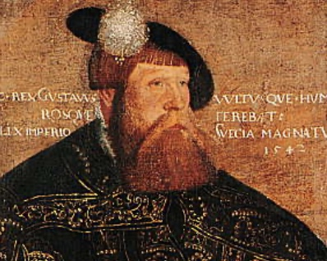 | 1523 - Swedish regent Gustav Vasa is elected King of Sweden (500 years ago today) |  |  | 1923 - Bulgaria's military takes over the government in a coup. (100 years ago today)
11 | 12 | 13 | 14 | 15 | 16 | 17
 |  |  |  | 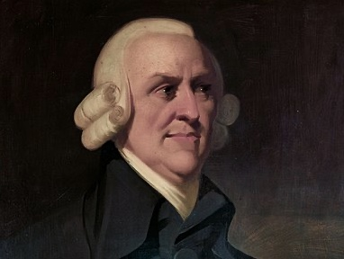 | 1723 - Birth of Adam Smith, Scottish philosopher and economist (d. 1790) (300 years ago today)
18 | 19 | 20 | 21 | 22 | 23 | 24
 | 1623 - Birth of Blaise Pascal, French mathematician and physicist (d. 1662) (400 years ago today) | 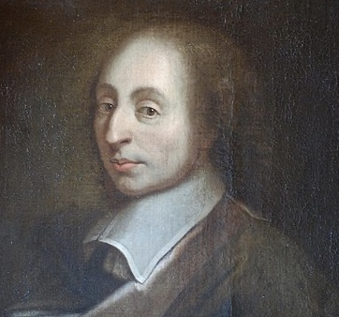
25 | 26 | 27 | 28 | 29 | 30
 |  |  |  | 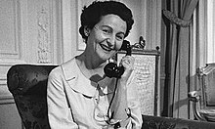 | 1973 - Death of Nancy Mitford, English journalist and author (b. 1904) (50 years ago today)

July 2023
Anniversaries for classroom discussion / assemblies |  | Find more anniversaries at www.activehistory.co.uk/calendar

Sunday | Monday | Tuesday | Wednesday | Thursday | Friday | Saturday
 |  |  |  |  |  | 1
2 | 3 | 4 | 5 | 6 | 7 | 8
1973 - Death of Betty Grable, American actress, singer, and dancer (b. 1916) (50 years ago today) | 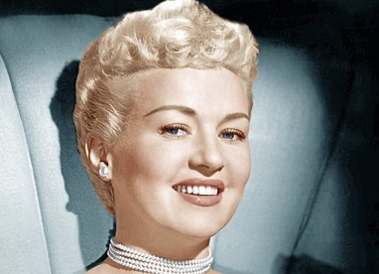 |  | 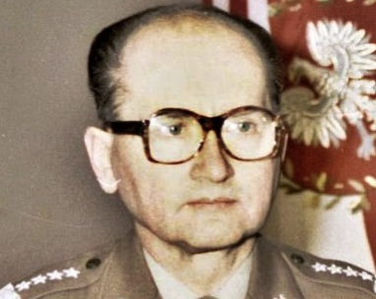 | 1923 - Birth of Wojciech Jaruzelski, Polish general and politician, 1st President of Poland (d. 2014) | 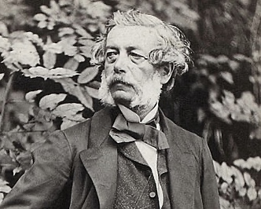 | 1873 - Death of Franz Xaver Winterhalter, German painter and lithographer (b. 1805)
9 | 10 | 11 | 12 | 13 | 14 | 15
 |  | 1923 - Birth of Richard Pipes, Polish-American historian and academic (d. 2018) |  | 1973 - Watergate scandal: Alexander Butterfield reveals the existence of a secret Oval Office taping system to investigators for the Senate Watergate Committee. |  | 1573 - Birth of Inigo Jones, English architect, designed the Queen's House (d. 1652)
16 | 17 | 18 | 19 | 20 | 21 | 22
 | 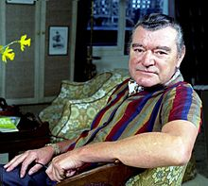 | 1973 - Death of Jack Hawkins, English actor (b. 1910) (50 years ago today) |  | 973 - Death of Bruce Lee, American actor and martial artist (b. 1940) (50 years ago today) |  | 1923 - Birth of Bob Dole, American soldier, lawyer, and politician (d. 2021)
23 | 24 | 25 | 26 | 27 | 28 | 29
 | 1923 - The Treaty of Lausanne, settling the boundaries of modern Turkey (100 years ago today) | 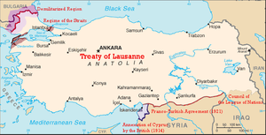
30 | 31

August 2023
Anniversaries for classroom discussion / assemblies |  | Find more anniversaries at www.activehistory.co.uk/calendar

Sunday | Monday | Tuesday | Wednesday | Thursday | Friday | Saturday
 |  | 1 | 2 | 3 | 4 | 5
 |  | 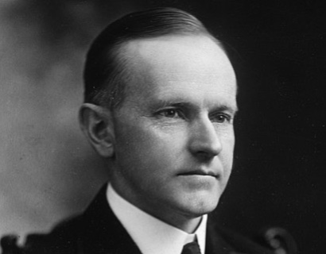 | 1923 - Vice President Calvin Coolidge becomes U.S. President upon the death of President Warren G. Harding.
6 | 7 | 8 | 9 | 10 | 11 | 12
1973 - Death of Fulgencio Batista, Cuban colonel and politician, 9th President of Cuba (b. 1901) | 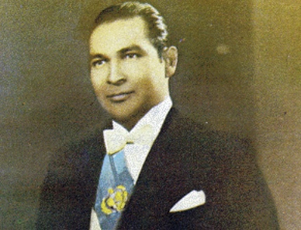
13 | 14 | 15 | 16 | 17 | 18 | 19
20 | 21 | 22 | 23 | 24 | 25 | 26
1923 - Birth of Jim Reeves, American singer-songwriter (d. 1964) (100 years ago today) | 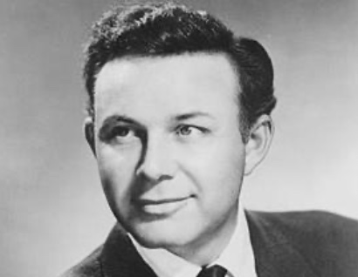
27 | 28 | 29 | 30 | 31
 |  | 1523 - Death of Ulrich von Hutten, Lutheran reformer (b. 1488) (500 years ago today) | 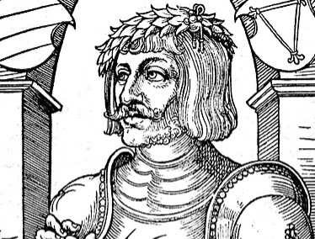 | 1973 - Death of John Ford, American actor, director, producer, and screenwriter (b. 1894) (50 years ago today) | 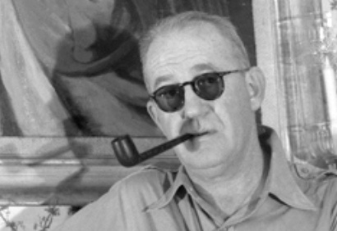

Produced by Russel Tarr
www.activehistory.co.uk
www.classtools.net

Disclaimer: all anniversaries have been selected purely at the discretion of the author

To find more anniversaries to customize this calendar: www.activehistory.co.uk/calendar

