Can you persuade the King to let you build a Cathedral?

Introduction
• In this online activity, you will try to persuade the King to let you build a cathedral.
• He will ask you ten questions to test your knowledge of cathedral building.
• You will be given a rating at the end, along with a summary of all your responses.

Task 1
▪ Open the activity by opening this weblink: http://www.activehistory.co.uk/medieval_cathedrals
▪ Your objective is to persuade the King to let you build the cathedral.
▪ He will ask you a series of ten questions and you should try to give the correct answer.
▪ Read his replies carefully.
▪ Continue with the interview until all questions are answered.

Task 2
• At the end, you will be provided with a full list of the questions and your responses.
• COPY AND PASTE YOUR COMPLETED INTERVIEW HERE:

????

Task 3
• Use your completed interview, plus your existing knowledge from previous lessons, to produce a resource entitled “My design for a medieval cathedral”. This can be on paper, or in digital form (e.g. PowerPoint, SketchUp, Minecraft…), or a combination of several of these ideas.

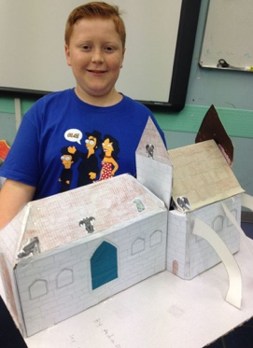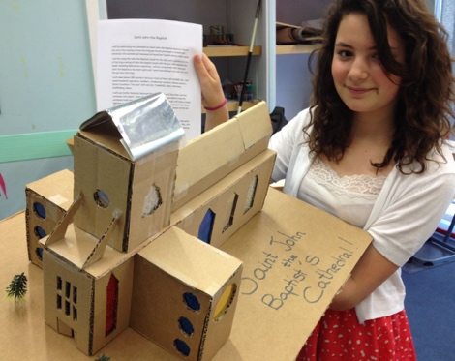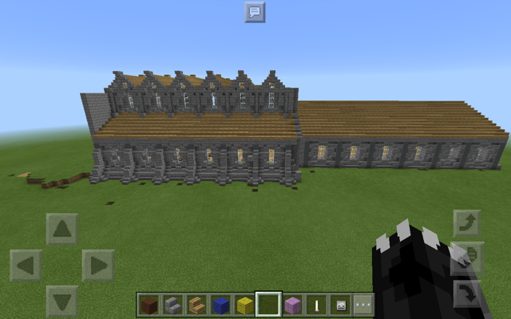

Within your project, answer as many of these questions as you can:
Which saint will you dedicate your cathedral to, and why?
Which relic(s) will you include in your cathedral, and why?
What sorts of workers and tools will you need to build the cathedral?
What sorts of Romanesque and / or Gothic features will you include?
Can you provide a diagram / model / sketch of your proposed design?
Can you label the key parts of the church?
What other things will you do / avoid, based on the feedback from the computer simulation?

TIPS
▪ The best grades will be given to students who
▪ Produce detailed written responses to the questions above and
▪ Produce a visual aid which shows the design of the cathedral.

